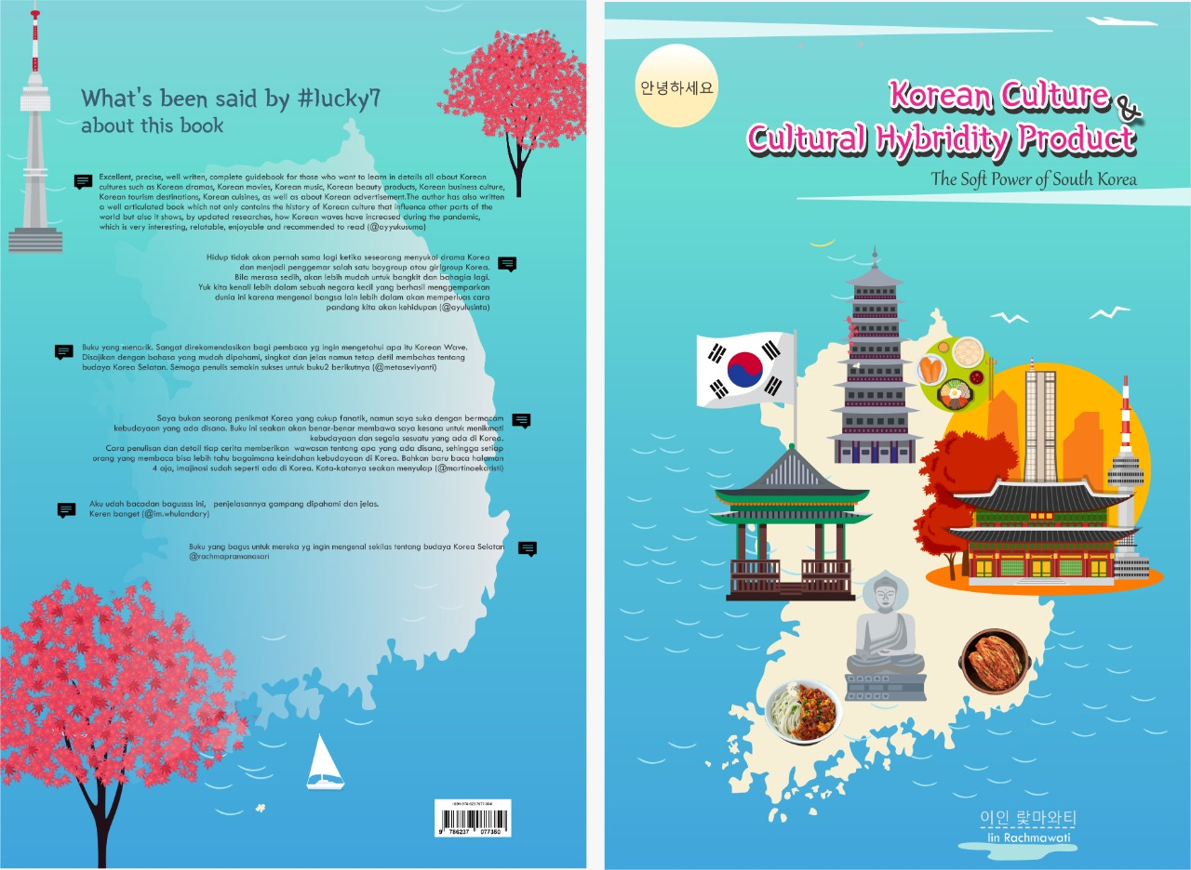

**Introduction**

As we have known before that culture in general means everything that comes from human made and everything that exists in our everyday lives. Culture can be found in the form of tangible and intangible things. Some of those tangible things are including chair, table, board, plane, train, tree, calendar, buildings, musical instruments, movies, fashion items, beauty products, stage, cuisines, and many more. Meanwhile what is meant by intangible things are including something like faith or belief, religion, perspectives, and some more.

Talking about culture means that we are going to talk about anything in our everyday lives and even those things can mean something good to certain people because those can make people feel relax, happy, and even inspiring. From the ancient time, people had already known that every country in this world has their own culture which is very unique and different from one country to another. This time, we are going to discuss everything we need to know about Korean culture.

Discussing about Korean culture will always related to the term *Hallyu* or more popular as Korean wave. Actually, the modern era of globalization has widely opened the gate for foreign cultural product exchanges which leads to cultural hybridity. Indonesia is one of many countries which is affected by the massive movement of Korean pop culture. Thus, it may influence a lot on the cultural relationship between Indonesia and South Korea by the year of 2021 and the years ahead.

South Korea is actually becoming a country which is responsible for spreading Korean wave in countries all around the world. Korean culture is actually a cultural hybridity product that links Confucian culture, Korean traditions, as well as Western popular culture in the form of drama, movies, music, fashion, and many more.

Korea and its culture, of course, there would be several interesting things to be discussed. Talking about Korea means that the discussion is mostly about South Korea and North Korea. However, the whole world knows that South Korea tend to be more developed and more modern than its counterparts, North Korea due to the fast development of the advanced technology as well as the popularity of the entertainment business cultures. Nowadays, there is no one in this world who do not familiar with South Korean entertainment business cultures including the most popular, K-Dramas and K-Pop wave. The term Korean wave is started from China to describe how fast South Korean entertainment business influences China, Asia, as well as the rest of the world from the early 1990s.

That is why; this book will discuss in details all about Korean cultures such as Korean dramas, Korean movies, Korean music, Korean beauty products, Korean business culture, Korean tourism destinations, Korean cuisines, as well as about Korean advertisement. Of course, all of those cultures can be simply categorized as essential parts of the new era of Korean wave. This Korean wave has hit the whole world in an amazing way. These days, South Korea has become one great power both in Asia and in the world.

**Korean Culture and Korean Business Culture**

It is truly interesting to learn more about Korean culture since there are many people in this world who are getting influenced by the culture of Korea through music, movies, fashion, cuisines, as well as its beauty products. Talking about Korean culture means that we are talking about a unique culture with the influences come from China, Japan, and also the Western countries such as US. South Korea is popularly known as well-organized country where you will be able to find a number of global stores as well as there are many people tend to speak conversational English in its big cities including Seoul, Busan, and Daegu.

Besides music, movies, fashion, cuisines, and beauty products, South Korea is also the home for cultures like crafts, dances, ceramics, paintings, and any other traditional arts. Most of the traditional buildings in Korea will show the image of dragon (용). But, do you know the meaning of dragon based on Korean traditional culture? Actually, dragon means something positive. It symbolizes water, rains, farming, and clouds. Korean people believe that dragon lives in bodies of water such as lakes, rivers, seas, and oceans.

Now, talking about dances in which there is a distinction between folk dance and court dance in Korea. A few of traditional dances are *jeongjaemu* (정재무), *hyangak jeongjae* (향악정재), and *dangak jeongjae* (당악정재) which is imported from China and Central Asia. In Korea, there are also variations of mask drama and mask dance with its traditional costume called *genja* (pink clothing with multiple symbols around the neck area for women). For the variation of classic Korean dance, we know about *taekkyon* or popularly named as Korean martial arts.

Moreover, the history of Korean ceramics is long and it is come from the period of Neolithic. One of the most popular ceramic arts is pottery which was advanced during the period of Silla, the oldest Three Kingdoms Period. Pottery was fired using deoxidizing flame and its surface was embossed with numerous geometrical patterns. The production of ceramics in Korea was reached its highest refinement in the *Goryeo* period or in the twelfth century. Even a popular artist, William Bowyer from Victoria and Albert Museum London, England stated that Korea has the best original traditional ceramics with the most gracious and unaffected pottery ever made. During the fifteenth century, white porcelain from Korea became popular all over the world. And in the late seventeenth century or during the *Joseon* period, blue and white ceramics became really popular as they are made, painted, and designed in cobalt blue and white porcelain.

Cx8TMlhUQAAgR-w.jpg | Legend of the blue sea wallpaper, Legend of blue sea, Blue  sea

Korean Traditional Ceramics and Porcelain as appeared in the Drama

‘The Legend of the Blue Sea’ (Source: Google)

Petroglyphs have then worldwide known as the earliest traditional painting which came from the pre-historic period in Korea. Among all those beautiful traditional paintings popular in Korea, there were *Goguryeo* tomb murals which were strongly influenced by Buddhism brought by India through China to Korea. For the ancient *Goguryeo* people, these murals are truly familiar to be painted inside the tombs for the use in the ceremonies, warfare, architecture, and daily lives. Traditional paintings in South Korea were practically influenced a lot in resulting naturalism technique with subjects like flowers, birds, and realistic landscapes. The painters use ink to paint above mulberry paper or silk. In the eighteenth century, calligraphy and seal engraving were advanced and it is popular as indigenous techniques in painting. This happened during the Joseon period where new genre of paintings introduced including *chaekgeori* (paintings of book) and *munjado* (paintings of letters). This is the first time where people could start to learn Korean culture through paintings and writings.

About another traditional culture in Korea, it is impossible not to discuss Korean traditional house which called *Hanok* (한옥) which was selected using traditional ‘geomancy’. This geomancy was re-introduced by China during the Three Kingdoms Period. This geomancy influenced a lot in deciding about the shape of the house, the material, as well as about the direction. Many South Korean people believe that a house should be built face south to receive as much sunlight as possible and it should be built against the hill. Usually, Korean traditional house is being structured into an inner wing or *anchae* (안채) and an outer wing or *sarangchae* (사랑채). The wealthy people will use *sarangchae* as the reception section, while the poorer people will use it to keep the cattle. An inner wing usually consists of living room, kitchen, and central hall, and of course more rooms for sleeping. Another part of the house is the garden. Korean people will usually make their garden influenced lots by Shamanism which emphasizes nature and mystery so that it pays much attention to the details of the layout. That is why; most Korean gardens will show lotus pond and terrace flower beds to represent more natural elements. Also, it symbolizes the importance of water in traditional Korean garden.

Another part of Korean culture is about the holidays. South Korea is actually sharing numerous holidays with the rest of the world, but it also has several holidays that are truly unique to its culture. There are two most popular unique holidays in South Korea such as *Chuseok* (추석) or Korean Thanksgiving and *Seollal* (선랄) or Korean Lunar New Year. During these holidays, Korean people will usually go home to visit their families. For more information, not all holidays in Korea are considered to be public holidays because in Valentine’s Day and during Pepero Day or White Day1; Korean people do not get a day off. Of course, it is good for the continuance of business in Korea.

Korean business culture is basically influenced by Confucian principles, and it is just similar with the beliefs of Korean people in their personal lives. These Confucian principles support something like the importance of family, friendship and ancestors, group harmony, tradition, as well as about respect for elders and authority. Thus, it can be clearly said that having good relationship is a crucial key to gain success in the business world in South Korea. That is why; attitudes like trustworthy, respectable and honorable are quite substantial in running business in South Korea. Korean people always make friends first, then they will consider about clients.

1)Pepero Day (White Day) is known as Korean Valentine’s Day which is being celebrated every November 11th. During this Pepero Day, everyone will give Pepero chocolate biscuits to someone they love to express their feelings and emotions.

This is explained on why Korean business is founded upon relationships. Even, such large companies still have family members in executive position. In order to maintain the continuance of this business system, Confucian principles have been regarded, showing respect for family, age, rank, and tradition which later known to be an essential part of the Korean business etiquette. Also, it is important to know that in the business, Korean people will usually give their clients or partners westernized version of their Korean name such as Lee Yeong Sung (Korean name) to become Mr. Johnny Lee.

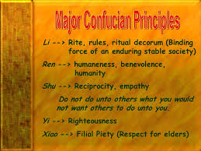

Confucian Principles in the Korean Business Culture (Source: Google)

Of course, when someone is having business with South Korean or doing business in South Korea, he or she needs to understand about the rules in taking and giving business cards. For Korean people, business cards are truly important as they will have their business cards printed in English in one side while the other side printed in Korean. It is very common to give and receive those business cards in both hands, take time to read the cards, and never write anything in the business cards.

Based on its culture, Korean business culture is quite traditional because of its track record as one of the oldest continuous cultures in the world. As the world has already known that Korea has been split into South Korea and North Korea since the mid-20th century. The original religion of the Korean people, which is known as Shamanism, is influencing a lot on their business culture whether in Korea or even when they are doing the business outside Korea. One big faith of this Shamanism is about doing anything in life based on the traditional value. So, even when Korean people have succeeded in exploring their business anywhere, they still hold on tight their traditional beliefs and values. Besides Shamanism, Korean people also believe on Buddhism and Confucianism which had been introduced earlier through cultural exchange with Chinese dynasty. Until today, Korean Shamanism, Buddhism, and Confucianism plays a vital role of their culture.

Actually, through the beliefs of most Korean people to hold on tight on their traditional value, South Korea can develop into one of the most influenced countries in the whole world. For instance, there are a bunch of Korean literary works are being translated into numerous different languages for global readers. That is why; there are more and more people in the world who tend to know and understand about Korean culture as well as Korean business culture. And it is made Korean people to be able to show off their capabilities to the whole world. All of these Korean cultural prosperities would not be possible without its traditional culture and arts. These Korean traditional cultures were built on the Korean people’s traits of perseverance and tenacity which has matured throughout the country’s long history. That perseverance and tenacity grew bigger and bigger throughout the decades from Silla period (676 – 935), *Goryeo* period (918 – 1392), and Joseon period (1392 – 1910). Later on this kind of traditional value called as the aesthetic sensibility which has been handed down through generations to generations.

Through the history, actually Korean business culture in the modern era had started from what is called as *Ramyeon*: The ‘Model T’ of Korean marketing. Why is it called as Model T? it is because during that period, per capita annual income for Koreans were just a few hundred dollars and that was not enough to just buy rice for those hungry masses (Ryun Chang, 2007). Then, *Ramyeon* (Korean instant noodles) came and it was magically fulfilling the needs for those hungry masses. Soon after that, this magical product became a staple of Korean life, both for the rich and for the poor. In the early 1980s, *Nongshim* offered a wide variety of *Ramyeon* brands including Shin *Ramyeon* (spicy soup), *Nuguri* (thick noodles), and *Ansungtangmyun* (milder soup). Up until now, this big brand is still really popular throughout the world as people can find it anywhere in the convenience store. What makes Korea interesting is that everyone in this world knows and wants these products and brands. In short, individual choice is driven by the collective will.

Later on, that kind of *Ramyeon* phenomenon has become what is called as the ‘We-Me’ phenomenon. As many Asian countries, Korean has known to have collectivistic cultures combined with Western culture which is more individualistic. Korea is both (Ryun Chang, 2007). The explanation on why *Ramyeon* can be called as a great example of the ‘We-Me’ phenomenon is because a group of people (friends or colleagues or families) will usually order the same menu item in a restaurant. It is a Korean thing where there is still a communal aspect to eating in Korea. It is very common to see people in Korea to share food or pass around alcohol in cups than drink it as a sign of bonding. But at the same time, Korean people do not afraid of showing their personal side, such as they love to sing and dance even when they are drunk. Thus the ‘We’ refers to collectivistic culture and the ‘Me’ refers to that individualistic culture.

And one good thing that makes Korea especially South Korea is popular all around the world is because Korea is a very brand-conscious country. The consumer preferences in South Korea are greatly influenced by brands (Ryun Chang, 2007) because brands can simply symbolize status and in group societies, brands provide social identity. It can also easily be seen through several Korean dramas where brands still being the greatest thing for those middle to high people. Let’s say in dramas like Boys over Flowers (2009), Secret Garden (2010), The Heirs (2013), Descendants of the Sun (2016), and What’s Wrong with Secretary Kim (2018). Those rich characters were competing to each other to look glamorous and increasing their social status. In South Korea, those rich characters who are supporting Korean economic and business called as *chaebol*. *Chaebol* is not only influencing South Korea’s economic sector, but also influencing the world such as the biggest *chaebol* in South Korea like Samsung and LG. Even though, there are a lot of benefits that come from those *chaebol*, but there are still a few negativities such as corruption as the practices close to family business culture.

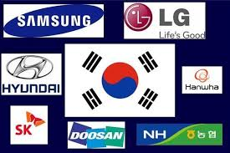

One Nation Divided Under the *Chaebol* (Source: Google)

Back into the history a long time ago, it was known that after the Korean War, Republic of Korea was one of the poorest countries. The Asian financial crisis during 1997-1999 has made Republic of Korea’s economy decline. In order to increase the economic sector and to achieve national interest, the government decided to focus on the growth of Korean cultural industry. The use of Korean cultural industry in influencing and attracting international communities has then called as South Korean’s soft power. The exports of Korean cultural products have later known as Korean wave which were indicating the first boom of cultural products in overseas.

Another good thing is that South Korea has the highest installed base of ADSL and VDSL in the world. As Ryun Chang (2007) had once stated that there were over 4,000 start-ups in the country. And all of those facts make South Korea to become the biggest target market for any industries to develop faster and grow bigger. That is why; doing business in South Korea or having corporation with Korean people will be very useful during this advanced development of technological era.

**Korean Wave**

The term Korean wave (한류) is actually about the raise of popularity of the Korean culture since 1980s. This term refers to the time period of 1990s, when the Korean culture was internationally visible, not only all around Asia, but also in the United States as the center of movie industry (Chua & Iwabuchi, 2008). According to Korean Tourism Organization (2012), the term Korean wave refers to a favorite phenomenon of Korean popular culture abroad. The widespread of its popularity has first driven by K-Pop and K-Dramas across the Southeast Asia, Eastern and Southern Asia. Korean wave has significantly reached its popularity from regional development into the global phenomenon carried by the social media and internet. In Indonesia, the Korean wave was first detected during the early 2000s when Indosiar aired some Korean popular dramas such as *Autumn in My Heart* (2001), *Winter Sonata* (2002), *Jewel in the Palace* (2003), *Full House* (2005), *Princess Hours* (2006), as well as Korean movies like *My Sassy Girl* (2001), *Conduct Zero* (2002), and *Marriage is a Crazy Thing* (2002).

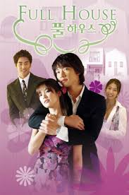 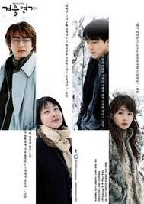

Phenomenal Korean Drama: Full House (left) and Winter Sonata (right) (Source: Google)

According to Howard (2006), this Korean wave was developed into four stages. The first stage is about the increased production of Korean dramas and movies. During the year of 2007-2008 Korean wave was facing its crisis due to the boring storyline which sticks to the old ones. But this crisis did not last for long time as by the year 2009, the second Korean wave emerged in Indonesia. The second wave signified by the increasing demand of products associated with the famous Korean pop idols such as Girls Generations, Super Junior, Shinee, TVXQ, Tmax, 2PM, Wonder Girls, and many more. After that, the rising of Korean wave seems to be unstoppable with the massive success of drama *Boys over Flowers* (2009) which set a new trend in Korean drama: Korean students’ school life and the success continued by similar theme of drama: *Dream High* (2011) and *The Heirs* (2013). The second Korean wave was successfully catapulted the name of Lee Min-Ho to become the most popular actor and got many awards as Best New Actor and Best Performance.

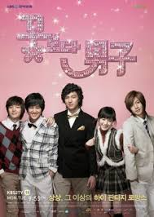 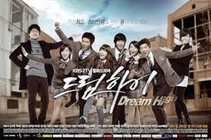 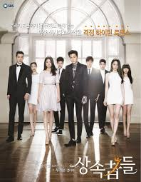

Boys Over Flowers (left), Dream High (middle), The Heirs (right):

Creating a new trend in Korean drama of ‘Students’ School Life’ (Source: Google)

During the third stage, many people in the world started to purchase numerous Korean goods and services such as electronic products which were not directly associated with Korean idols. Then in the last stage, people started to perceive a desirable impression of South Korea which results in the changes of the Korean domestic markets (Hwang & Sung, 2000).

Moreover, the changes in broadcasting regulations and policies have become one of several factors that ensure the growth of the Korean movies. In the beginning, only a small number of film studios existed and the TV viewers were also limited. In other words, only dramas and movies which meet the requirements in line with the government were enable to be broadcasted. At that time, the government controlled the entry, the content of the movies, as well as the distribution channels. In the year of 1984 – 1985 can be said to be the turning point of the Korean film industry. During that year, the censorship standards and import regulations were revised. The big impact of this new “law and regulation in cinema” made Korean film productions to be able to import their movies to foreign countries, as well as foreign countries gained the entry to be played and broadcasted in South Korea in order to give fair competition. Then, nowadays, the quality of the Korean movie industry increased significantly and there are more and more Korean movies, dramas, and music won many international awards.

Since the 21st century, Korean wave has become such global phenomenon and it is emerged as a major exporter of Korean culture and tourism as well as increasing its economic growth (Kim, 2017). It is majorly because of the massive growth of Korean fans all over the world who are very loyal to their idols by starting to visit South Korea in order to know more about the shooting place of their favorite Korean drama series. This kind of fandom has then developed largely into the tourism sector in which there are more and more Korean fans across the world who tend to take advantage of tasting some traditional Korean food and snacks while they are visiting South Korea. Of course, this phenomenon has also created the massive growth in the economic sector of South Korea.

Fortunately, this growing popularity of Korean culture all over the world has fully supported by the government by supporting its creative industries through subsidies and funding the start-ups. In the year of 2014, Korean government had invested 1% of its annual budget to cultural industries including the creative industries such as media. Nowadays, with the fast development of video sharing platforms and social networking services, Korean entertainment industry has reached a sizeable overseas audience. For instance, there are many Korean dramas have been adapted throughout the world and have been translated into multiple languages in the world. These Korean dramas are not only interesting in terms of actors and actresses, but also in terms of style, fashion, cuisines, music, as well as Korean culture.

And in the mid-2000s, this Korean wave is heavily giving impact to some sectors including music industry, contemporary cultures, television industry, film industry, as well as behavioral aspects of numerous people all around the world. As an American scientist, Joseph Nye (2018) said that Korean wave is about the growing popularity of all things in Korea including film, music, fashion, tourism, and cuisine.

Based on the development of cultural industry during 1995 – 1999, Korean government began to develop its authentic cultures based on its colonial ruler, Japan with its Japanese movies, manga, anime, and J-Pop. During the time in the year of 1999 – 2010, Korean wave began in Asia region. During February 2000, SM Entertainment with its boy band H.O.T became the first K-Pop artist to have sold-out concert and having overseas performance. The success of H.O.T followed by Shinhwa (2001), BoA (2002), TVXQ (2003), SS501 (2005), Super Junior (2005), and BigBang (2007). Meanwhile, in the Korean film industry, “My Sassy Girl” (2001) became a major international breakthrough. Then, it was followed by Korean drama “Winter Sonata” (2002) and “Full House” (2004).

In the United States, Korean wave has spread over especially by the Korean American communities, most notably those in New York City and Los Angeles. This kind of phenomenon has made Korean wave began to be received well in the United States as it is seldom to see other music or film industry can gain success in the United States. After Psy’s video entitled “Oppa Gangnam Style” went viral during 2013, a dedicated and growing global fan base started in the United States and some parts in the world. Also, the massive development of Korean wave in the world developed into the foreign diplomacy of South Korea. It is used as a means to promote Korean cultures to some foreign countries.

After the popularity of film industry and music industry, Korean wave touched the culinary industry as many Korean dramas having the big influence in promoting Korean traditional cuisines such as *bibimbap*, *tteokbokki*, *rabboki*, *gojhujang*, *ramyun*, *samyang*, *kimchi*, and many more. The two most recognizable features of South Korean cultures overseas are including cuisines and beauty products. In Asia Pacific region, Amorepacific and LG Household & Healthcare are recognized as Korean skincare products that gained massive popularity overseas. One popular skincare product from Amorepacific is Innisfree in which released a range of darker-toned cushions which matched the skin tones of most Southeast Asian women in 2017. Until today, Innisfree has spread out its influence with their beauty products by taking the most popular Korean actor, Lee Min-Ho as its global ambassador.

These days, talking about Korean wave has created the new term of *Hallyu 2.0* which means as “the new Korean wave” and it is began since 2007. The term *Hallyu 2.0* was first used during August 2010 by Japanese media since the performance from Korean girl band, Girls’ Generations at Ariake Coliseum in Tokyo. The term *Hallyu 2.0* has actually had larger scope than the first Korean wave because it is not only about music, fashion, film, cuisines, and cultures but also about other big Korean exports: video games and animation. According to Sun Lee (2012), it is practically impossible for Korean culture to have massive popularity all around the world without YouTube’s global platform. It is about 80% of the total 24 billion views of videos in YouTube of the top 200 Korean artists came from outside South Korea. This lead to K-Pop’s relationship with platform YouTube since 2009 with the big three record labels including SM Entertainment, JYP Entertainment, and YG Entertainment. YouTube has enabled the fans throughout the world to connect with K-Pop with their own content such as reactions to certain videos or channels, dance covers, and cover versions of popular songs.

In the mid-2010s, the term *Hallyu 3.0* has been introduced as the third generation of Korean wave. The rise of some K-Pop channels such as BTS official YouTube channel has become the characteristic of this *Hallyu 3.0*. This new rise of global Korean media consumption has also signed by highly collaboration with international media production such as Netflix. In this era, BTS has become the most popular boy band as their successful appearance and performance at U.S Billboard Music Awards. Moreover, this collaboration has been succeeded with more Korean artists tend to sing along with some foreign artists such as Psy released a song with American rapper, Snoop Dog, Blackpink released a fun song with American diva, Selena Gomez, and some more. In the end, the growth with these foreign artists indicates a large-scale present of Korean culture that had never seen before. There are a lot of good Korean movies can be easily seen through Netflix like “Okja” and “Parasite” which won several awards at International Film Festivals. Even the movie “Parasite” has made history by winning two Academy Awards 2020 in the category of “Best International Film” and “Best Picture”.

Eventually, the relationship between South Korea and North Korea has been greatly influenced by Korean dramas as there are a lot of K-Dramas aired in North Korea since 2007 (Lee, 2012). Furthermore, the influence of K-Drama has gotten closer since the airing of 2019’s phenomenal drama, Crash Landing on You. This drama has been such phenomenon because it tells a story that seldom to bring out to the television series. It tells the story of Yoon Se-Ri (starred by Son Ye Jin), a South Korean *chaebol* heiress who is swept-up in a sudden storm and crash-lands in the North Korean portion of the DMZ. Later, she falls in love with a soldier from North Korea, Captain Ri (played by actor Hyun Bin).

Even though, J-Pop and Japanese culture has spread out earlier than K-Pop and the Korean wave, what makes *Hallyu* fever or Korean wave being incredibly popular until today is that it is continually influenced by European and American trends, while J-Pop remains static from year to year. In the aspect of socio-cultural, Korean wave brings the significant impact to people where these days, there are more and more people outside Korea eager to learn Korean language, visit South Korea, as well as enjoy Korean food. According to Korean Cultural Center (2020), it is known that Korean has become the second most widely spoken foreign language in India and in some Southeast Asian countries.

In the aspect of tourism, the Korean government fully realized that K-Pop and K-Dramas are their essential assets to attract tourists from all over the world. In 2014, Korean government launched a campaign entitled “Imagine Your Korea” which highlighted Korean entertainment industry as the most popular point to attract tourists. According to KTO survey in 2015, 9 from 10 Korean wave’s fans wished to visit South Korea and for about 75% amongst them were actually planning to go. Those Korean fans are motivated to travel to South Korea because they want to visit some iconic filming locations such as Nami Island where drama Winter Sonata was shot, Jeju Island where Boys over Flowers was shot, and the heart of Seoul, Namsan Tower (filming spot of several Korean dramas including Legend of the Blue Sea).

In the end, it can be said that actually most Korean fans from Indonesia see that Korean wave is something that they have already familiar with since early 2000s. Film industry and music industry has become the two largest Korean industries that gained various spectators in Indonesia. From the research done by the researcher since February 2019, for about 80 percent of those Indonesian fans are female. They stated that the influence of this Korean wave growing higher and higher from year to year until today. It can be clearly seen from the significant increasing of total number of Korean fans from the first Korean wave until the third generation of Korean wave in the year of 2020.

As already mentioned above that the Korean government has contributed a lot in the development of Korean wave. The government aided the broadcasting stations and networks as well as the media industries to expand Korean pop culture internationally. Of course, all of these regulations had been done to develop positive national image of South Korea as well as to boost up Korean economic condition. In the short time, the pictures of Korean stars can be seen everywhere in South Korea and there is changing consumers in Korea especially consumers who want to look like their idols by doing plastic surgery or following the fashion and clothing style from their favorite Korean idols (Sujeong, 2009).

From the data of Inlingua School of Singapore, it can be stated that there is a significant increase of 60% in the number of students who are willing to learn Korea in 2003 due to the attention generated by Korean movies, dramas, and music. Korean pop stars were used to promote Korean goods and services internationally. The impact of Korean wave was not only limited to the Korean economy, but also to the lives of its pop idols. After Korean wave, several Korean celebrities such as Bae Yong Joon and Lee Min-ho became two of the highest paid actors in the worldwide film industry.

Apart from the impact of Korean wave as the national phenomenon, it can also be concluded that Korean wave made such transnational phenomenon. One good proof is about the fact that Korean wave helped in improving foreign relations of Korea (Iwabuchi, 2008). As we have already known that Korea had a long history in diplomatic frictions with some neighboring countries. Like Korean soldiers fought against the liberation of army in Vietnam and established ties with Beijing in 1992.

Of course, beside all of those positive impacts of Korean wave, there are also several negative impacts affected by this Korean wave. First, it is about the classical music which tends to be used in almost every Korean dramas and movies before the Korean wave established. But, after the Korean wave, this classical music and culture was suddenly replaced by pop culture. Some of Korean neighboring countries like China, Taiwan, and Vietnam has decided to limit the number of the broadcast of Korean dramas and movies in order to protect their own entertainment industry (Jeon & Yoon, 2005). This movement can be said to be the way to retaliate against the success of Korean wave.

However, besides some of negative sides of Korean wave, E-Daily reporter, Yoon Jong-Seong (2021) reported about the 2021 Overseas Korean Wave Survey (which was released by the Ministry of Culture, Sports & Tourism), that actor Lee Min-Ho and boy band BTS reached the massive success of being the most beloved Hallyu Star (taken from naver.com released in January 28th 2021). Lee Min-Ho ranked as the most preferred Korean actor with more than 40 million followers on social media and he is regarded as the number one most influential Korean wave actor. Also, Lee Min-Ho has ever been given a title of ‘*public ambassador*’ as “**The Face of Korean Tourism**”. Still, according to the Korean culture wave survey, actor Lee Min-Ho, who has followers a lot more than the number of total population in South Korea, got 9.6% vote with Hyun Bin following in second position with 3.5% vote and actress Song Hye-Kyo with 2.1% vote. Besides Lee Min-Ho and BTS, a phenomenal drama ‘Crash Landing on You’ and a movie ‘Parasite’ were also in top contributors who spread Korean wave through Covid-19 crisis.

 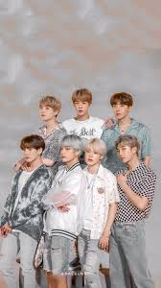

Lee Min-Ho (left) and BTS (right) as The Most Beloved Hallyu Star in 2020

(Source: Google)

For more, according to the Korean International Cultural Exchange Promotion Agency, the portion of Korean wave content consumption (including games, entertainment, and dramas) raised the survey which was conducted through online survey from September 24th 2020 – December 4th 2020. The survey was targeting more than 8500 Korean cultural content experiences from Korean lovers in 18 countries abroad. Korean foundation for this International Cultural Exchange gave US$ 8.2 million for South Korean’s economic level in 2020 (detik.com, 2020). The market share of Korean wave consumers’ consumption by sector was highest in the order of Korean drama (29.7%), beauty products (27.5%), entertainment (26.9%), and fashion items (24.8%). Meanwhile, music has become the sector with the highest percentage of contacts through both online and mobile platforms during 2020, with the percentage of 82.0% (Jong-Seong, 2021).

One great reason on why this phenomenon of Korean wave can last for long time is because South Korean government supports a lot on this Korean culture as the number one export to spread out all about South Korea to the world. The government can maximize the phenomenon of Korean wave and culture as soft power to keep South Korea as one of the strongest countries in Asia, in the future, in the world. Other than that, in some countries including in Indonesia, as the cooperation between South Korean government and Indonesian government, there are several events held to celebrate bilateral relationship between South Korea and Indonesia such as what is called as “*Pekan Budaya Korea*” or Korean Cultural Week. Even campus like Indonesia University (UI) held this ‘Korean Cultural Week’ annually since this campus has Korean studies as one of their departments in Faculty of Humanities.

Kim et.al (2014) studies the effect of Korean wave in Indonesia. Their study showed that the characters and scenario of those Korean television dramas have successfully touched Indonesians’ emotions including empathy and sympathy. Thus, the positive image of Korea can be said to be a result from this emotional touch of seeing and adoring the attractiveness of those Korean celebrities.

**Korean Dramas**

Korean television drama or it has been popularly known as *hanguk drama (*한국드라*)* made in South Korea. Actually, Korean dramas are widely popular due to the spread of Korean popular culture as well as the widespread of availability via streaming services and have been translated into multiple languages. Some of the most famous Korean dramas have been adapted worldwide and some had massive impact on other countries such as drama “Dae Jang Geum” (Jewel in the Palace - 2003) which was sold to 91 countries (Kyong, 2012). Historically, South Korea had started to broadcast television series in the 1960s and at that time, the television series has transformed into the miniseries format. The first Korean drama series was aired by KBS in 1962.

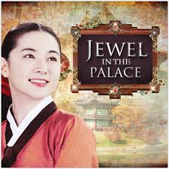

Phenomenal Korean Drama: Jewel in the Palace (2003) (Source: Google)

What makes Korean drama interesting is about the making of those dramas. Korean drama usually lead by one director and has been written by a single screenwriter. This differs from American television series which can rely on multiply directors and screenwriters working together (Je-Hae, 2012). Moreover, Je-Hae added that Korean drama sets for a single season which usually contain 12 to 24 episodes of 60 minutes per episode, except for historical series which usually contain up to 200 episodes but still being made a single season. Meanwhile, American drama tends to consist of multiple seasons. Most of these dramas appear in nationwide networks: SBS (Seoul Broadcasting System), MBC (Munhwa Broadcasting Corporation), and KBS (Korean Broadcasting System) or even appear via TV cables: Channel A, TvN (Total Variety Network), OCN (Orion Cinema Network), and Joongang Tongyang Broadcasting Company (jTBC).

According to The Korean Herald (2014), Korean dramas have multitude of different genres including something like school drama, medical drama, action drama, legal drama, historical drama, fantasy drama, and even horror comedies. The main themes of these Korean dramas are generally about love, friendship, and family values. But it is not limited to those themes since the modern Korean dramas have also told the spectators about some societal issues such as gender inequality, bullying, suicide, classism, mental illness, corruption, homophobia, spy cameras, racism, and many others. Even at recent study conducted by Van My Ta Park et.al (2020) entitled “Promising Results from the Use of a Korean Drama to Address Knowledge, Attitudes, and Behaviors on School Bullying and Mental Health Among Asian American College-Aged Students” in the International Journal of Environmental Research and Public Health stated that Korean drama television shows can be such an innovative approach to improve knowledge, attitudes, and behaviors (KAB) on bullying. This KAB about school bullying improved after watching K-Drama. It is because those participants love the K-Drama, felt emotional connection, and thought that K-Drama can be an educational tool for improving mental health among Asian American college students.

When it comes to Korean drama or popularly known as K-Drama, there are hundreds of people in Indonesia especially those youngsters who have been loyal fans. The popularity of these Korean television dramas are mostly affected by the characters appear in the drama itself. Generally, the romance drama uses ideal portrait of Korean male protagonists: handsome, rich, intelligent, and emotionally loved. As Sara (2020) stated, the romantic tension in Korean dramas typically "*is built up so expertly that it is more emotionally resonant when the main couple finally hold hands halfway through the series than when a full-blown bedroom scene happens in an American series*". This is actually becoming the highlight point of why Indonesian perspectives in seeing Korean dramas have become more intimate to their daily life than when they see some romantic scenes in American dramas or TV series. Also, because of Korea’s puritanical culture of "love scenes rarely progress past kissing" seems to look much closer to most of Asian culture in general and Indonesian culture in specific.

The change in Korean dramas had become in the 1980s where color television became available. It began with Kim So Hyun’s first real commercial success with the drama entitled *Love and Ambition* *(사랑과야망, Saranggwa Yamang)*, aired on MBC in 1987. According to The Korea Times, it is regarded as a milestone for the Korean television drama series as it succeeded in having 78% viewership. And jumped into 2010s, the most popular Korean drama genre was web-drama. Web-dramas are regarded to be a short form of drama mostly shoots through non-conventional broadcasting platforms including search engine (Naver, Yahoo, Google) or video channels (YouTube).

It started to take over the popularity of conventional Korean dramas among 2010s and 2020s because they are shorter, hence easier to watch, and often feature trendy contents which teenagers are easy to sympathize with. Some of those popular web-dramas include “Idol Drama Operation Team”, “Pongdang Pongdang Love”, “Line Romance” (Line at The First Sight), “Summer Love”, and “Lotte Duty Free: Seven First Kisses” (Levine, 2019). Those web-dramas are played by some popular actors and actresses as well as began to utilize as the advertisement for certain products, with the duration longer than the usual advertisement.

 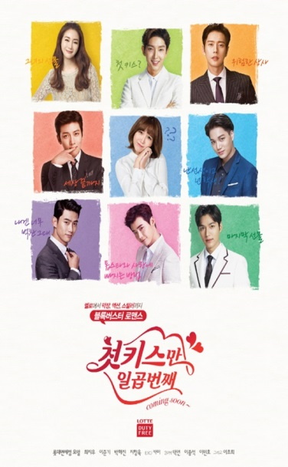 

Korean Web Dramas: Summer Love (left), Lotte Duty Free (middle), and

Line Romance (right) (Source: Google)

Due to the popularity of Korean dramas abroad, then from the late 2015, especially with the success of drama “My Love from the Star” in China, the producers began to shoot their dramas abroad more often in order to steal the attention from wider spectators abroad as well as started to do pre-selling the overseas broadcast. In 2016, some popular Korean dramas such as *Descendants of the Sun*, *Uncontrollably Fond*, *Moon Lovers: Scarlet Heart Ryeo*, *The Legend of the Blue Sea,* and *Hwarang: The Poet Warrior Youth* were all pre-produced (re-edit and re-shot) before airing due to the audience feedback (taken from Wikipedia/Koreantelevisiondrama).

Of course now, talking about Korean dramas means that we are also talking about the leading actors and actresses. Due to the Korean wave or *hallyu*, those leading actors and actresses in the Korean dramas have become popular outside of South Korea. In the 2000s, it became customary to cast popular K-Pop idols in dramas. Nowadays, this has become much more common feature in Korean dramas, as the public has been getting more used to the concept of "idol actors" and some idols have become known for their excellent acting skills. These K-Pop idols who also become lead role in the Korean dramas are including Siwon from Super Junior, Lee Seung Gi, Yoona from SNSD, Bae Suzy, and many more.

Furthermore, besides the leading actors and actresses, music also plays an important role in Korean television dramas. Original soundtrack (OST) is explicitly made for each series, and in contrast to American series, fans have a need to buy the soundtrack album of their favorite dramas. Based on the data from MBC dramia (2014) this trend started in the 1990s, when producers swapped purely instrumental soundtracks for songs performed by popular K-Pop singers. During the 2000s, it became customary for lead actors to participate in the original soundtracks, also partially due to the employment of K-Pop stars as actors. Actor Lee Min-Ho and leader of boy band SS501, Kim Hyun-Joong both recorded songs for the hit drama they’ve played: *Boys over Flowers* with their hit single “My Everything” and “Because I am Stupid”. A few years later Lee Min-Ho has also recorded his song entitled “My Painful Love” as the original soundtrack for his own hit drama, “The Heirs” (2013).

Original soundtracks of popular Korean dramas can also become hits on regular music charts, with good sales of both physical and digital albums. The chart performance of the OST songs usually co-relate to the popularity of the drama itself. For example, songs from the OST of *Secret Garden*, had high digital sales and high rankings on music charts. *My Destiny*, performed by Lyn for *My Love from the Star* drama, led the music charts in Hong Kong, Taiwan, South Korea, and other Asian countries. It also won the best original soundtrack award at the 2014 *Baeksang* Arts Awards.

Nowadays, during the pandemic in 2020, there are more and more K-Dramas had been produced in order to fulfill the needs of those loyal fans. Furthermore, this Korean fever has become more and more intense since the existence of some legal online platforms such as Netflix, Viu, Disney+ Hotstar, Mola TV, Genflix, and bioskoponline.com. Today, those loyal fans are being able to choose and watch their favorite K-drama from those online platforms. This activity has been called as online streaming. Korean dramas are also driving highest viewership on [Netflix](https://en.wikipedia.org/wiki/Netflix) with second season of TV series [*Kingdom*](https://en.wikipedia.org/wiki/Kingdom_(South_Korean_TV_series)) attained the Top 10 series row as of March 2020. And the success was followed by another drama; [*It's Okay to Not Be Okay*](https://en.wikipedia.org/wiki/It%27s_Okay_to_Not_Be_Okay) is on Netflix Top 10 list in India and Indonesia for several weeks in August 2020 (Sara, 2020).

Furthermore, the global community of non-Korean-speaking fans is more involved in the consumption aspects: fans share their opinions through tweets and comments on newsgroups (for example, “the Soompi discussion forum”) as well as reviews and recaps on websites and blogs (Soompi web, 2014). However, the impact of their social media activity goes beyond the fan community. It spreads the word about the K-drama genre to social connections like acquaintances, friends and family (e.g. Facebook friends or followers on Twitter and Instagram) and thereby generally raises its popularity. But it also has an effect on the creation of new dramas. It influences the popularity of certain dramas, leading to higher demand for those videos from streaming sites and additional income for broadcasters. When a substantial profit results, it raises not only the prestige of people involved in the production, but also provides feedback for production teams and indirectly influences future productions.

After some countries such as Bangladesh, India, Bhutan, China, Hong Kong, Taiwan, Japan, Malaysia, Thailand, now Korean dramas have gained its popularity in Indonesia. Their rising popularity in Indonesia has led to the Korea Foundation for International Culture Exchange (KOFICE) cooperating with broadcasters to distribute Korean dramas for free in the country.In [Indonesia](https://en.wikipedia.org/wiki/Indonesia), Korean dramas have gained popularity and the first popular Korean dramas *Winter Sonata* and [*Endless Love*](https://en.wikipedia.org/wiki/Endless_Love_(2000_TV_series)) were aired on Surya Citra Media in 2002. Even in Brunei, the growing impact of Korean culture in Brunei led to the hosting of The Ninth Korea Forum in the country at Universiti Brunei Darussalam in 2010. This results that Korean television dramas, movies, music, and clothing have had a great impact on the people of Brunei (taken from Wikipedia/Koreantelevisiondrama).

Additionally, the popularity of Korean pop culture throughout Asia countries has led to an increasingly warm reception towards Korean people as well as giving positive perspectives of Korean expatriates in those countries. Korean dramas such as *Autumn in My Heart*, *Winter Sonata*, *Jewel in the Palace*, and *Full House* are considered to be some of the most well-known K-dramas all around Asia, Europe, Middle East, Africa, and even in North America and Latin America.

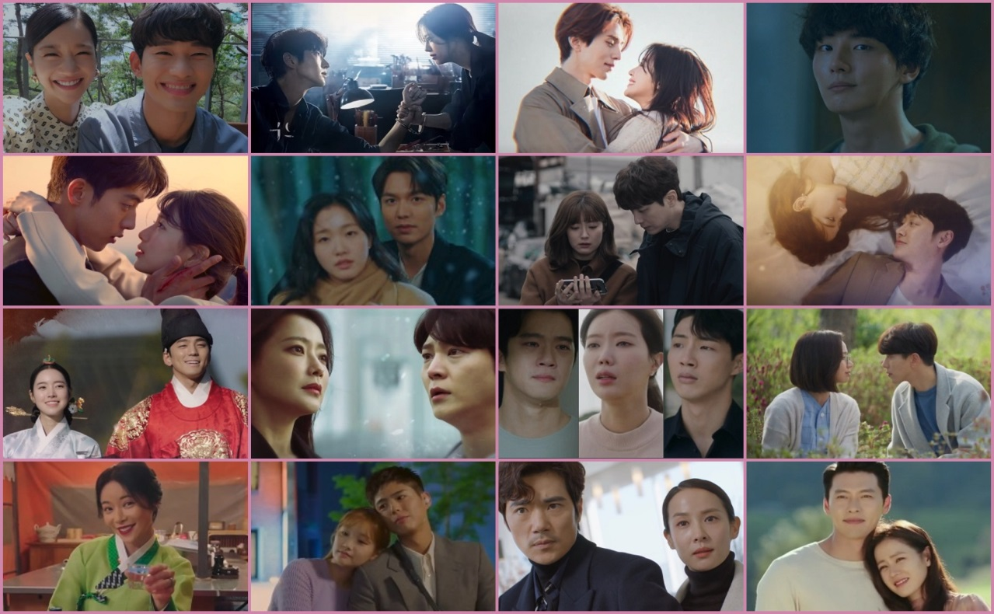

2020 Korean Dramas (Source: Google)

According to the data statistic from “Top 50 Series per nationwide viewers (Wikipedia, retrieved on September 2020)” that in 2020, a lot of K-Dramas such as The World of the Married, The King: Eternal Monarch, It’s Okay to Not be Okay, Start Up, Mr. Queen, Hospital Playlist, Itaewon Class, The Penthouse, and The Uncanny Counter has been such phenomenon in some countries including in Indonesia.

**Korean Movies**

Besides the popularity of K-Drama, South Korea has also popularly trending worldwide in producing box office movies. These box office movies has starred some great talented actors and actresses such as Lee Min-Ho, Hyun Bin, Cha Eun Wook, Ji Chang Wook, Song Joong Ki, Kim Hyun Joong, Kim Bum, Cha Eun Woo, Kim Woo Bin, Song Hye Kyo, Han So Hee, Jun Ji Hyun, Park Shin Hye, Park Min Young, Kim Go Eun, Son Ye-Jin. All of those actors and actresses are actually generations from the year of 2010 until 2020. Also, they have great impact on the fast development of Korean movies in the international entertainment industry (Seung-Hye, 2019).

For instance, the popularity of Korean movies in the international entertainment industry can be seen from the trending movie in Korea entitled Train to Busan or부산행 (2016) which starred Gong Yoo, Jung Yu-mi, and Ma Dong-seok. This movie is about zombie apocalypse which suddenly breaks out to the country and threatens the safety of the train passengers. This movie premiered in the 2016 International Cannes Film Festival and breaks the record of ten million theatergoers. Following the success, a sequel was released in South Korea with the title Peninsula in July 2020. During the year of 2020, Korean movies like The Admiral: Roaring Currents, Extreme Job, Along with the Gods, Ode to My Father, Veteran, Ashfall, Alive, Summit, and Pawn are regarded to be a few most popular movies.

Also, there are a few box office movies during the year of 2003 – 2019 such as Old Boy (2003), Mother (2009), A Taxi Driver (2017), and Parasite (2019). The movie “Old Boy” won Grand Prix Cannes in the year of 2004, while “Mother” succeeded to become winners in 4 international awards including Dubai International Film Festival, Boston International Film Festival, Toronto International Film Festival, Los Angeles International Film Festival, and Society of Film Critics’ Awards. Moreover, a movie “A Taxi Driver” won Grand Bell Awards, Dragon Film Awards, and Oscar 2017 for Best Foreign Movie. And the last is about “Parasite” which has succeeded to become the first Korean movie to win 4 different awards in Academy Awards (Oscar) in the year of 2020 as Best Picture, Best Director, Best International Feature, and Best Original Screenplay (taken from Wikipedia/bestkoreanmovies).

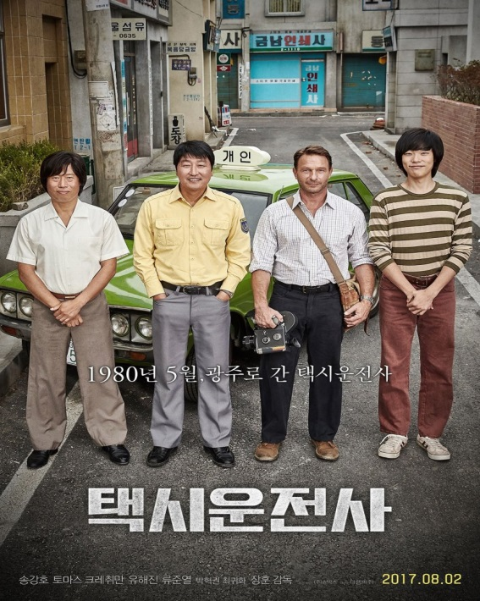 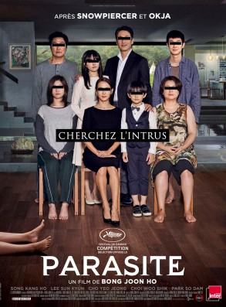

A Taxi Driver (left) and Parasite (right) (Source: Google)

Based on what we have read in the section of Korean wave and K-Dramas above, discussing about Korean movies might not be too far from all the information given above. It can be said that the international competitiveness of Korean wave (dramas, music, fashion, movies, cuisines, and cultures) has already succeeded to stay popular from decades ago until today. With the comprehensive analytical tool provided by Parc & Moon (2013) in their article entitled “Korean Dramas and Films: Key Factors for Their International Competitiveness”, Korean wave is actually not a temporary phenomenon, but a sustainable industry segment. This international competitiveness has been started since an event of ‘A Week of Korea’ in the The Vesoul International Film Festival of Asian Cinema held in France in February 2011. There are 36 Korean films received more than 300 visitors for each showing during ‘A Week of Korea’ in that event. This unexpected response has then lead to Belgium production decided to purchase broadcast rights to three Korean dramas in April 2011, including *Iris*, *Chuno*, and *Jeonwoo* with the purposes to televise them in Europe (Dongailbo, 2011).

There are several interesting things that make Korean movies be able to steal the attention from its global viewers: various genres, depiction of pure love, longing, and resonance with characters’ portrayals, nostalgia, story or plot, as well as beautiful backdrops (Hanaki et al, 2011). Furthermore, based on what (Son, 2001; Jin, 2003) stated that political and economic reasons can be other external factors on why Korean movies interest many global viewers out there.

Korea is globally known as one of the biggest powers in Asia related to its political and economic sectors and this fact makes those global viewers tend to give more attention to its entertainment industry because they expect to see and learn it from Korean movies (Parc & Moon, 2013). It is relate with the fact that some Korean movies and dramas are being made based on its traditional cultures and conditions. The Korean movies have such virtuous circle with the economy condition, both domestic and international (Shim, 2006). It enhances the image of Korea and also Korean products; it attracts more international and domestic tourists to visit some iconic places in South Korea.

Parc & Moon (2013) continued their research to randomly selected students from three biggest economic Asian countries: Korea, Japan, and China. Each of those students were asked to choose five most popular actors and actresses from each country at that time. After those fifteen actors were sorted, they compared the heights and the ages of those actors. The result showed that Korean actors tended to be more handsome, taller, and younger than their counterparts in Japan and China. Moreover, this research continued by Kim & Chung (2015) in which they found that there is assimilation of attractiveness and beauty between Americans and Koreans so that those Korean actors and actresses have appeal and can gain popularity in non-Asian countries because the global viewers saw that Korean actors have such appeal for non-Asian audiences. Of course, the quality is not only counted based on the appearance of the actors and actresses but also consider more about the performance of the movie as well as the story or plot.

The Korean film industry represents the film industries come from both North Korea and South Korea, but with the longer list comes from South Korea. Based on the statement from the research done by Parc & Moon (2013), only the Korean film industry has been able to receive international acclaim and recognition. It is because the film industry in North Korea has only been talked about old topics like communism and revolutionary ideas. The development of the Korean film industry has begun since the establishment of the first movie theatre in Korea during 1903. In that time, the movie theatre had only played American and European films. During the 1926 – 1930, Korean films began to produce and played in the theatre.

In the international movie industry, Hollywood has become such continuous treat to the movie industry of Korea. It is because in the face of blockbuster movies produced by Hollywood, Korean movies seem to have low budget production as well as having low quality especially in the eyes of international viewers. Even during the late 1980s, the Korean movie industry has dropped as low as 15% of the market share. However, after that kind of difficult situation, the transformation of the Korean movie industry had started since the success release of blockbuster movie entitled “Shiri” in 1999. “Shiri” had succeeded in capturing more than five million viewers and making it to become the top South Korean movie, breaking down the records for the entire time favorite movie: “Titanic”. In the process, the market share of Korean movies arises to 39.7%. And the success of “Shiri” has led to the open gate for the next Korean movies to reach its popularity internationally.

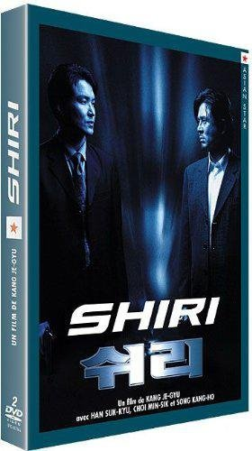

Korean Movie: Shiri (A Blockbuster Movie with Millions Viewers, 1999) (Source: Google)

Recently, most international viewers of those Korean movies, Korean dramas, as well as Korean music come from Chinese, followed by Hong Kong, Taiwan, Thailand, India, Bangladesh, Japan, Malaysia, and Indonesia. Thus, it is not unusual to see the influence of Korean culture and tradition as appeared in the Korean screens, on the Asians. Due to the immense success and the rapid spread of Korean culture, the Chinese has become the first who used the term “Hallyu” or later known as Korean wave to refer to the massive influence of the Korean culture portrait primarily through the media. A phenomenal Korean drama, “Daejanggeum” has signed the popularity of Korean influence in 2005.

The popularity of Korean movies in Indonesia influences mostly with the phenomenon of Korean dramas. Usually, many production houses in South Korea tend to recruit some actors and actresses in the drama to play some movies with more characters from South Korea as well as outside South Korea. For instance, we can simply take a look at the production filming of Confidential Assignment 2 who presents Hyun Bin (who is popularly known as the lead role of Captain Ri in the super popular drama, Crash Landing on You with talented actress Son Ye Jin), and Yoona SNSD. Also there is the drama based on the best-selling novel by Lee Min Jin entitled Pachinko which will be released soon in the middle of 2021. This drama is almost like a movie, released internationally, with 8 episodes where the shoot will be in three countries including South Korea, Japan, and Canada and use three languages in the dialogue (Korea, Japanese, and English).

Most viewers in Indonesia know about Korean movies because they are already familiar with the actors and actresses. They know those actors and actresses from the Korean dramas they often watch during their spare time. This is one primary factor that makes Indonesian viewers tend to watch Korean movies. For instance, most viewers tend to watch movies starred Lee Min-Ho (including Our School’s ET, Public Enemy Returns, Gangnam Blues, and Bounty Hunters) because they already know about the reputation of that actor in some popular dramas. Thus, the familiarity with the actors and actresses has become the number one factor, and the second factor is about the story or the plot. That is why; most production houses of Korean movies also recruit their actors and actresses to play the roles in their movie based on the popularity or the successfully of characters played by certain actors in the drama (Sara, 2020).

**Korean Music**

First of all, when talking about Korean music, it means that we are talking about the music of Korean peninsula ranging from the prehistoric times to the nowadays time. The music is varied a lot including court music, folk music, poetic songs, and religious music used in Buddhist traditions. During the Japanese colonization in the 1910s, Korean traditional music remain survived and then, there is tremendous change in the Korean music as it began to be influenced by Western music until today (Timothy, 2016).

Nowadays, people in the world called Korean music as K-Pop. Korean is generally known as a vibrant environment of contemporary music. During the 1990s to 2020s, the country has produced several internationally phenomenon acts such as Psy, BoA, Super Junior, 2AM, 2PM, T-Max, TVXQ, Wonder Girls, Rain, IU, Girls’ Generations (SNSD), SHINee, EXO, Big Bang, Monsta X, 2NE1, GOT7, NCT, The Boyz, BTS, and hundreds more. Whether their music is categorized as R&B, electronic pop, reggae, country, hip-hop, classical, jazz, or pop, it belongs to a genre called K-Pop.

K-Pop (케이팝) is a popular music originating in South Korea and had spread out all over the world to become an essential part from the Korean wave. Boyband H.O.T (1996) appeared as the first icon of modern K-Pop idol where K-Pop grew into sub-culture which amazed enormous fandoms of teenagers and young adults all over the world. BoA and TVXQ started a new generation of K-Pop idols that continue to popularize K-Pop internationally until today. According to the International Federation of Phonographic Industry in Global Music Report 2019, K-Pop is ranked number 6 in the top ten music market worldwide, with Blackpink and BTS as the leading artists (Choi, 2014).

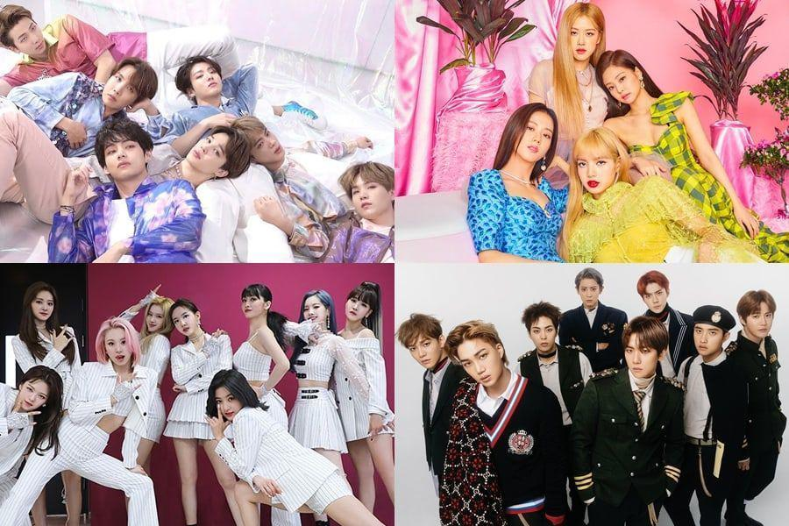

K-Pop Sensation: From Super Junior to Blackpink (Source: Google)

Moreover, South Korea has popularly known to have music industry like a ‘robotic’ system of training. It means that after binding contracts to potential talents, those several young talents has gathered around in a place and live together. They spend many hours a day together in order to learn music, dance, foreign language, as well as some other skills needed to prepare their debut. This kind of ‘robotic’ training is often critized by the Western media such as what has been done by Wall Street Journal in 2012 that reported about the total cost of training of one Korean idol under SM Entertainment is about US$ 3 million.

In terms of marketing strategy, South Korean entertainment industry has popularly known to have such creative and innovative strategy. Along with a marketing hook, groups are given a name and a concept from the very beginning of its debut. These concepts can be divided into general concepts and theme concepts such as fantasy or cute. In order to secure the successful debut, new idol groups might be formed with new concepts. Sometimes, sub-groups are being formed among the existing members of popular groups such as Super Junior with their Super Junior K.R.Y, whose consist of SuJu members: Kyuhyun, Ryeowook, and Yesung. Similar thing also happens to a popular group NCT with their sub-groups NCT-U, NCT 127, and NCT Dream (Caitlin, 2019). Usually, these sub-groups are created based on the characteristics of the members such as members who have good acts in dancing.

Of course, choreography as part of dance is considered to be an integral part of K-Pop. During singing in the stage, idol groups will usually also dancing by forming such prompt movement in synchrony. This is strategy called as ‘formation changing’ (자리바꿈) or *Jaribaggum* (Choi, 2014).

One great factor that makes massive development of K-Pop music is about the fact that K-Pop uses English phrases in the lyrics, even though not all of them, but mostly it used this. The use of English phrases is regarded to be very effective to attract many global audiences all around the world to listen to Korean music (Jin Dal Yong from Popular Music and Society). In the progress, there are more and more Western artists and acts involve in the production of Korean music such as some big names in the USA: Will I Am, Sean Garrett, Akon, Ludacris, Kanye West, Selena Gomez, Snoop Dog whose also featured on K-Pop songs.

In order to occupy large markets all around Asia, Europe, and USA, it is a must to use English as part of the lyrics. Even, some of those artists are not only learning English to spread out their influence, but also learning other languages such as Japanese and Chinese in order to steal the attention from those Japanese and Chinese markets. Nowadays, even there are more and more Korean artists use English names as the name of their group or band in order to allow the songs and artists to be marketed to a wider audience in the world.

An expert, Choi JungBong (2014) had once said that Korean music is a kind of using hybrid identity in order to make its industry remains popular all over the world. The use of English phrases in the groups/bands’ name as well as in the lyrics of Korean songs can be categorized to be a part of this hybrid identity. In this modern era, almost all K-Pop idols use properties like cornrows, bandanas, jackets, necklaces, headphones, earmuffs, earrings, and many others as the borrowing cultural elements from cultures outside Korea. Furthermore, most idol groups in South Korea will wear outfits inspired from Western style such as oversized t-shirts, sweatshirts, windbreakers, as well as American sport team jerseys, baseball caps, bucket hats, baggy pants, and some others. For example, in the clip video by Blackpink featuring Selena Gomez entitled “Ice Cream”, Blackpink uses hair ornaments like large bows and hair bands, and wear crop tops and miniskirts in order to look like an American idol as well as to look a little bit cute to match the songs and to match with the character of Selena Gomez.

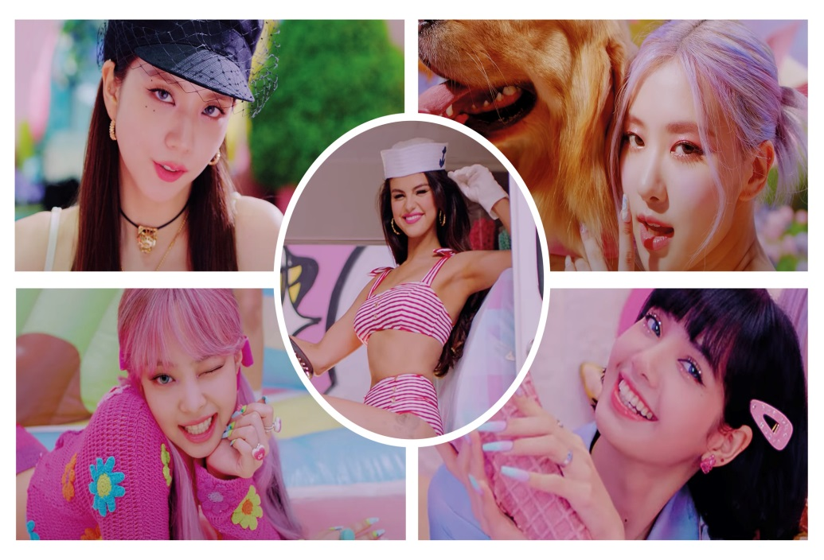

Selena Gomez feat. Blackpink in a video: Ice Cream (2020) (Source: Google)

Later on, K-Pop has also been utilized by the government as a media for doing cultural diplomacy. One great thing about doing this cultural diplomacy is when the South Korean government performs K-Pop acts in North Korea in 2005. Then, in 2018, some great South Korean talents including Red Velvet, Cho Yong-pil, Lee Sun-hee, and Yoon Do Hyun performed in Pyongyang, North Korea in front of the President of North Korea, Kim Jong-un (Timothy, 2016).

Korean music has become one of the most popular music in the whole world especially during the era of the rise of Hallyu in the 21st century. This time, K-Pop is increasingly making appearance on Western charts such as Billboard. During the World Cup in South Korea in 2002, Baby Vox’s single ‘Coincidence’ has become super popular around Asian countries since it is chosen as one theme song for World Cup. Since 2000s, a big portion in the East Asian Music Market has been dominated by K-Pop (Caitlin, 2019).

Almost every month, some big labels such as Big Hit Entertainment launch new songs from their wonderful artists: BTS. Even boy band BTS has succeeded to break the world record as the first Asian artist who can perform live in American Music Awards. BTS’s even has been nominated as Top Social Artists at the 2017 Billboard Music Awards and they won the award. It makes them to become the first South Korean group who win the award. According to Caitlin (2019), in the following year, BTS has succeeded to reach number 1 on the Billboard top 200 with the song, Love Yourself: Tear. Later on, their album entitled “Map of the Soul” has become the best-selling album ever in South Korea with more than 3.2 million sales in just a month. On May 2019, BTS appeared Good Morning America’s Summer Concert Series. For more, BTS has been succeeded to attract the interest from the world as one of their members, Kim NamJoon or RM (Rap Monster) gives phenomenal speech at UN in 2020. Before that, NamJoon as the leader of BTS also gave phenomenal speech at UNICEF in 2018. And in front of billions viewers from all over the world, BTS had once again kicked off the record in the year of 2020 with their fantastic performance at the New Year’s Eve Celebration in the most iconic place, Times Square - New York.

A study in 2011 shown that when people listen to music, their emotions change. And this can effect much on their behavior. Based on the research conducted by Project Nightfall in the video entitled “The Most Dedicated Fan Base”, it is clear to know that music and lyrics can both have positive and negative effect. The lyrics can both uplift people and cause anger and depression. Recently when #blacklivesmatter has become the trend in the US because of the tragedy of black people being shot by US police, South Korean phenomenal boyband BTS donated $1,000,000 towards black lives matter movement. And soon, ARMY (BTS loyal fans) decided to make the same thing with #matchamillion to match their idol’s donation. And in just 24 hours, they succeeded in raising another 1 million dollars for black lives matter movement.

And ARMY did not just do that because in Malaysia, ARMY made #BTSforcharity donating to many causes for blind people and for turtle conservation. In the US, the ARMY’s movement made #savethechildren raised money for disadvantaged children, in the Phillipines BTS fanbase donated rice for the poor and in Pakistan, ARMY created a champaign called “because everyone deserves to smile” and sent out dentists to school for free. And it is all because BTS music has been influenced their fans a lot through the positive lyrics.

While most popular songs today are just encourage those youngsters to go out and party, BTS lyrics in their songs encourage the opposite. The lyrics motivate their fans to always work hard for reaching their dreams like in the lyrics: “*follow your dreams like a breaker, even if it breaks down. Don’t ever run backwards. Never! Because the dawn right before the sun rises is the darkest…*”. Thus here, ARMY is a perfect example of how music can greatly influence people’s behavior. It is because of music and lyrics that ARMY has been consistently creating good causes all around the world. And because of that, BTS is worth for about $5 billion to South Korean economy.

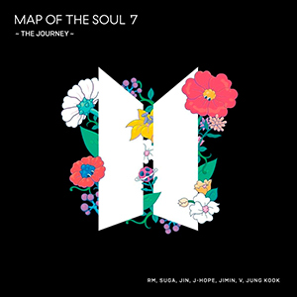 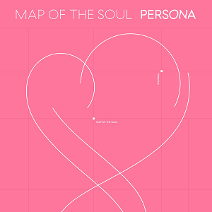

Map of the Soul by BTS (Source: Google)

After discussing in details about K-Pop and K-Pop idols, it would be a better idea to discuss more about their fan base. Of course, there is no idol in the world without strong fan base. According to Cheol-min (2018), not all K-Pop fans are young women because they interviewed hundreds of male young adults who becoming K-Pop fans from some different nationalities. For about 54% of them even come from Indonesia and they explained that following K-Pop idols and being part of their fandoms had helped them to understand themselves as well as to understand the concept of new masculinity better.

New masculinity according to those Indonesian male young adults fans, it is about men still look manly and handsome even though they are not suitable with the definition of old masculinity with mustache, beard, muscular body, and having dark or not-too-light skin. Old concept of masculinity which had been introduced in the Western society has successfully turned upside down by the facts that there are more and more women (teenagers and young adults) tend to pay attention to a man who looks neat, clean, has no beard or mustache, as well as having light skin color (Cheol-min, 2018). This new definition of masculinism brought by Korean wave has even portrait a man with gorgeously and impeccably smooth, non-porous skin. Even fans see these handsome Korean idols as wax breathing sculpture for their impeccably smooth skin.

In Indonesia, Korean music has become the two most popular Korean wave products along with Korean dramas. And the term new masculinity has made most fans are crazy about their idols, in which they often call their idols as their *bias* (the most favorite personnel in a group or band, and the second most favorite personnel is called as *bias wrecker*). From the participants involved in this research, most of those fans refer to those adolescents to young adults from the age 14 to 35 years old. They said that they love the new masculinism as they do not like men who have beard or mustache, it makes them to feel not comfortable as well as men with beard or mustache looked like having ‘dirty’ face. So, here the definition of ‘clean’ face for men is literally clean and smooth with no beard or mustache. Also, according to some opinions from those participants, men with clean and smooth face skin looks a lot younger than their actual age.

In relation to fan base, it is widely known that there are numerous fans travel overseas in order to see their idols on tour. Even there are many of them who dedicate totally as part of Korean fandom by following their idols’ tour from one country to another. It is very usual to see many fans fly to one place to another just to see their idols and even do the camping overnight to gain entrance. A survey done by Korean Culture and Information Service in 2013 reported that there were over five million active members of Hallyu fan clubs. An article published by the Wall Street Journal in 2014 stated that the future K-Pop’s power will be depend on their fan base and it is called as micro-business.

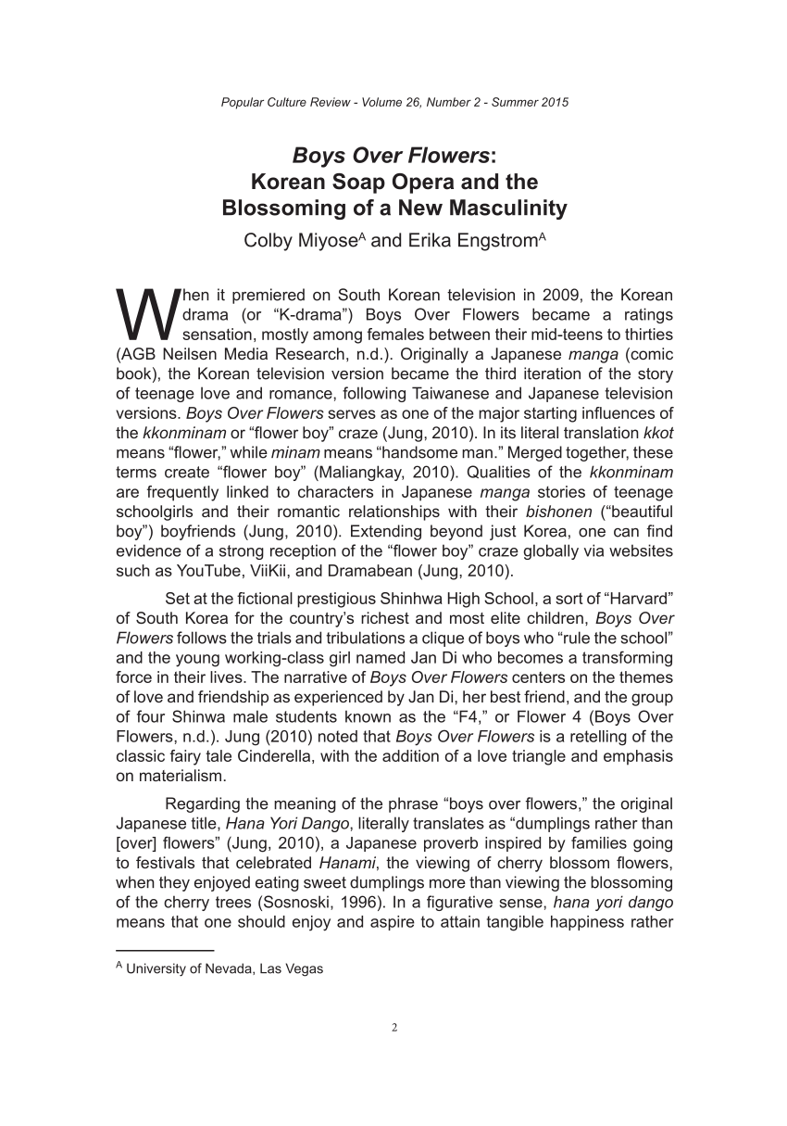

An Article (2015) about Korean New Masculinity in Korean Soap Opera

(Source: Google)

Usually, K-Pop groups will give collective name for their fans as well as assigned color. For instance, TVXQ fans are widely known as ‘Cassiopeia’ and their official color is pearl red; and BTS fans are generally called as ‘ARMY’ and having official color of purple. This purple color has been used for the first time in an annual fan meeting, 3rd Muster and it has been used again during Wings Tour Concert in Seoul and Thailand. Even, this official color has created new term *I purple you* and new word in Korean language: *borahae* which means “I love you forever” or for a deeper meaning, it also means “believe in each other”. Especially for BTS fans, who are popularly called as ARMY, *borahae* means more important and intimate meaning. The color purple has been chosen as the last color of the rainbow. It has a philosophy that they will make the whole world colorful until the end of time and their love for their fans is just like a never-ending story. Moreover, V BTS or Kim Taehyung (2017) made the term *borahae* to represent that BTS and ARMY will always love, believe, and support each other forever.

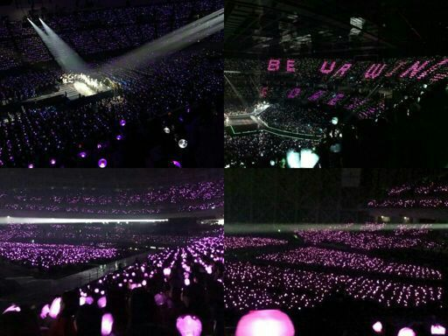

*Borahae: I Purple You* during BTS Concert made by ARMY (Source: Google)

Furthermore, fan clubs will usually participate actively in charity events to support their idols. For example, according to Time magazine, during one Big Bang show, 12.7 tons of rice were donated to those in need from more than 50 fan clubs all over the world. Another great and positive thing doing by the fans is by delivering meals to their idols during their tight schedules. All of these are called as micro-business in South Korea. There are some companies in South Korea involved to shipping rice from the farmers to the stage as well as to deliver meals with the catering services (Timothy, 2016).

Of course what is called as Korean music is not only about K-Pop, but it is also including numerous original soundtracks from Korean drama and Korean movies. Big names like Baek Yerin, Lee Seunggi, Chen, Kyuhyun, Chai, Kim Tae Woo, Yoon Mirae, Gummy, Baek Ji Yung, Davichi, Park Bo Ram, Lyn, Lena Park, and many more are popular names in the Korean music industry. They often were being asked to sing the soundtracks from various popular dramas and movies. All of their songs are being popularly worldwide as the movies and the dramas are succeeded in attracting the local and global audiences as we can see in the dramas like Descendants of the Sun, The Heirs, Boys Over Flowers, Winter Sonata, Full House, Crash Landing on You, The World of the Married, It’s Okay to Not Be Okay, Start Up, Mr. Queen, True Beauty, The Penthouse, The King Eternal Monarch, Itaewon Class, Pinocchio, Sisyphus: The Myth, and many more.

The strength of these original soundtracks is that it is truly related to the theme of the dramas or movies as well as the soundtrack is usually being played in the iconic scenes and in the right time in the drama or movie so that it is very easy for the viewers to relate one song with a drama or a movie. “You are My World” sung by Yoon Mirae OST. The Legends of the Blue Sea, “You are My Destiny” sung by Lyn OST. My Love from the Star, “Aloha” sung by Jo Jung Suk OST. Hospital Playlist, and “You are My Everything” sung by Gummy OST. Descendants of the Sun are just a few examples of the phenomenal songs from original soundtracks of K-Drama.

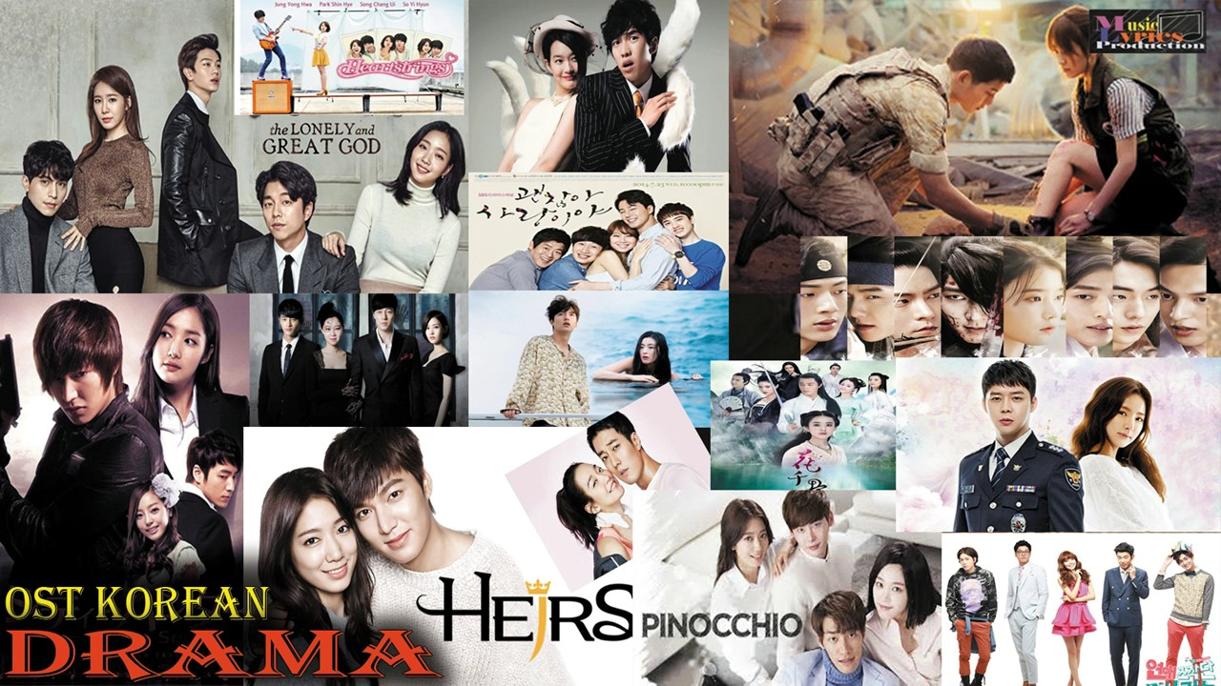

OST Popular Korean Dramas (Source: Google)

Besides that, there are also many actors or actresses who are also singers such as Lee Min-Ho, Lee Seunggi, Cha Eun Woo, Bae Suzy, Hyun Bin, Yoona, and many more. Some of them also record album and sing the original soundtrack for their own drama. Actor Lee Min-Ho sing the original soundtrack from his hit drama in 2009, Boys Over Flowers entitled “You are My Everything” and also sing again for his another phenomenal drama, The Heirs in 2013 with his hit single, “My Painful Love / *Naui Apeun Sarang*”.

**Korean Cuisine (Food, Beverage, and Snacks)**

South Korea seems not to just stop in dramas, movies, and music. The world has also known South Korea to have such delicious traditional food, beverage, and snacks. Cooking traditions and practices of the culinary arts in Korea will usually call as Korean cuisine. Actually, this Korean cuisine has evolved through mix interactions of numerous different cultural trends with the natural environment. In the past, Korean cuisine is derived from culinary arts in Korea and southern Manchuria based on the Normadic traditions. Traditionally, Korean cuisine is based on rice, meats, and vegetables. People all around Korea (both in South Korea and North Korea) will usually eat this kind of complete Korean meals during breakfast, lunch, and dinner.

People in the whole world love to visit South Korea because some of them are interested in their unique traditional food. For instance, Indonesian people love to visit South Korea because they want to try those delicious Korean food, beverage, and snacks right in the Ginseng country. One of the most popular Korean cuisines, Kimchi is usually served at nearly every meal. Soy sauce, garlic, salt, sesame oil, ginger, Napa cabbage, fermented bean paste (*doenjang*), fermented red chilli paste (*gochujang*), and pepper flakes (*gochutgaru*) are widely known as the basic ingredients of Korean cuisine (Han-Seung, 2016). Of course, just like in Indonesia and any parts of the world, Korean ingredients and dishes are varied lots by province.

During the pre-historic time, people in Korea grew barley, rice, legumes, wheat, and millet. During the Kingdom period (57 BCE to 668 CE), three Kingdoms including Goguryeo, Baekje, and Silla were known by fermented foods like Kimchi and cold foods (S.Huh, 2004). Legumes in Korea is regarded to be basic ingredient for making soy milk, tofu (*dubu*), noodle dish (*kongguksu*), soybean paste, soy sauce (*ganjang*), and some more. Since the cultural exchange with China as well as the widespread of Confucianism and Buddhism, Korean cuisine began to change due to the distinct culture of Korea. After that, the opening of Korea to the Western world brought further exchange of both culture and food. This happened during *Goryeo* to *Joseon* period in Korea where there were more alcoholic drinks imported from China and numerous seasonings imported from Japan through the Western traders.

During the colonization of Japanese in Korean peninsula (1910 – 1945), most of the agricultural systems had taken over by Japanese in order to support Japan’s food supply. Cheaper grains like barley and millet began to be a part of Korean meals. During this time, Koreans usually ate two meals a day in the cold time and three meals a day in warm season. For the upper class, Western food like pre-cooked noodles and white bread started emerging in the Korean diet. According to Kim & Chun (2005), in the 1970s, agriculture products were increased through the utilization of modern farming equipment and commercial fertilizers. The great impact from this time is about the increasing consumption of processed and instant food such as pork and beef in Korea. It is suitable with the statement from Han-Seung, (2016), with more and more societies were willing to eat meats everyday, there were the big rise of *bulgogi* restaurants all over Korea. The rise of high consumption of meats had followed by the rise of fish consumption (for about 49.5 kg in 1998). Through the years from 1980s until 2000s, the consumption of rice was decreasing and it was followed with the rising consumption of noodles and bread.

It cannot be forgotten that the variety of Korean cuisine influences a lot by Chinese cuisine and Japanese cuisine due to the geographic location of Korea between the islands of Japan and mainland of China. Not only cultural characteristics that influence the variety of Korean cuisine, but also about the nature’s influence. For instance, geographically Korea is surrounded by water so that it results in a flourishing fishing industry. A variety of wild edible greens in Korean cuisine was influenced by its located in mountainous terrain which covers 70 percent of the nation (Kim & Chun, 2005). The features and climates of 4 different regions in Korea resulted in differing regional cuisines. The eastern coast of Korea is smooth coastline, but western and southern coast consist of jagged coastline. Meanwhile, the northern part of Korea predominated by dry-field farms.

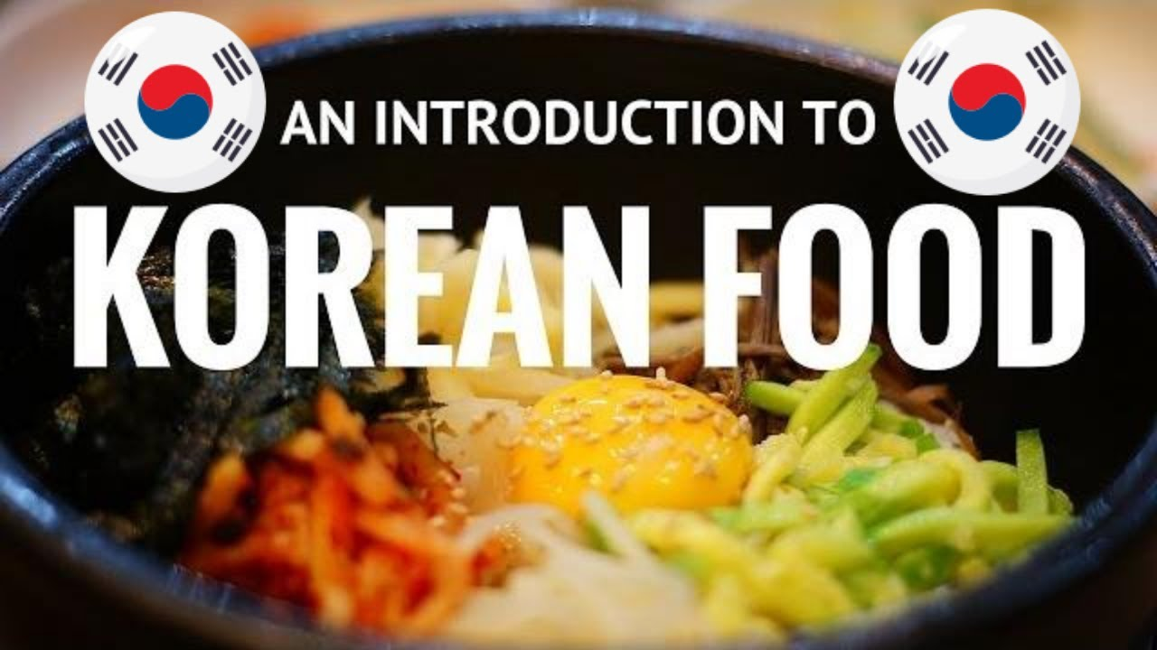

An Introduction to Korean Food (Source: Google)

Moreover, the variety of Korean cuisine can also be significantly influenced by the climates which are characterized by four seasons: summer, spring, winter, and autumn. During the winter time, Koreans will usually eat dried or fermented vegetables, while during warm season, they will eat fresh vegetables. Salted fermented fish had long been known as Korean meals during the long period of winter time or even in the hot summer. With this salted fermented fish, they still enable to eat fish even during the cold season.

Grains have been one of the most essential ingredients in Korean dishes. Due to the high price of rice when it first came to Korea, the grains were usually mixed with other grains in order to stretch the rice such as became *kongbap* (rice with beans) and *boribap* (rice with barley). The basic ingredient, rice, can be used to make several dishes such as rice cakes (*tteok*) with over two hundred varieties; it also can be cooked down to become gruel (*mieum*) and congee (*juk*). Also, Korean produces lots of rice wines whether it is filtered or unfiltered (Dai-Ja, Kyung Rhan, Hye Jeong, Kang-sung, Dae Young, 2015).

Then, Korean dishes also familiar with the ingredient of mung beans (*nokdu /* 녹두). Ground mung beans are usually used to make porridge (*nokdujuk*) which is often eaten for digestive aid or as nutritional supplement or it can also be used for making *bindaetteok* (mung bean pancakes). For more, starch which is usually extracted from ground mung beans is used to make cellophane noodles (*dangmyeon*). From those kinds of noodles, it became the primary ingredient for making *japchae* (salad-like dish) and *sundae* (blood sausage). This kind of starch can also be used to make *nokdumuk* and *hwangpomuk* (jelly-like food).

Besides snacks, grains, and rice, Korean cuisines are also known to have an abundant result of fish and seafood due to the geographical location of the major part of Korea which is located in the oceans bordering the peninsula. Seafood such as oysters, shrimp, abalone, shellfish, clams, and loach are really popular among Koreans. Both fresh and salted fish consumed by the locals whether they are served grilled, raw, broiled, dried, or even served with stews and soup. Herring, mackerel, hair tail, and croaker are known as the most common grilled fish in Korea. Speaking about soup, the local people in Korea are truly familiar with *samgyetang* or known as ginseng chicken soup. It is made from whole chicken stuffed with garlic, ginseng, and sweet rice. This *samgyetang* is very common on *sambok* (삼복) or *jungbok* (중복) days which is believed to be the hottest day in Korea. This is because this ginseng chicken soup is believed to be such energizing food to increase the stamina and mood during the hot day. In some other cultures, soup is just known as the dish to end the meals. But in Korea, soup has become the most common part of Korean dishes as it is served as a part of the main course. Some variations of soup popular in Korea are including *malgeunguk* (맑은국) which is flavored with *ganjang*, *tojangguk* (토장국) which is seasoned with *doenjang*, *gongguk* (곰국) or known as *gomtang* which is made from boiling beef bones, and *naengguk* (냉국) which is known as cold soup to cool the diner during the summer season (Han-Seung, 2016).

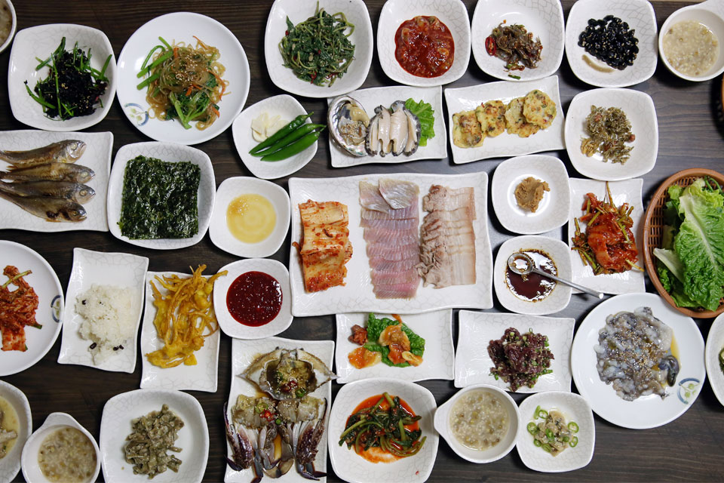

Varieties of Korean Cuisines (Source: Google)

And the last is about the noodles. As already mentioned above, Korean cuisine is also popularly known to have a lot of different variations of noodles. Noodles in Korean are called *guksu* or *myeon*. Based on the history (cited from Wikipedia.com), *milguksu* or wheat noodles were called as specialty noodles for weddings, birthdays, and any other special occasions to pray for the bliss of longevity. Some Korean traditional noodles are including *bibim guksu* (cold noodle mixed with vegetables), *kongguksu* (noodles with cold soybean broth), *kaiguksu* (knife-cut noodles), *naengmyeon* (cold buckwheat noodles), *jajangmyeon* (Koreanized Chinese noodle), *ramyeon* (it is like ramen or Korean instant noodle), and *japchae* (cellophanes noodle made from sweet potato mixed with vegetables).

After discussing about the food, let’s take a look at the beverages. *Soju* has long been known to be the most popular alcoholic beverage in Korea. Korean people called it as the best liquor. The difference between Korean alcoholic beverage and Western beers is that *soju* brewed from rice rather than barley. Consequently, Korean alcoholic beverages tend to be sweeter, lighter, as well as have less head than Western beers. *Soju* in Korea is being consumed by many local people from different backgrounds, from college students, blue collar workers, to hard-drinking businessmen (taken from Encyclopedia of Korean Culture, retrieved September 2020).

Of course, discussing about Korean cuisine and culture, we cannot forget about dining etiquette in Korea. This dining etiquette is considered to be the most important part from Korean cuisine and culture. Dining etiquette can be traced back to the Joseon period, especially about Confucian philosophies. From the guidebook written in 1775 by Yi Deokmu (士小節, Elementary Etiquette for Scholar Families), it is mentioned about Korean dining etiquette during that period and it was including:

1. When you see a fat cow, pig, chicken, or goat; do not immediately speak of slaughtering, cooking or eating it
2. When you are having a meal with others, do not speak of smelly or dirty things
3. When eating a meal, neither eat it slowly as to appear to be eating against your will nor so fast as if to be taking someone else's food
4. Do not throw chopsticks on the table
5. Spoons should not touch plates and making a clashing sound
6. The eldest male at the table was always served first, and was commonly served in the men's quarters by the women of the house
7. Women usually dined in a separate portion of the house after the men were served
8. The eldest men or women always ate before the younger family members
9. The meal was usually quiet, as conversation was discouraged during meals
10. The younger members of the table should not pick up their chopsticks or start eating before the elders of the table or guests and should not finish eating before the elders or guests finish eating
11. The rice or soup bowl is not lifted from the table when eating from it
12. Diners should also cover their mouths when using a toothpick after the meal
13. Each diner is expected to face away from the eldest male and cover his mouth when drinking alcohol
14. Guest should not refuse the first drink offered by host, and in the most formal situations, the diner should politely twice refuse a drink offered by the eldest male or a host
15. Blowing one's nose when having a meal is considered an inappropriate act as well

All of those Korean dining etiquette came from Joseon period are no longer been used in the modern era, although some of the local people still use it in order to appreciate the elders. Some families in Korea who are still holding on their traditional culture tend to serve the elders first before the youngers. However, during the modern era, young parents are no longer used that kind of culture where young people and old people can eat together in one table. They are also serving themselves (Han-Seung, 2016).

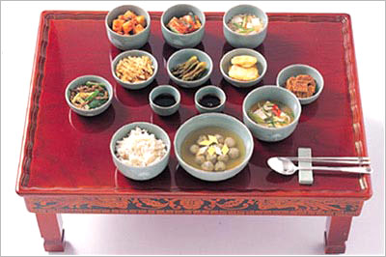

Korean Dining Etiquette (Source: Google)

Nowadays, some of the Korean traditional dishes such as tteokbokki, rabboki, ramyeon, bibimbap, and many others have popularly served in some restaurants all over the world, including in Indonesia. In Indonesia, even those Korean food, beverage, and snacks are not only being served in fancy restaurants or café, but people can also find it everywhere such as in the food stall, food court, and even find it homemade.

Moreover, several fast food restaurants in Indonesia like McDonalds, KFC, KimchiGo, and some others offered a few of Korean food in their menu: *gochujang*, *kimchi*, *samgyeopsal*, *eomuk*, *tteokbokki*, *bulgogi*, *namul*, *samgyetang*, *bibimbap*, *japchae*, and many others. Let’s say that Mc Donalds has kinds of Korean cuisine in their menu such as Korean fried chicken, gochujang chicken, and some more. Meanwhile KFC has *Korean grill* and *bulgogi chicken* to attract their customers by utilizing the phenomenon of Korean wave. These days, even there are several start-up business serving Korean street food such as *chickydang* (Korean rice bowl). This kind of start-up business is the result of business development of SASA to spread its global business especially to attract those young people. Their menus including Korean *rice bowl*, Korean *gochujang fried chicken*, and *kimchi bokkumbap* (Korean fried rice). The concept of bringing mobile pop-up station make *chickydang* is possible to be reached by many people around the areas. They bring such great marketing strategy to promote directly to the target market, just like they can bring their mobile pop-up station to the school, mall, office, college, and some other crowded public places.

Thus, it can be clearly said that this Korean cuisine has become such phenomenon in the global world. According to the article written by Kyung Chung, Jeong Yang, & Shin Kyung (2016) entitled “Asthetics of Korean Foods: The Symbol of Korean Culture”, it is found that during the year of 2015 and so on is considered to be the era of the globalization of Korean food. Their reason is based on the fact that these days, there are more and more Korean people all over the world who live in a modern apartment or land-houses, wearing Western fashion outfits, going to international colleges or working in such westernized environment; but they are still eating rice and *kimchi* instead of bread and meat.

One most important factor that makes this kind of phenomena is about the essence of Korean food which preserved Korean traditional culture. Korean people believed that their traditional food has to be developed and enjoyed in daily life. Based on the beliefs of Korean people, traditional food has to be considered in a cultural code because if not, Korean food will not survive. That is why; Kyung Chung believed that it is very essential to understand and communicate Korean food through cultural aspect. It is because Korean food has already become a cultural product, that is caught the attention of the world and it also has excellent future opportunity. One great example about food becoming cultural product can be easily found through a phenomenal drama “Daejanggeum”2, which reached a big hit not only in Korea, but also in China, most Asian countries, even in African countries, which shows how cooking can make a region as the grounds for sustaining food life or in other words, how Korean food can become globalized. With the big success of this drama, later on there are more foreign people understood about Korean food and it resulted in the requirements of learning more about Korean food culture (Kyung Chung, Jeong Yang, & Shin Kyung 2016).

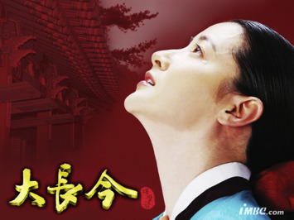

Daejanggeum, a television series produced by MBC (Source: Google)

2)Daejanggeum is based on the life of a woman who became the first physician during the *Joseon* period. It depicts numerous traditional Korean food to treat certain ailments and about the story of how that woman became the King’s personal physician.

In Indonesia, the phenomenon of Korean cuisine happened since a decade ago. Nowadays, it is very easy to find various different Korean café and restaurants all around big cities in Indonesia such as in Jakarta, Bandung, Surabaya, Makassar, Malang, Yogyakarta, Medan, and Semarang. We can look at ‘Chingu Café’ Yogyakarta, ‘Loona Café’, ‘Oppa Korean food Café’, ‘Korean House’, ‘Bingsoo’, ‘Kimchi Story’, ‘Donwoori, Sarang Korean BBQ’, ‘Seoul Scents Korean Café’ Malang, and many more. All of those cafés and restaurants serve a lot of Korean cuisine variations in their menus including food, beverages, and snacks.

From the research done by the researcher, it is known that most of those visitors come to those Korean cafés and restaurants based on several reasons:

* They want to follow the trends by uploading photos and videos with the background of anything about Korea.
* They want to taste Korean cuisines just like what they watched in dramas.
* They want to look exactly like the scenes from the dramas they’ve watched. For instance, sitting down face to face while eating a bowl of ramyeon and soju.
* They want to share with their friends, colleagues, and families about the place they found.
* They just want to know about the trending place for young people.
* They want to spend their spare time with people they love in those iconic spots.
* They want to celebrate their bias’ birthdays or certain important events related to Hallyu phenomenon.

**Korean Fashion**

Traditionally, Korean people tend to wear white clothing from the Three Kingdoms Period since white was symbolizing integrity, sincerity, simplicity, innocence, as well as nobility. Based on the article from wikipedia/koreanfashion (accessed on February 2021), there are some periods of fashion trends in South Korea:

* The year of 1950s to 1970s: Introduction of Western clothing into Korean culture.
* The year of 1970s to 1980s: The Development of ready-made clothes industry (factory-made clothing).
* The year of 1980s to 1990s: Organization of SFA; the era of the increased popularity of designer brands.
* The year of 1990s to now: Internationalization of fashion; overseas expansion of Korean designer clothes.

Of course discussing about Korean fashion would not complete without knowing first about Korean traditional dress which called *Hanbok* (한복, 韓服) or *Joseonot* (조선옷). This *hanbok* consists of *jeogori* (shirt) and *chima* (skirt). In the last period, Korean people wore dresses differently based on their social status. At that time, costumes were only worn by those rulling class and Royal family. These wealthy people with high social status also wore jewelries to distinguish themselves from the ordinary people. These ordinary people were restricted to undyed plain clothes. Until the Joseon period, the basic everyday dress was shared by everyone, and they only look different when wearing such official and ceremonial clothing. What is meant by ceremonial clothing is that the clothes worn during the formal situations such as child’s first birthday (*doljanchi*), wedding, and funeral.

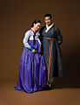

Korean *Hanbok* (한복, 韓服) (Source: Google)

Nowadays, *hanbok* is still worn during some formal occasions but the use of *hanbok* in everyday life, has been lost. Moreover, South Korea is not only popular because of its entertainment industries, but it’s been spread out to the fashion industry especially during the Korean wave where fashion industry has developed massively due to its appearance in K-Dramas, K-Movies, as well as in K-Pop stages. This thing, between entertainment industry and fashion industry are related to each other. This is because what can be seen as ‘stylish and trendy’ in the fashion industry are mostly coming from its dramas, movies, and music industry.

In recent years, Korean fashion trends have developed a lot and it is still influenced by the Western culture through social media practices and through the country’s developing economy. Despite these influences, South Korean fashion trends are also widely influenced the worldwide trends through its unique style. As the world know that Korean fashion is truly expressive and tend to express a sense of individuality. It is firstly brought by the Korean wave. According to Euny Hong (2019), fashion trends within K-Pop reflected diversity and distinction so that K-Pop can be said to be an example of modern hybrid of Western and Asian cultures. Fashion trends in Korea from the late 2000s until early 2010s can be categorized as follows:

* Street: focuses on individuality; features bright colors, mix-and-match styling, graphic prints, and sports brands such as Adidas and Reebok.
* Retro: aims to bring back "nostalgia" from the 1960s to 1980s; features dot prints and detailed patterns. Common clothing items include denim jackets, boot-cut pants, wide pants, hair bands, scarves, and sunglasses.
* Sexy: highlights femininity and masculinity; features revealing outfits made of satin, lace, fur, and leather. Common clothing items include miniskirts, corsets, net stockings, high heels, sleeveless vests, and see-through shirts.
* Black & White: emphasizes modern and chic, symbolizes elegance and charisma, mostly applied to formal wear.
* Futurism: commonly wore with electronic and hip-hop genres; features popping color items, metallic details and prints; promotes a futuristic outlook.

K-pop has a significant influence on fashion in Asia, where trends started by idols are followed by young audiences all around the world.Some Korean idols have established status as fashion icons, such as rapper G-Dragon (Kwon Ji-Yong) and CL, who has repeatedly worked with international fashion designer. Korean actor, Lee Min-Ho has also popular with his respectable and high-styling fashion styles. He often becomes a model for several luxurious fashion brands such as Fendi, Elle, Bazaar, and Versace. Thus, it can be clearly said that Korean fashion cannot be truly separated from the glamorous business of K-Pop and K-Dramas. There is one good relationship between Korean wave industries and the fashion world. All of the outfits worn by those popular artists and actors are partnering up with major fashion houses in order to showcase their amazing work.

 

Actor Lee Min-Ho as an Ambassador for Fendi (left), and Actress Song Hye Kyo as an Ambassador for Bazaar (right) (Source: Google)

Besides all of those Korean actors and actresses, of course South Korea has a great numbers of famous designers. In the early 1990s, South Korean designers such as Lee Shin Woo, Lee Young Hee, Hong Min Wha, and Jin Tea Ok participated in Tokyo Collection as well as in Paris Fashion Week. Some of those South Korean designers appeared actively in the global stage which makes the government decided to encourage those talented designers in order to help South Korea to be seen as one of the fashion centers in the world. Later on, during the early 2000s, a talented South Korean designer, Lee Suk Tae who graduated from *L'ecole de la Chambre Syndicale de la Couture Parisienne*, has succeeded in participating in the designing team of a famous brand: Christian Dior and Chanel. A year later, Lee Suk Tae inaugurated his own store, Galleria Department Store in Apgujungdong, Gangnam District. And then he was also awarded to become one of Seoul’s ’10 Soul Designers’ (Hong, 2019).

In terms of stage for designers, South Korea has Seoul Fashion Week which held twice a year during Fall/Winter season and Spring/Summer season. This fashion week has started since 1987 and it was held every March and October every year, and it was followed by similar fashion week in New York, Paris, London, and Milan. Seoul Fashion Week is marked with inclusivity as well as diversity where the spectators can see a lot of different fashion styles from houte couture style to street style. Furthermore, based on the article taken from wikipedia/Koreanfashion, that Seoul Fashion week can be split into:

* **The Seoul Collection**: A high-end Korean fashion event. The collection is among some of the biggest in Korean fashion.
* **Generation Next** is an upcoming fashion design program for Korean designers. It concentrates on designers with fewer than five years of experience. Unique appearance and creative thinking are emphasized in this section.
* **The Seoul Fashion Fair** is an exhibition showcasing Korean fashion companies. Its mission is to grow Korean fashion companies by helping to build business partnerships to compete in the global fashion market. It is easy for companies to get a spot at the fair.

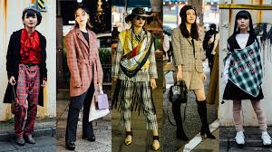 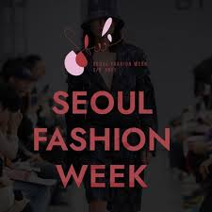

Seoul Fashion Week (Source: Google)

South Korea has several popular fashion brands including Modern Creation Munich (MCM) which was owned by Sungjoo Design Tech & Distribution. Besides that, brands such as Bean Pole, Who A.U (pronounced as ‘Who are you’), Hazzys and Darks, Teenie Weenie, Beyond Closet, BangBang (focused on fashion for teenagers and young adults which was endorsed by Ha Ji-won), and AndZ (men’s clothing wear which was endorsed by phenomenal actor, Lee Min-Ho in 2021) are just a few of famous fashion brands in South Korea.

Almost all of the participants in this research said that they decide to adopt Korean fashion style from several K-Dramas, movies, and music. Just as can be seen from these sample statements:

*“Aku suka banget nonton drama Korea selain karena pesona kegantengan aktor-aktornya, juga karena aku juga bisa melihat banyak model fashion terbaru yang lagi trending. Model fashion itu bisa banget diadopsi biar terlihat kekinian dan mengikuti tren yang lagi berkembang. Fashion Korea itu unik, beda dari yang lain karena mereka berani menciptakan tren baru dengan warna-warna yang cerah khas musim semi tapi ga terlalu aneh kayak model fashion Jepang. Jadi masih bisa untuk dipake kegiatan sehari-hari tentunya dengan menyesuaikan dengan cuaca di Indonesia yang cenderung panas dan lembab ya”.* (Participant B)

*“Aku justru tertarik nonton drama Korea selain karena ceritanya yang bagus, juga pengen tau tentang tren fashion terkini. Makanya biasanya yang aku tonton itu drama-drama yang modern seperti The World of The Married, Penthouse, The Heirs, It’s Okay to Not Be Okay, dan lain-lain. Gaya pakaian para aktor dan aktrisnya itu keren banget. Ada gaya formal, gaya informal, gaya sekolah, gaya kantor, gaya sehari-hari, termasuk juga aneka tren untuk baju-baju sesuai musim. Menarik sekali”.* (Participant E)

Korean style is actually an amazing mix of street wear and luxury style. This is in line with the statement from Hong (2019), that they further highlighting that the trend is combining European brands and street wear brands together. That is why; it is easier for Korean fashion to influence the fashion style of some people in several countries including in Indonesia. The style is quite different by presenting colorful style along with elegant style. Even though it is different and unique, Korean fashion style is not too weird to be wore by anyone, even in their everyday lives.

**Korean Beauty (K-Beauty) Products**

For more, besides fashion, South Korea has also been trending as a country which has great number of beauty products’ export. When it comes to products’ ingredients, packaging, and formulations, of course Korean beauty products can be easily attributed to its accessibility in terms of innovation and pricing. According to article in Women Health, Korean beauty products are widely known as products with natural ingredients such as snail mucin, green tea, red ginseng, tea tree, ginseng, burdock, honey, marine water, centella asiatica, lemon, salt water, and many more (Yoon, 2018). Actually, the production of Korean beauty products decides to make their products to be used routinely as multi-step skincare because they believe that skin as the largest organ of the human body should be treated with as much care as other internal organs (Mejia, 2020).

Laneige, Peach & Lily, Banila Co’s, Then I Met You, Sweet as Sugar!, Acwell, Mizon, Innisfree, SNP, Good Skin Day, Missha, and Rojukis are considered to be a few of numerous popular brands for Korean beauty products. All of those magical products are including cream cleanser, refining serum, essence, repair cream, eye cream, sheet masks, acne spot docs, and others. There are more and more people in the world who consider about these Korean beauty products as they can easily get those products around their areas of living. The advanced development of technology in communicating as well as in transporting can be said to be great factor in spreading globally of these Korean beauty products. On the internet, there are many people stated about K-Beauty to refer to those magical Korean beauty products. What is meant by K-Beauty is the secret to look as luminous as is humanly possible (Yoon, 2018). The term K-Beauty is created by beauty industry in Korea, just as like they created the term K-Pop (refers to music), K-Drama (refers to Korean drama), and K-Movies (refers to movies). The K-Beauty industry targets both girls and boys. That is why the reason people look Korean boys are just as beautiful and having radiant skin as Korean girls.

For more, what makes these Korean beauty products look familiar to many women all over the world is because the traditional appearance of Korean women who tend to have such glowing glass skin. For this, there are many women out there who want to have such beautiful and radiant skin even though they need skincare routines that focus on clarifying, toning, and layers of foundation and hydration on their skin to allow them to achieve maximum luminosity.

What is meant by having skincare daily routines is not only applying various skincare make-ups in the morning, but also at night before going to sleep. The simple example of Korean skincare routine is as follow:

* Eye Make-Up Remover 🡪 to remove make-up around the eye since ordinary cannot be expected to step up the mark around the eye without dragging the skin around.
* Double Cleanse 🡪 to dissolve make-up as well as to tackle pollution from within the pores.
* Exfoliate 🡪 to remove any daily exfoliates.
* Tone 🡪 to remove any left-over cleansing residue.
* Treatment Essence 🡪 to prepare the skin for the next products.
* Treatments 🡪 to hydrate the skin with active ingredients.
* Sheet mask 🡪 to infuse more moisture into the skin and leading to that glass-skin glow condition.
* Eye Cream 🡪 to give special care to the eye.
* Sleep Pack or Moisturizer 🡪 to hydrate and detox the skin with overnight pack routine.
* SPF 🡪 to eschew sun damage as well as to protect the bad effects of sunrays.

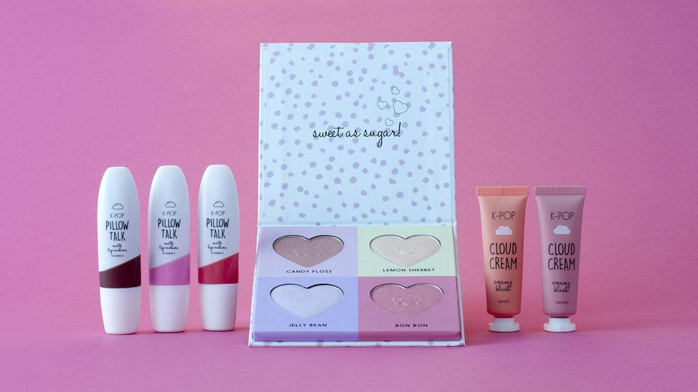

Sweet as Sugar! Skincare (Source: Google)

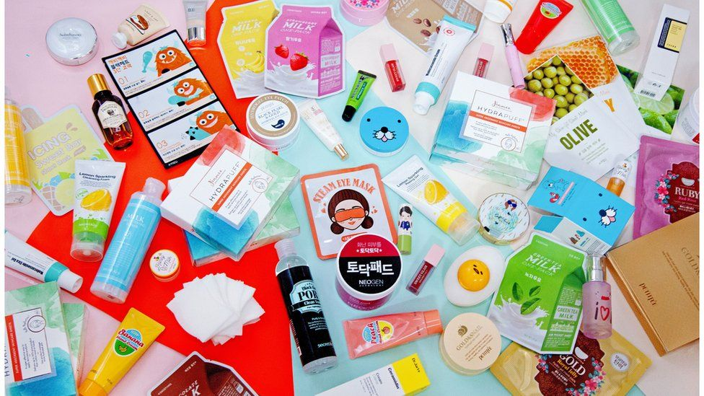

K-Beauty Products (Source: Google)

For what is discussed above, it can be simply stated that Korean women tend to have long steps for their skincare routines. According to BBC News (2017), South Korean women tend to spend twice of the amount of their income on skincare and other beauty products than American women. Yoon (2018) had once said that starting at early young age; Korean women are being educated to take care of their body especially their skin and they are taught proper techniques from cleansing to moisturizing the skin so that it becomes their second nature once they grow up.

Not only for girls, but also for boys who are invested much for their skincare routines. Skincare and beauty products are available everywhere in Korea around thousands of convenience stores and even in the subway. This fact shows on how much they value the importance of skincare routines. Skincare and beauty products are not luxury things in South Korea since you can get it anywhere with cheap prices. Thus, it is not such a strange thing to look at those beauty products as social thing, instead of beauty thing since teenagers and their family can apply sheet mask under $1.

As already mentioned above that actually, Korean beauty products are available for anyone, from those with minimum salary to those with high-level of income. Thus, it can be said that Korean beauty products are available for all people, including many actors and actresses in the showbiz world. The fact said that all of those Korean artists routinely had their special and expensive treatments (facial, hair, and body treatment) in order to make them to look perfect and glowing anytime (Yoon, 2018). Some of them even did their plastic surgeries in order to make their look and appearance become prettier and perfectly shinning.

In one of the most popular K-Dramas during 2020, The King: Eternal Monarch, Lee Min-Ho wore LED face mask. After that performance, this LED face mask has been widely popular all around the world including in Indonesia. The function of this LED face mask is to help rejuvenating the skin after long hours of business. Ashanty has become one lucky Indonesian artist who can have that limited-edition LED face mask which appears in the popular drama, The King: Eternal Monarch. LED face mask which has been wore by actor Lee Min-Ho had only been produced 5 products in the world.

 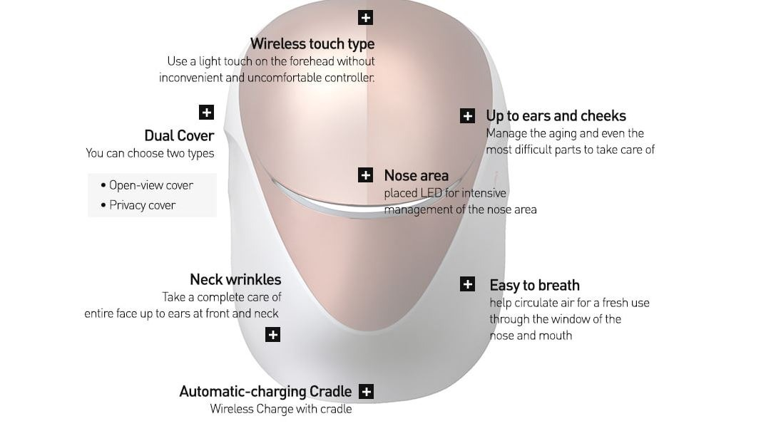

Cell Return Platinum LED Mask with its Brand Ambassador (Source: Google)

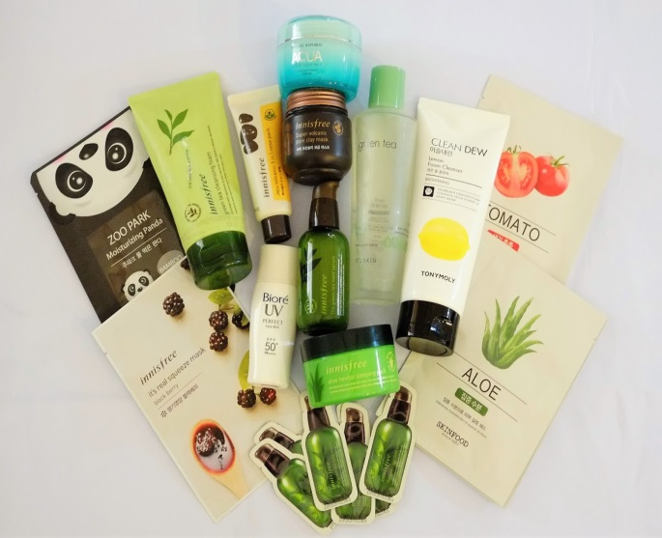 

Korean Innisfree Products and Masks (Source: Google)

The phenomenon of Korean beauty products has been impacted many countries including Indonesia as there are more and more Korean brands open its official stores in some big cities in Indonesia like in Jakarta, Bandung, and Surabaya. For instance, Innisfree and Sociolla had already been opened their official stores in order to get closer to the users especially those who are greatly influenced by Korean waves. Some products of Innisfree like Green Tea Seed Special Kit (Green Tea Balancing Skin, Green Tea Balancing Lotion, Green Tea Seed Serum, and Green Tea Seed Cream), products of Jeju Volcanic / Color Pore Clay Mask, and Orchid Gel Enriched Cream have been their popular products since a famous actor, Lee Min-Ho has become its brand ambassador. Those products sold out in just a few days whether through online store or offline store.

With the popularity of those K-Beauty products, it is not a strange thing that nowadays, there are more and more people all around the world tend to buy those products. Based on the article “K-Beauty: The Rise of Korean Make-Up in the West” wrote by Mary-Ann Russon (2018), the global beauty industry is experiencing a revolution driven by South Korea. There are many young people in the Western countries begin to be infatuated with K-Pop, K-Movies, K-Dramas, and now, with K-Beauty. All of this popularity of K-Beauty cannot be separated from the signature looks of many Korean celebrities such as actor Lee Min-Ho, Hyun Bin, boy band BTS and girl band Blackpink as the trendsetter in introducing Korean beauty to the whole world.

Katie Thomas (2017), an editor from Marie Claire magazine, had once stated that the fascination with Korean beauty products is happening due to how innovative and creative they are in producing those beauty products including skincare and cosmetics. She also explained that South Korea’s beauty industry is typically ten years ahead of the rest of the world. This is primary because of the perspective of Korean culture to look after the skin from the early young age so that it becomes habits for many young people in Korea to protect their beauty from early age.

For more, what is make Korean beauty industry has become one of the greatest industries in the world is about various competing brands which always try to do their best. For instance, they are not afraid of introducing new formulas along with new and unique ingredients which would never been considered in the West. Karen Hong (2017), an owner of K-Beauty Bar from TopShop’s flagship store in Oxford Street, London said that several unique ingredients used by Korean beauty products are including snail mucin for moisturizing, green tea and tea tree for oil controlling, pearl and burdock for brightening, as well as propolis from bees and red ginseng for soothing and nourishing the skin.

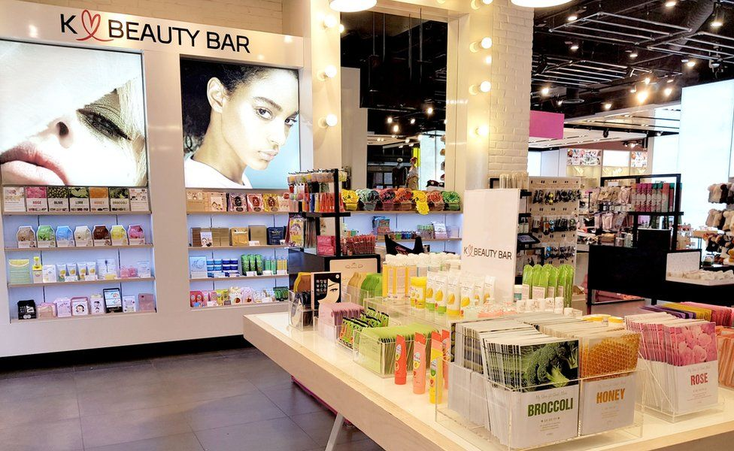

K-Beauty Bar in London’s Oxford Street (Source: Google)

According to Mintel's global beauty analyst Andrew McDougall (2019), Korean beauty trends have grown fast because of clever digital marketing strategies on social media. In the US alone, for about 13% of 10 to 17 years old young girls tend to have interest in trying Korean beauty products, while up to 18% from 18 to 22 years old women tend to use those K-Beauty products. Of course, this fact had succeeded in gaining the interest of Western beauty influencers, bloggers as well as journalists to get to know more and write about these Korean beauty products. Still based on McDougall’s research, it is clearly seen that most customers around the world tend to get interested in those unique, colorful, and fun packaging of those K-Beauty products. McDougall also reveals that Korean beauty products as big business in which Hong Kong-based e-commerce firm carry more than fifteen Korean beauty brands. Furthermore, some global brands such as Primark for England launched its K-Pop range of cosmetics which was sold out quickly.

These days, the phenomenon of K-Beauty trends have been followed by several global brands such as Yves Saint-Laurent, Victoria’s Secret, and Chanel on their recent launch of make-up line targeted men. Chanel launched men’s beauty product called Boy de Chanel. With this spreading influence of K-Beauty trends, if it is viewed through the cultural studies, men who tend to start caring for their look and appearance called as a new term: new masculinism. New masculinism can be such a term to describe how men start to take care of their body, wear such good accessories to help them look stunningly fashionable. Nowadays, we can easily find men who have radiant skin along with glowing appearance, as well as adding more accessories to increase their physical appearance like glasses, necklaces, earrings, bracelets, rings, and even tattoos.

**Korean Tourism Destinations**

Finally, for those travelers out there, it hasn’t been completed yet to discuss about South Korea if they do not talk about Korean tourism destinations. Tourism in South Korea simply refers to tourist industry in the Republic of Korea. During 2012, for about 11.1 million tourists visited South Korea, making it the sixth most visited country in Asia and the twentieth most visited country in the world. The number of international tourists has increased from year to year because the influence of Korean wave and culture spread out all over the world. Seoul is still being the principal tourist destination for both Korean and non-Korean visitors. Besides that, Busan is worldwide known as the capital city of culture and history, so that Busan has become the second most visited city in South Korea after Seoul followed by Daegu and sub-tropical Jeju Island (Korea Tourism Organization, 2019).

Due to the Korean War, in the past, South Koreans were not allowed to travel overseas. However, since the era of liberalization of international travel during the 1980s, South Koreans have been able to travel freely abroad. These days, the hectic lifestyle of those modern South Koreans have contributed to the fast growing number of South Koreans traveling alone abroad. This phenomenon has then lead to the increasing number of tourists’ visit around the areas close to South Korea. According to the result from plane ticket analysis in 2016, the top foreign destination for South Koreans is including Osaka, followed by Tokyo, Bangkok, Shanghai, and HongKong.

Besides K-Drama and K-Pop, Korean tourism and travel directly contributed up to KRW 26.7 trillion to South Korean GDP and directly supported more than 600.000 jobs in the country (Chang Dae, 2007). Up until 2019, the number of tourism and travel contribution to South Korean GDP and jobs growing bigger and bigger. And up until now, China has known as the largest tourism source for South Korea with more than 60% of tourists from China each year.

For the tourists’ destination, South Korea has plenty of touristic attractions including natural destination, history destination, cultural destination, man-made destination, and culinary destination. Some famous landmarks of natural destination include the peaks of the Baekdudaegan, the caves of Danyang and Hwangsengoul, Seorak-san and Jiri-san, and beaches of Haeundae and Mallipo. The main attraction for cultural destination in South Korea is about its annual festivals such as Boryeong Mud Festival and Cheongdo Bullfighting Festival. For international tourists, of course, the capital city of Seoul has become their primary destination once they have arrived in South Korea. This is because Seoul is popularly known all around the world as the combination of modern culture and traditional culture of South Korea. Seoul is also known as one-stop tourism destination with plenty of shopping places, cultural festivals, traditional and world-class performances, natural tourism, and of course culinary tourism.

According to the Ministry of Culture, Sports and Tourism (2015), there is a cultural gap between Seoul and other regions in South Korea in terms of infrastructure. For about 36.4% of cultural infrastructure such as museum, art galleries, and public libraries are concentrated in Seoul which makes more tourists interest visiting Seoul than other regions in South Korea. A few of famous touristic attractions located in Seoul including Gyeongbokgung Palace, Changdeokgung Palace, Deoksogung Palace, Fortress Wall of Seoul, Gwanghwamun Square, 63 Building, Namsan Seoul Tower, War Memorial of Korea, Jogyesa Temple, National Museum of Korea, Bukchon Hanok Village, and Cheonggyecheon.

According to the data got from the participants’ statements, all of these tourism destinations are becoming more popular today in the world including in Indonesia because some dramas taken place there. Namsan Tower has worldwide known because it often is being appeared in some famous dramas such as Boys over Flowers (2009), My Love from the Star (2013), and Legend of the Blue Sea (2016). Then, Bukchon Hanok Village had once been the important location for drama Personal Taste (2010) with the popular house ‘Sanggojae’ inside the complex area. And Yongin Daejanggeum Park has been the historic location for some *saeguk* dramas such as Faith (The Great Doctor) in 2012, The Moon that Embraces the Sun, and the legendary *saeguk* drama: Jewel in the Palace.

Most of the participants said that they want to visit South Korea and some iconic places there because they want to look a lot like in the drama. Those iconic places that becoming most wanted places to visit in South Korea are not only modern destination like Namsan Tower or Lotte World, but also include some other destinations like historic place, cultural place, as well as natural place. Even the shooting places like Nami Island in drama Winter Sonata, ‘Sanggojae’ in drama Personal Taste, Heo Joon Jae’s iconic house in drama The Legend of the Blue Sea, Gwanghwamun Square and Ahopsan Forest Busan in drama The King: Eternal Monarch has now becoming the new destinations for K-Drama fans.

As the second largest city in South Korea, Busan has popularly known as the city of culture and history because of 11 festivals held annually here. As Busan located in the southeastern coast of South Korea, Busan has sea festival which had been held every August. Every October, many tourists come to Busan in order to get to know more about Busan International Film Festival. Gukjae Market, Haeundae Beach, Beomeosa Temple, Geumjeongsanseong Fortress, Dongnaeeupseong Fortress, Haedong Yonggungsa Fortress, Chungnyeolsa Shrine, and Dongnae-hyanggyo Confucian Academy are just several interesting tourism destinations in Busan.

Beside all of those tourism destinations, there are still plenty of interesting and beautiful places all around South Korea which can be considered to be the next destination to travel and they are located in several regions. For instance like Palgongsan Mountain in Daegu, Songdo Central Park and Chinatown in Incheon, Mudeungsan National Park and Gwangju National Museum in Gwangju, Yuseong Hot Springs in Daejeon, Gapyeong – The Garden of Morning Calm and Yongin Daejanggeum Park – Korean Folk Village in Gyeonggi Province, Donghae and Park Kyung-ni Literature Park in Gangwon Province, Guinsa Temple and Gosu Cave in North Chungcheong Province, Cheonan – The Independence Hall of Korea in South Chungcheong Province, Jeonju Hanok Village in North Jeolla Province, Cheongsan Island in South Jeolla Province, Wollyeongo Bridge in North Gyeongsang Province, Historic Park of Geoje and German Village in South Gyongsang Province, Jeju Stone Statue Park and Mount Halla in Jeju Island.

[](https://en.wikipedia.org/wiki/File:Halla01.JPG)

Mount Halla in Jeju Island, South Korea (Source: Google)



Cruise in Jeju (Source: Google)

Most international tourists will tend to deal with one day trip in Seoul or another tour package based on the duration of their stays. Usually, joing the tour package will save the money and the time for the first time tourists visiting South Korea. Trip around Seoul will usually include traditional place Gyeongbokgung Palace or Bukchon Hanok Village, modern place of Lotte World and Namsan Seoul Tower, shopping place of Myeongdong, and nature place in Nami Island or Jeju Island. Moreover, Namsan Seoul Tower has already been primary destination for all tourists when visiting South Korea.

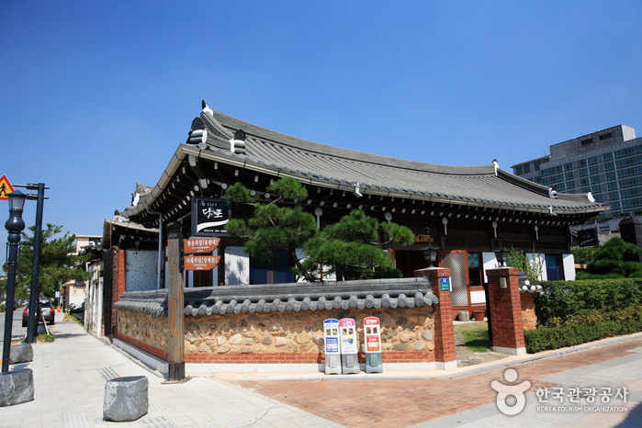

Jeonju Hanok Village (Source: Google)

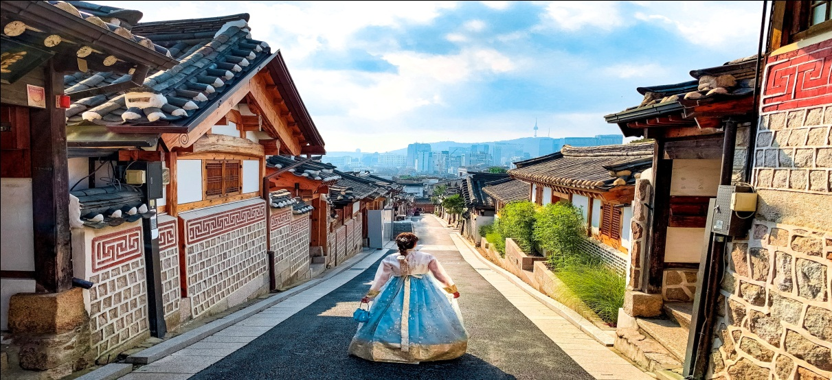

Bukchon Hanok Village (Source: Google)

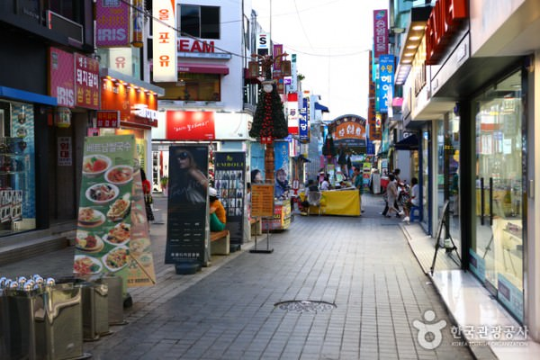

Chuncheon Myongdong Dakgalbi Alley (Source: Google)

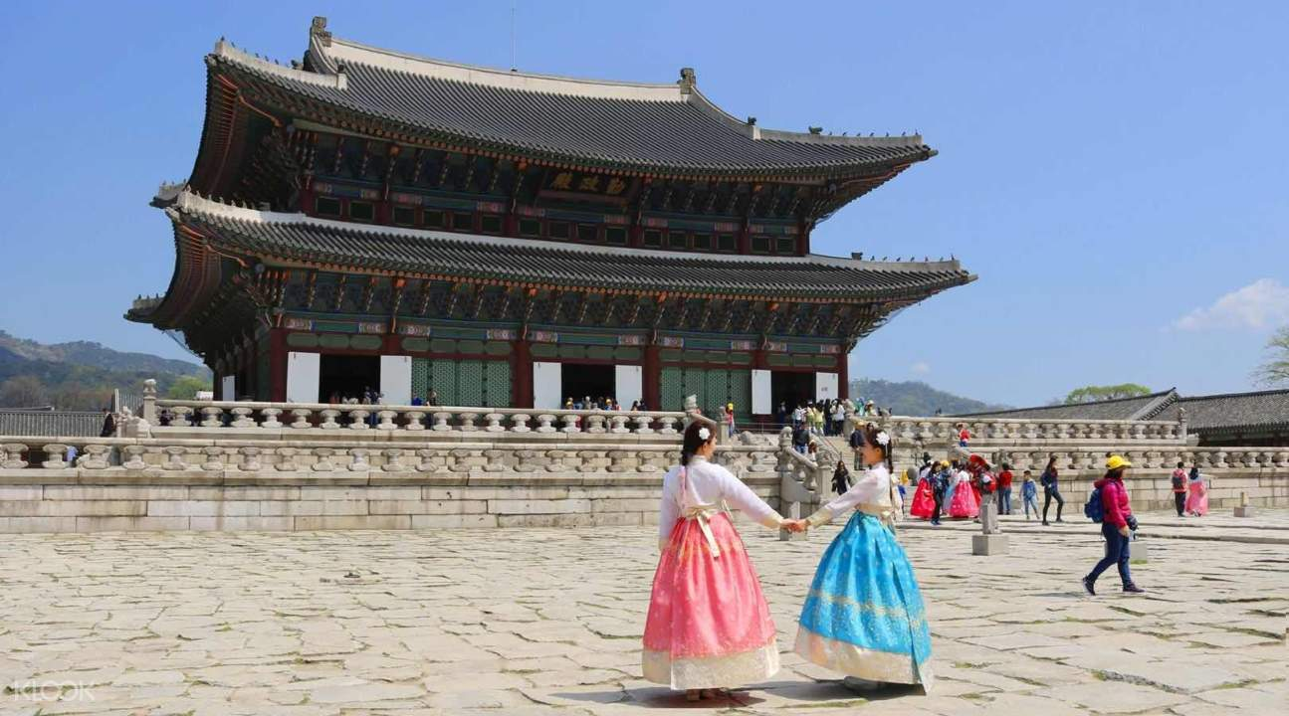

Gyeongbokgung Palace (Source: Google)

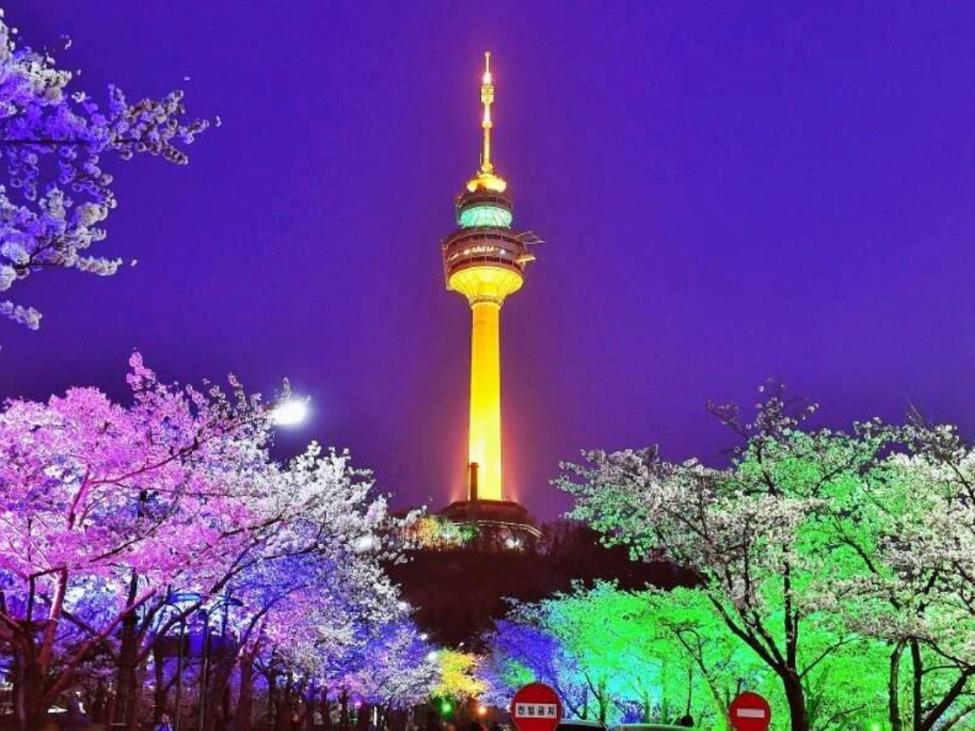

Namsan Seoul Tower (Source: Google)



Namiseon Island (Source: Google)

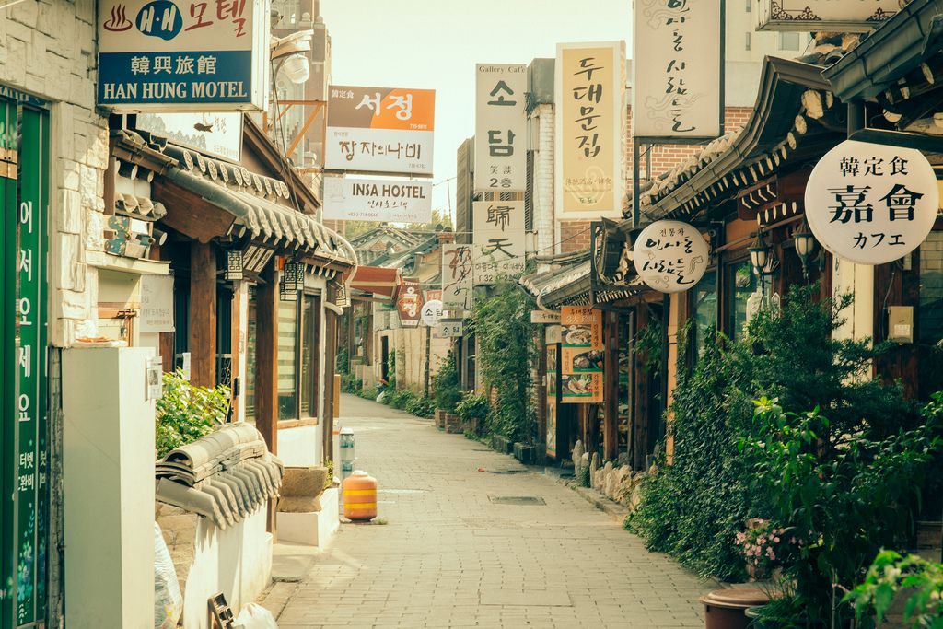

Insadong: Street of Korean Traditional Culture (Source: Google)



Lotte World and Lotte World Mall (Source: Google)

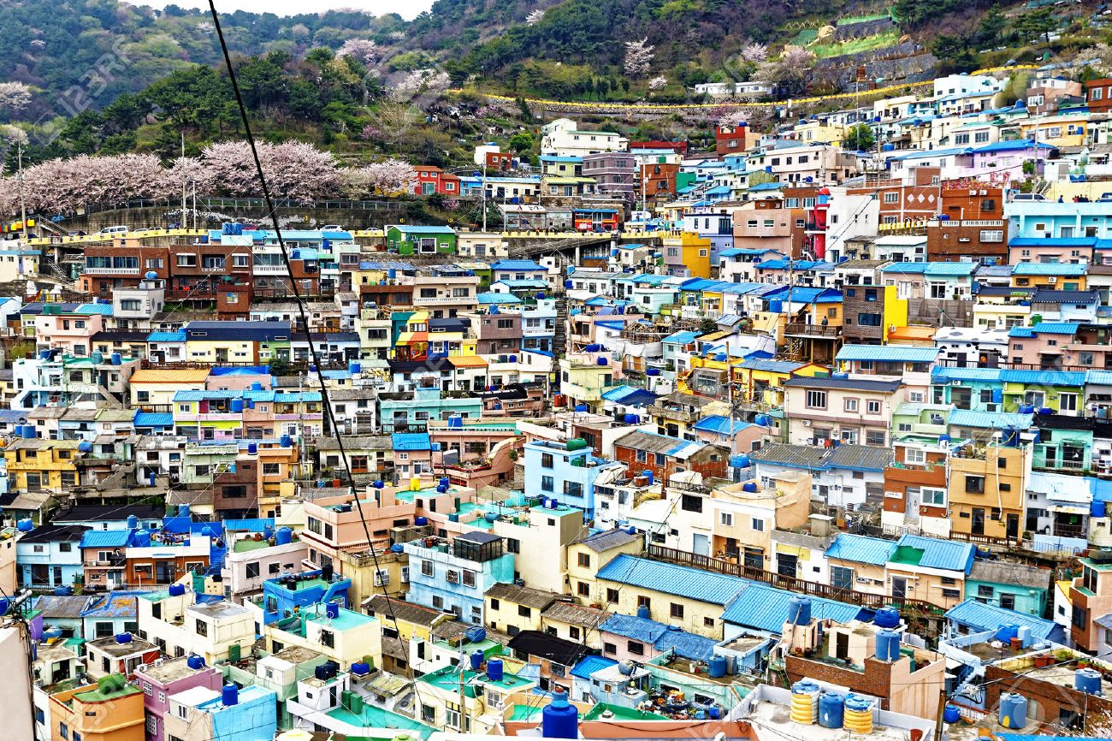

Busan Gamcheon Culture Village (Source: Google)

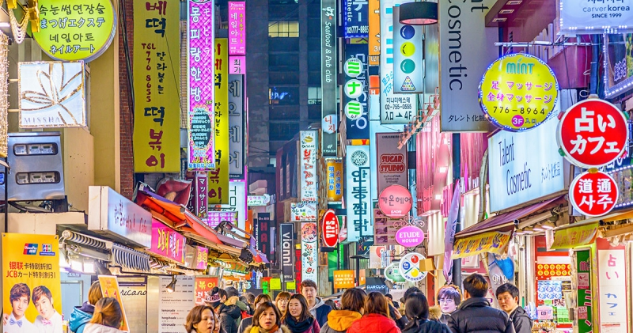

Myeong-dong (Source: Google)

For the international events, South Korea has hosted a lot of events including Summer Olyimpics in 1988, Taejon Expo in 1993, World Cup in the year of 2002 (hosted with Japan), APEC Conference in 2005, G-20 Seoul Summit in the year of 2010, Asian Games in 20014, and the last is Winter Olympics in 2018 (cited from UNTWO, 2018).

Let’s mention about the trending destination today: Purple Island which is located in Banwol and Bakji Islands in South Jeolla Province, South Korea. As its name, this island was colored purple in every inch of the property such as the houses, the streets, the bridge, the traffic lights, pylon, and the roads. And it is not just the outdoor views that have been painted purple, but also the indoors. Even some restaurants there offer rice purple and serve their dishes on purple plates and bowls. The purple color is actually inspired by the native balloon flower and since then, it has been adopted for practically everything to catch tourists’ attention.

Some tourists, both local and international, told that they wore purple outfits when walked around the Purple Island in order to match the place and of course to be allowed free entry. This is such great strategy that the government did because since then, there are many visitors travel to these islands by wearing purple outfits and both the pictures and the videos went viral on social media. This makes Purple Island to become popular in just short times. These islands have been chosen as the government tourism project and the government gave fund for about US$ 4.25 million to turn the whole areas into purple color. Flowers like lavenders and asters were planted around the islands (taken from Indianexpress.com, February 2020).

The iconic Cheonsa Bridge has become the new icon of Purple Island. This beautiful bridge connects Banwol Island with Bakji Island. For most sources, the best time to visit the island is at night where the bridge shines bright as the backdrop of the pictures or videos taken. Moreover, the visitors can also enjoy the breathtaking sea view over the bridge. Since it was just being released during last Summer 2020, the local government is still developing tourism on the island by building more hotels and restaurants, which are all painted purple.

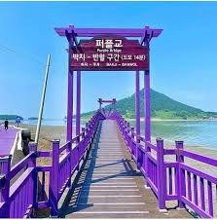

Purple Bridge (Source: Google)

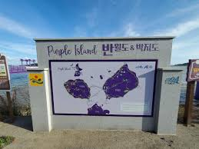

Purple Island (Source: Google)

**Korean Advertisements**

Advertising industry in South Korea is all about multi-billion dollars industry which is growing fast through the years. The biggest spent in the South Korea’s advertising industry is on the television ads, internet ads, and followed by newspaper and magazine ads. The fact said that the internet advertising revenue generated for about more than 12% of the total gross revenue from the Korean advertising industry. Of course, the influence of the Western culture cannot be separated from South Korea’s advertising industry through the use of the English in the advertisement or using American celebrities to advertise the products such as what can be seen in the advertisement of Isa Knox which was presenting an American actress, Jessica Alba partnered with Lee Hyori (Pil Han, 1994).

Talking about Korean advertisements, we should also discuss about the trends. The advertisements in South Korea during the 1970s to 1980s were portioned in big picture, appeared in fully direct words instead of the use of ellipsis. But these days, the trend is changing a lot through the usage of jingles, hints, as well as logos to represent the message to its viewers. In order to attract the consumers to buy the products, the models or celebrities will usually try to recommend the products by giving such questions and suggestions (taken from Wikipedia/South_Korean_advertisements).

Furthermore, the trends in the advertising industry are also introducing the change in gender roles (Yee Cheon & Kim, 2010). Traditionally, women will portrait as submissive and dependent so that they were often being portrait in the domestic field such as in the kitchen or at home. But nowadays, the advertising industry begins to portrait women or female figure around the work place and having more freedom from the traditional values based on old Korean society. The reflection of the change in advertising has done in order to reflect the Korean society that has become more individualist, lenient, as well as more independent just like the Western society.

According to Pil Han (1994), in the advertising industry in South Korea, celebrities played essential role in promoting the products since celebrities are often being viewed as symbols of Korean culture to connect with the consumers. And of course, it is not just talking about advertisements which endorse Korean artists to become its ambassadors, but also talking about some local advertisements which make use of ‘the taste of Korean’ as their strategy to attract the consumers (Hee Kim, 2010).

Recently, a handsome actor, Lee Min-Ho, has been endorsed as the regional brand ambassador for online merchants, Lazada. Long before that, in Indonesia, Lee Min-Ho had been endorsed by the local product, *Luwak* White Coffee to promote their brand in 2016. There were also other Korean celebrities who had been endorsed as the ambassador of the local brands in Indonesia such as Rain (Clear Men in 2007), Gong Yoo (Asus Zenfone 4 in 2017), Kim Bora (Korea Glow), boy band Winner (Oreo in 2019), Lucas Way from NCT-U (Neo Coffee in 2019). In 2020, several online merchants, *Shopee* endorsed group band GOT7 and *Tokopedia* endorsed the phenomenal boy band BTS and girl band Black Pink. And in the same year, Siwon Choi from Super Junior has been endorsed by *Mie Sedaap*, and boy band NCT 127 has been endorsed by *NU Green Tea*.

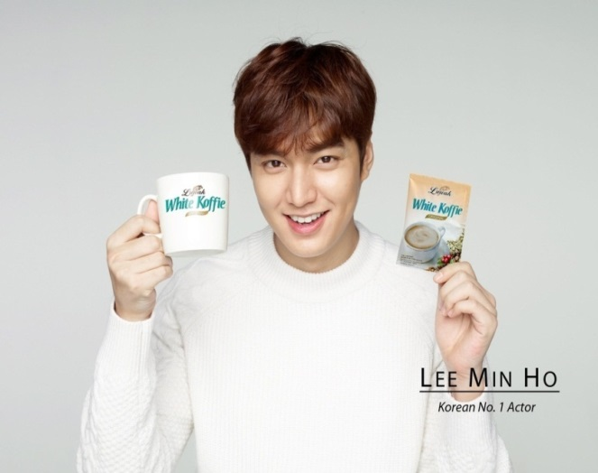

*Luwak* White Coffee Advertisement in 2016 (Source: Google)

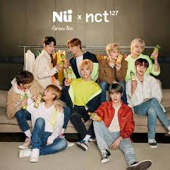

*NU Green Tea* presented by NCT 127 (Source: Google)

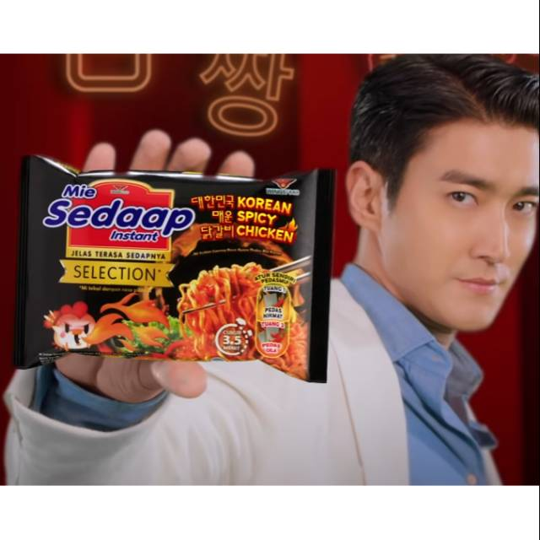

*Mie Sedaap* presented by Choi Siwon from Super Junior (Source: Google)

Of course the rapid expansion of South Korea’s advertising industry cannot be separated from the Korean wave itself as most of those South Korean products are familiar throughout the world because of the global phenomenon of Korean wave (including Korean movies, dramas, music, and pop culture). According to Miller (2008), this Korean wave is also recognized as an American pop culture in Korean style or in other words, it is considered to be the combination of local and global culture. If we were looking back in the mid-1990s, some Korean products such as Samsung and LG became sponsors of Korean television dramas (Cho, 2005).

At that time, one great marketing strategy had been done by those two big Korean companies by distributing copies of popular Korean dramas along with their products. The effect was amazing because consumers were not only being able to enjoy their favorite Korean dramas, but also be able to find Korean stuff everywhere (Lee, 2005). Thus, Shim (2006) stated that “the best marketing media is drama series”. From that time, South Korea has succeeded in exporting a few of their cultures like music, dramas, movies, fashion, beauty products, advertisements, electronics, food, and animation. According to former studies, it is clearly said that Korean wave has influenced a lot the sales of Korean products throughout Asia from China, Japan, Vietnam, Phillipines, Hong Kong, Thailand, Malaysia, and Indonesia.

According to Tada-amnuaychai (2006), the effect of advertisements which use Korean celebrities is very big because usually those Korean drama fans have such impressive perceptions towards Korea and its products as the products are mostly tied-in with Korean television dramas. This kind of perception makes them to be easily consuming Korean products because they think that all products made in South Korea have good quality. In this part, it can be simply stated that Korean wave can be such a soft power of Korea which can promote the country image and exports (Son & Kijboonchoo, 2016).

In this recent year, one of the phenomenal Korean dramas which present a lot of advertisement of the Korean products is ‘*The King: Eternal Monarch*’ (2020). In the drama that appeared Lee Min-Ho as the King of Korean Kingdom, the viewers can see some Korean products such as Cell Return LED Mask, Korean Red Ginseng, KAHI lip balm, Kimchi, The Alley (tea café), bb.q Olive Chicken, skd Coffee Lab (Songgeumdang), Paris Baguette (boulangerie shop), and Samsung Galaxy Note 10+. Some viewers gave critics to this as too many products appeared in the drama, but some others tend to buy those products and visited the cafés presented in the drama. Advertisements appeared in the popular dramas can be said to be the best marketing strategy made by those capitalist companies out there to directly promote their products. Some companies like Miniso even produces specific dolls as appeared in drama, Goblin, as well as the Body Shop that achieved massive success as its perfume White Musk has become the main sponsor in drama Goblin.

 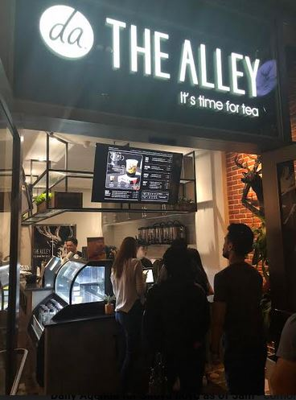 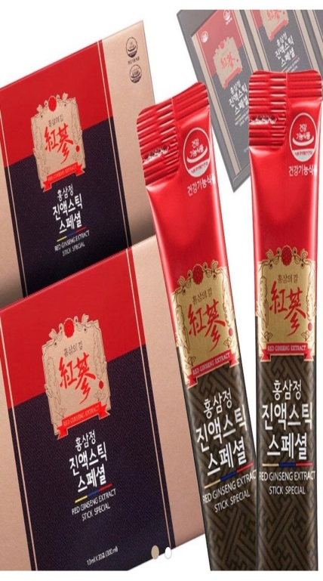

bb.q Olive Chicken (left), The Alley Tea Cafe (middle), Korean Red Ginseng (right)

(Source: Google)

**Korean Influence on Indonesian Perspectives**

In line with the purpose of this study, it can surely be noted that the Korean drama and cinema seen as a mixture of traditional values with modern style, which adds to its appeal. This statement can be used as a conclusion how Indonesian people see Korean entertainment industry having big impact to the lives of its people, especially for teenagers to early adults.

The first example, we can see through several statements from the participants in this research. All of them said that there are many positive things they can find when they become fans to K-Pop or K-Drama.

@ami.bts.1 : *“Aku salah satu yang jadi belajar mencintai diri sendiri karena lagu-lagu BTS”.*

@seoksil12 : *“Lucunya tuh ya aku curhat pengen bunuh diri di weverse ARMY intern, banyaaak banget yang respon positif dan ngasih support. Malah kebalikan di dunia nyata aku dikatain lebay baperan aja. Sampai akhirnya aku lebih nyaman curhat sama ARMY ketimbang temen real life aku”.*

@yasstatirmz01113 : *“Mereka memotivasi banyak orang. Dulu aku sering menyakiti diri sendiri akibat depresi atau pertengkaran orang tua, sering cutting, jedotin kepala ke tembok agar ngerasa ada beban yang hilang. Banyak di luar sana yang ngehakimi SuJu dengan tuduhan yang kalian sendiri tau gimananya. Tapi di balik itu semua, SuJu sangat berarti bagi banyak orang. Sekarang lebih bisa ngontrol diri dan ngerasa lebih berharga dengan apa yang telah diri sendiri lakukan. Thanks Elf dan SuJu atas semangat untuk mencintai diri sendiri”.*

@minoz87 : *“Aku merasa banyak sekali perubahan positif dalam diri aku sejak aku kenal dan jatuh cinta sama aktor Lee Min-Ho. Dari dia, aku jadi sadar untuk menjadi manusia yang lebih peduli pada sesama dan selalu memperlakukan orang lain sebaik mungkin karena kita gak akan bisa jadi seperti kita sekarang tanpa bantuan dan dukungan dari orang-orang di sekitar kita. Dia menginspirasiku lewat yayasan amalnya, PROMIZ, yang bantu ribuan anak-anak miskin di Afrika dan negara-negara miskin lainnya. Juga yang bantu hewan-hewan terlantar untuk diadopsi”.*

@seonlover : *“Sejak jadi penggemar K-Drama dan juga film-film Korea, aku jadi terinspirasi untuk menjaga tubuhku, terutama kulit ya dengan perawatan maksimal. Dalam salah satu drama favoritku, ada satu karakter yang bilang bahwa salah satu cara kita untuk bersyukur dan menghargai diri kita adalah dengan merawat diri sendiri. Jangan abai dengan kesehatan tubuh kita baik fisik maupun mental. Makanya sekarang aku jadi rajin beli krim perawatan tubuh dan juga untuk rambut, untuk perawatan kulit biar makin glowing, meski ga akan semulus bintang-bintang Korea itu, tapi setidaknya aku sudah mencoba untuk merawat diri dan menghargai diri sendiri”.*

From the statements above, it can be stated that Korean entertainment industry as part of Korean culture has given positive effects to the fans around the world, especially in Indonesia. Their inspiration is not only limited to the entertainment and leisure industry, but also related to the mental health issues, caring for each other, and giving support for donation. In case of mental health issues, which had been one of the most discussed issues these days, there are many fans out there who are being helped from their mental disorder due to the impact of K-Pop. Some of those fans are succeeded in rising from their depression and stress since they listen to those K-Pop idols’ songs. For instance, songs from BTS are mostly talking about how to love ourselves and how to keep sane even during the worst time. Even the speech from the leader of BTS, Kim NamJoon give new insights to millions of ARMY out there to love themselves no matter what happens.

Thus, it is wrong that people out there are still talking about the negative sides of being Korean fans. The fact said that there are thousands of fans from all over the world often make birthday projects for their bias or idols. For the example, we can take a look at the newest birthday project from ARMY Indonesia for JHope BTS in Februari 18th 2021. ARMY Indonesia decided to make inspiring birthday project for their idol by gathering the donation for creating ‘Jhope Forest’ in Kalimantan. This project tends to use the donation from ARMY Indonesia to re-plant mangrove tree seeds to do the reforestation in Kalimantan. Meanwhile, at the same time, ARMY in China gathered the donation for buying medical tools for Hope Hospital in the Province of Anhui (which they had been built last year for the 2020s Jhope birthday project). All the donations come from fanbase ‘Jhope Bar’ and ‘HOPEEYES218’ and it is used to buy medical tools such as EKG monitors, B-Mode Ultrasound imaging machine, high-frequency electrosurgical, AED Defibrillator, as well as some herbal medicines.

Furthermore, according to the statement from Minoz (a fan of actor Lee Min-Ho), it is said that she is truly inspired by her idol. She is inspired to do something more for those unfortunate people around her, she is inspired to give more to those in needs as well as asking other people to help hand in hand for the victims of flooding in some areas in Indonesia. The impact on her is so deep so that it changes her life to become a better person. Now, she said that she is proud to be a fan of Korean drama and Korean culture because she’s fully consider that there is no better person than a person who can give meaningful contribution to other people, someone who can give benefits to as many people as possible.

Meanwhile, there is also a girl who is inspired by the beauty of Korean idols. She is inspired to treat her body better than before as a signal to always be grateful for what we have. If long time ago she was just treating her body in a usual way, now she said that she become a picker when it comes to beauty products like hair care and skin care. She only wants something best for treating her body from head to toe. Also, she is inspired to look glowing just like her idols by consuming some Korean beauty products such as Innisfree, Rojukis, SNP, and a lot vitamins to keep hydrating her skin.

Thus, the impact of Korean entertainment industry is truly massive to those Indonesian fans, even it is succeeded in passing the limit of the entertainment industry. It means that the impact is not only about the entertainment industry itself, but more than that, it is also about the impact on the fans’ everyday lives including their mental health as well as their physical health. Also, the fans do a lot of good things for their surroundings by saving the Earth. Among the discussion about mental health issues and the image of physically beauty standard, these facts are very interesting because it can help to decrease any mental health issues as well as to make another beauty standard: everyone is beautiful no matter what their hair style, skin color, body shape, race, and etc.

Furthermore, there is also another interesting fact that the researcher found during the time of observation. The observation has done through observing some conversations and activities both online and offline. The interesting fact is that most of those K-Drama fans are more likely to be able to understand Korean language more quickly than those K-Pop fans. It can be seen from the natural conversations (unplanned conversations and the respondents did not realize that they are being observed): those K-Drama fans are able to communicate as well as understand some Korean language in everyday conversations in which often heard in K-Drama scenes such as *jinjja* (sungguh/betul-betul), *museun suriya* (apa maksudmu), *jamkanman* (tunggu sebentar), *hajimallago* (aku bilang jangan lakukan itu), *na meonjeo galge* (aku pergi duluan), *gwaenchanha* (tidak apa-apa), *johahae* (aku suka kamu), *jinjja masisseoyo* (sungguh enak), *baegopa* (aku lapar), *bangawoyo* (senang bertemu denganmu), *olaen manieyo* (sudah lama tidak bertemu), *yaksohkhae* (berjanjilah padaku), *geokjeong hajima* (jangan khawatir), *kyulhon-haejo* (menikahlah denganku), *waegurae* (ada apa / apa yang salah), and many more.

According to Lu & Lo (2007), it can be concluded that the main factor on why those K-Drama fans are having better understanding of Korean language than those K-Pop fans is because of the connectedness. Connectedness of the audiences with all the characters as well as contextual settings in some K-Dramas contributes a lot to the audiences’ satisfaction towards that particular K-Dramas. And because of that kind of connectedness, K-Drama fans tend to be paid more attention to as well as to be more aware of Korean language. They want to understand what the characters said in the dialogue of the drama. Moreover, it is in line between the result of the interview and the theory from Lu & Lo about celebrity culture that the subtitles (whether it is in English or in Indonesian) in every K-Drama surely help them to understand more about Korean language including the pronounciation and the basic grammar.

The emotional state that Lu & Lo (2007) stated has become the essential factor that influences the K-Drama fans a lot. From the dramas they’ve watched, those fans realize that they become easier to understand Korean language especially through the dialogue of the characters in the drama. Usually, most fans will tend to search for the meaning of Korean words they’ve heard in the drama, find the way on how to write those words, and they will exercise how to pronounce it well. Based on this reason, it is clear enough that K-Drama fans tend to have more understanding of Korean language than those K-Pop fans. As Lu & Lo said that it would be quite more difficult to learn or catch the words through the lyrics of song rather than catch the words and its pronounciation through the dialogue. Lu & Lo added that those K-Pop fans tend to be more focus on learning how to sing the song and trying to remember the lyrics rather than learning to understand the meaning of the language they sang.

Another phenomenon also happened during Covid-19 pandemic in relation to the interested feeling of K-Drama fans. A study conducted by researchers in Research Center for Society and Culture LIPI (2020) stated that K-Drama consumption amidst Covid-19 pandemic in Indonesia is facing the increasing level. The surveys showed that before Covid-19, people who were watching K-Drama in the 87.8% and during Covid-19 were increasing up to 91.1%. The survey was answered by women as the majority respondents.  About 92.6% respondents are female and the rest 7.4% are a male. And the survey was involving among 924 respondents.

From those who watched, 73% of them are the new viewers that prior to pandemic never had any experience on watching K-Drama. Meanwhile, in terms of frequency of consumption, there are also several important findings. From 924 respondents, 41.3% respondents watched K-Drama more than 6 times a week. The results of this study showed that leisure consumption is important during the time of pandemic crisis because most of them need something to spend their time while they were forcing to stay at home. The data can be seen as follows:

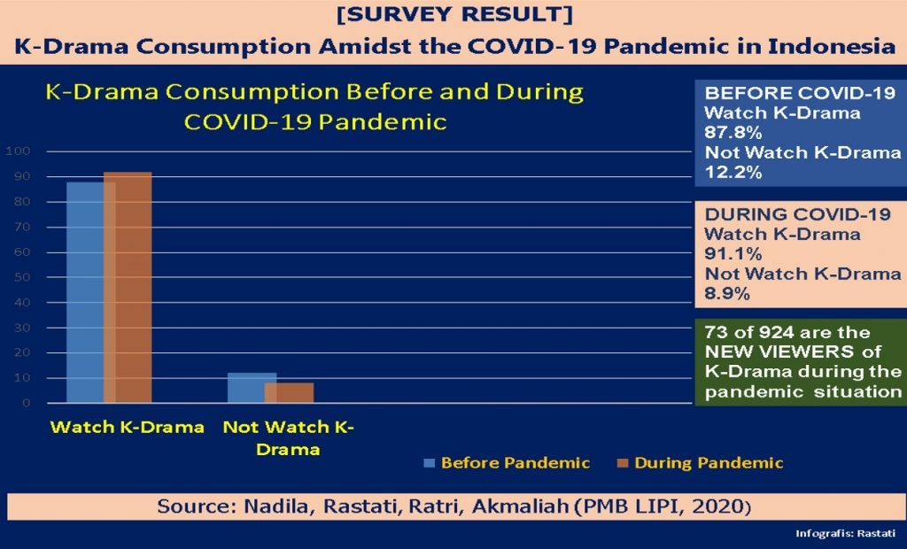

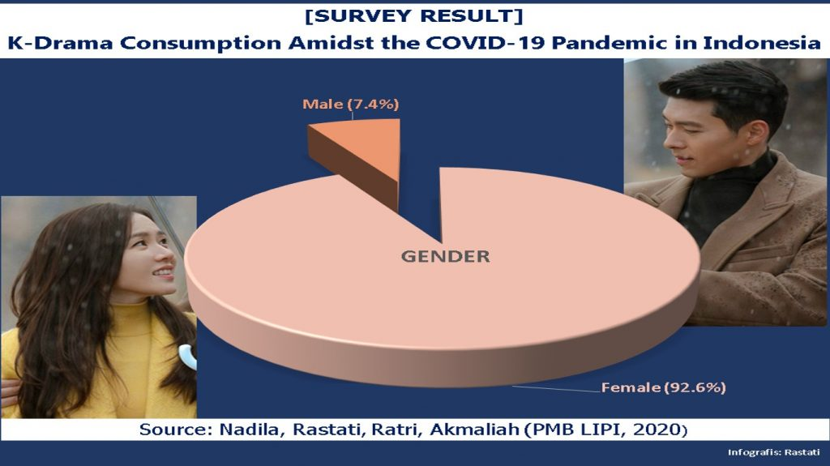

Moreover, from the research done by the researcher, it was clearly known that actually there are several essential factors which make people (adolescents, young adults, and adults from age 14 to 40 years old) tend to attract to watch K-Drama:

* Friends often discuss about Korean drama they watched
* To watch Korean drama with friends and family
* To be updated with the latest Korean fashion trend
* To have common conversation topics with friends and family
* To learn more about the famous tourist destinations in Korea
* To learn more about Korean cuisine
* To learn Korean language

So, it can be concluded that most of those participants involved in this research decided to watch K-Drama because of those seven reasons. The top two answers are about being able to watch and talk about Korean drama with the people around them. It is not only talking about the story of the drama they’ve watched, but also talking about the plot, the characters, the settings, and some more.

Also, the impact of watching Korean drama make the participants were also interested in searching more about the latest fashion trend, tourist destination, cuisine, as well as Korean language. When they watched their favorite dramas, they tend to be interested in the fashion trends that were worn by the characters both male and female. And all those fashion styles worn by characters in the popular drama often are being the new trend in the fashion world, which makes South Korea to become one of the most influence fashion centers in the world (Lin, 2019).

Then, they tried to search more about the place setting in the drama to be their next wishlist to go there. This kind of activity has then known as ‘Hallyu tourism’ where more and more foreigners (including foreigners from Indonesia) who decide to visit South Korea due to the influence of Korean wave. According to Lee (2011), the starting point of foreigners’ interest in visiting South Korea is from Japanese tourists in the mid-1990s. The term ‘Hallyu tourism’ itself can be simply divided into narrow meaning and broad meaning. Narrow tourism means that the foreigners who visit South Korea have specific activities related directly to their interest in Korean wave such as visiting drama shooting sites, participating in performance of K-Pop idols, or even participating in fan meetings. And about broad tourism means that those foreigners do not participate directly to the activities related to Korean wave, but their main reason in visiting South Korea is about their interest in the phenomenon of Korean wave.

Related to this kind of tourism, Ko (2009) had once said that there are also viewers of movies or dramas who turn into tourists who visit South Korea and this is widely known as ‘movie tourism’ which is used to enhance tourism attractiveness as well as becoming a business to show attractive tourism incentives. Nowadays, this ‘movie tourism’ is known as one of the modern cultural tourism. Thus, it is not a secret that Korean wave has massive influence on increasing the number of tourists’ visit to Korea especially to South Korea as the center of Korean wave. And this fact has then lead to the appearance of popular South Korean actors and actresses as the brand ambassador or PR ambassador of government’s promotional tourism tagline: Visit South Korea Year. During the year of 2016 to 2019, actor Lee Min-Ho has been chosen as *The Face of Korean Tourism* for promoting ‘Visit South Korea Year’ (taken from instagram feed @leeminho_nation, 2020).

And of course, the fans of K-Drama will want to know more about Korean cuisine as appeared in the drama. This is one logic answer on why today we can easily find a lot of Korean cafés and restaurants, both in big cities and small cities all around Indonesia, with the authentic Korean menus. And the last result showed that there are more and more K-Drama fans tend to get interested in learning Korean language. Sage Institute has now found to be the most searched Korean language course for K-Drama fans in Surabaya (taken from Sage Institute website, 2020). Most of those fans are interested in learning Korean language because they want to be able to understand the dialogues in their favorite dramas as well as they want to look update by being able to speak Korean and write both Romanization version and Hangeul version of Korean language.

The interesting thing is that fans of Korean drama tend to get interested more in learning Korean language than those K-Pop fans. According to the result of the interviews with sample of participants (7 participants: 5 Korean drama fans and 2 Korean music fans), this is because those Korean drama’s fans had more desire to learn Korean language since they want to understand what is said in the drama’s dialogue between the characters. Also, dialogues in dramas are categorized as everyday life’s conversation in which everyone can learn to speak it anytime and anywhere. The dialect and accent that the characters in the drama spoke were also becoming the reason on why the fans tried to learn about it more. Meanwhile, the fans of K-Pop were also interested in learning Korean language but not as much bigger than those K-Drama fans. The top reason is because they can easily get the lyrics of every Korean song they hear from the internet, so as long as they can pronounce it well to sing the song, it is enough for them to sing along with their idols in the concert or even through CD or DVD.

If it is seen through the theory from Jiang and Leung (2012), all of those factors people watch Korean drama can be categorized into four gratifications: sociability, entertainment, learning, and escape. Gratification theory here means an audience-centered approach on how the viewers use media to satisfy their affective and cognitive needs. This study also found that most of those young people decide to watch Korean dramas because of their imagination, identification, and imitation of modernity through learning cultures from those drama series.

Moreover, participants who tend to choose to watch drama over Korean music or those who prefer to enjoy both drama and music but spend more time in watching drama, stated that there is more benefit in watching drama. From the drama, they enable to get to know more about knowledge, story, and even history about South Korea. From dramas with the theme of certain aspects like business or health or criminal or politics, the viewers can learn more about that aspect in life especially happened in South Korea and how South Korea deals with social and cultural problems in their country and outside their country. From dramas that mainly tell about love and life, the viewers can learn about the story behind every situation. And from most *saeguk* dramas, the viewers can know and learn a lot about the history of South Korea from the era of Three Kingdom, from Silla period until Joseon period. Even from dramas like ‘Crash Landing on You’ and ‘The King: Eternal Monarch’, the viewers can have more information related to the history of South Korea and North Korea.

Of course talking about Korean influence on Indonesian perspectives, we also need to talk more about the cultural contact of South Korea and Indonesia. As we have known that South Korea and Indonesia have two different backgrounds, in which South Korea as a developed country and Indonesia as a developing country. However, South Korea and Indonesia have been having good relationship for centuries from the aspect of culture, economy, and politics. Overall, the cultural bond between these two countries is the closest since in the last ten years, there has been a steady expansion of cultural contact between South Korea and Indonesia.

Some examples of the remarkable cultural contact between South Korea and Indonesia are found in the collaboration between an Indonesian comedian, Sule with a Korean singer, Eru whom released a song entitled *Saranghaeyo* in 2013. Other examples are including South Korean band, DAY6 sang NOAH’s song ‘*Separuh Aku*’ during their concert in Jakarta and a phenomenal South Korean actor, Lee Min-Ho sang ‘*Hati yang Kau Sakiti*’ as the Indonesian version of his popular song, ‘My Painful Love’ (*Naui Apeun Sarang*) OST The Heirs. The video of him sang that song went viral within several minutes after released (taken from detik.com, 2013).

In the recent year, a Korean popular band NCT uploaded 6 videos when they learned Indonesian language as well as learned traditional Indonesian dance, *Tari Saman* on their YouTube channel. Moreover, SBS’s reality show *Barefoot Friends* and *Running Man* have ever chosen Indonesia (Yogyakarta) as the place for their program. According to Lin (2019), the cultural contact between South Korea and Indonesia also happened in the field of education when Hankuk University of Foreign Studies offered a lot of Koreans to study Bahasa Indonesia. And in Indonesia itself, there are more and more formal and informal institutes offer the chance to study Korean language as South Koreans have become one of the largest expatriate communities found in Indonesia.

Still about cultural contact between South Korea and Indonesia, from the marketing or economic strategy, they can make the utilization of the fans for various contents including beauty products, food, medical care, shopping, fan meeting, merchandise, performance visit, and many more. From most of the participants involved in this research, it is known that they fully consider that merchandise from their idols is truly expensive and even some are having overly-high price, but they still want to buy the merchandise in order to give full support for their idols. K-Pop idols such as BTS, EXO, Seventeen, Blackpink, NCT Dream, and Big Bang tend to release a bunch variety of official merchandise and they’ve always been sold out.

Fans of Korean wave are popularly known to be very loyal and they don’t mind to spend much money as long as it is used to support their idols. That is why; they always prefer to buy the official merchandise no matter how much the price is. For instance, all those Korean drama lovers must know that there is often the release of official merchandise based on accessories appeared on the drama, let’s say like Minomi dolls (as shown in the drama Personal Taste and The King: Eternal Monarch) or perfume (as shown in the drama Goblin). The loyal fans out there wouldn’t mind to directly buy those drama accessories. Based on the research done, it is a simple way for those fans to support their idols by ensuring to only buy the official merchandise and accessories released by the management. Buying the official merchandise and accessories has also guaranteed that it has good quality and it is similar to what is appeared in the drama. Later on, the experience of having the official merchandise and accessories make the fans to have the feeling of satisfaction and the lust of being the loyal fans. For them, this kind of feeling cannot be exhanged with anything.

Most Korean idols are also known to be very loyal to their fans by releasing new contents (like video or teaser or single or merchandise) every month and even every week in order to satisfy the lust of their fanatic fans. And at the end of the year, those Korean idols are often releasing special packing like Season’s Greetings. The content of Season’s Greetings is varied lots such as calendar, diary, sticker, photo card, puzzle, mask strap, beauty products, and many more. This Season’s Greetings means to be a special year-end gift for their loyal fans who always support them no matter what.

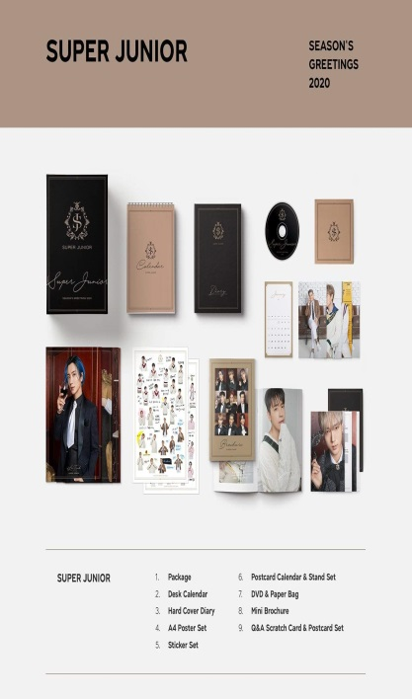 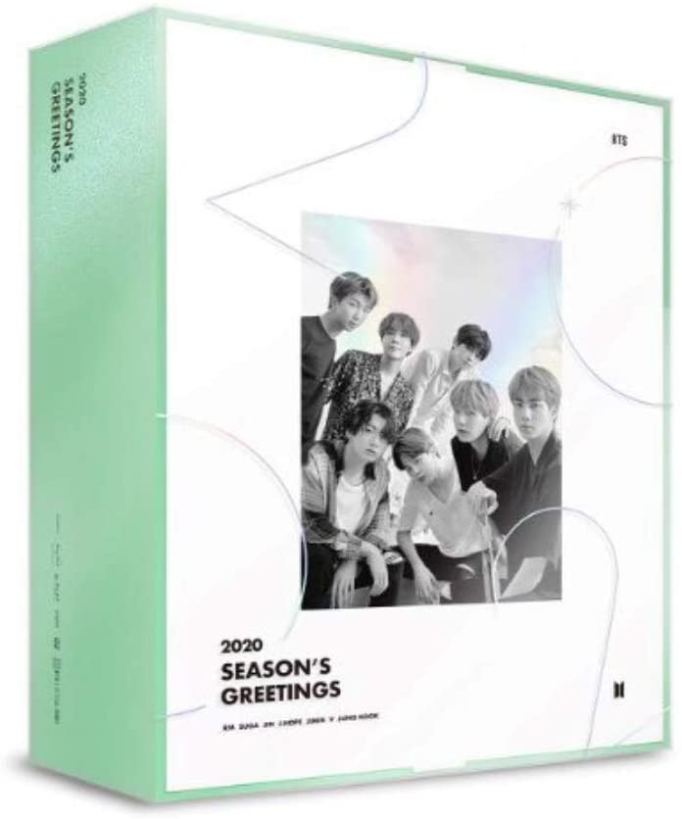 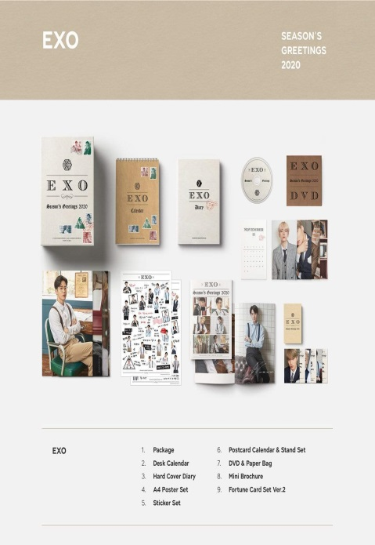

2020 Season’s Greetings: Super Junior (left), BTS (middle), EXO (right) (Source: Google)

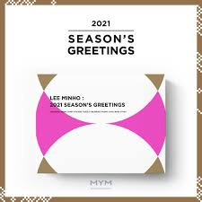 

Season’s Greetings from Korean Actor: Lee Min-Ho (left) and Hyun Bin (right)

(Source: Google)

For more, Korean influence on Indonesian perspectives can also be seen from some instances of popular culture that developing much in Indonesia. Let’s say about drinking coffee habit in Indonesia.

“Let’s go get a cup of coffee!”

People in Indonesia might be very familiar with that kind of sentence. Everyone can say that sentence from blue collar workers, white collar workers, housewives, students, college students, and unemployed people. Coffee has become a part of popular culture in many countries including in Indonesia and Korea. Almost everyone in this world is familiar with going to a coffee shop to just drink a cup of coffee and order snacks along with friends. Their purpose to drink coffee in a coffee shop is varied lots. It can be for the purpose of business meeting, or just hanging out with friends and colleagues, gathering around with families, spending the morning or afternoon time, or even just to getting inspiration for work. This kind of activity is in line with what Cheon & Kim (2010) had once stated that popular culture can be anything that is doing by people in the world and it becomes popular for people from any levels and background. Even any simple things can be a part of popular culture so that popular culture will always develop through time, related to what’s been the trend in certain year or era.

Of course, if people drink coffee and tea both in Indonesia and in Korea; there is still the difference related to popular culture. In Indonesia, besides coffee and tea, people will tend to order mineral water, juice, or soda when they are in a café or restaurant. But in Korea, people will tend to order mineral water and soju to accompany their time in a café or restaurant. Of course, this will be differ in terms of the snacks and food they eat. If you want to look for food that contains pork in Indonesia, you need to ask to the waiters or you can fully aware of the sign put in front of the café or restaurant. But on the other hand, you must look and ask in details in Korea when you are about to find a café or restaurant that will serve you ‘halal’ food and snacks.

Another interesting thing about why Korean wave has been massively impacted the whole Asia including Indonesia is that the tradition in South Korea is still similar to the tradition in Indonesia. It is usual for Korean people to always bow their head to other people especially to those who are older or to those they are appreciate to. And it is very usual to take something from other people by using both hands to express politeness and sincerity. From the research done, those Korean wave fans are mostly coming from those who are categorized as adolescents and young adults. These adolescents and young adults tend to love Korean culture because they still look at the traditional culture of South Korea. They feel like they can learn much from South Korean traditional culture which always put first the tradition and habit of politeness and sincerity, just like what Indonesians do for their values. For more, in most Korean dramas and movies, often appeared the relationship between men and women that is shown to be very traditional and not following the Western relationship where unmarried men and women slept together. But recently, there are several Korean dramas and movies which show that kind of Western relationship even though it is still in the corridor of Eastern culture (Cheon & Kim, 2010).

The next question appeared is that ‘why are international fans so crazy about K-Pop?’. It is strange at first because they don’t even understand the lyrics. There is a strategy from the management that every single K-Pop band has at least one member who can speak good English and answer the interviews outside South Korea. The artists use English name to be easily remembered by the international fans, their songs use English words to make them catchy and being understood by those international fans. It is considered to be a brilliant business plan.

From the first time, K-Pop is becoming so magical that took over the world including Indonesia. When people’s being asked about K-Pop, most of them will imagine about flawless skin, doll-like faces, spectacular outfits, expert choreography, catchy melody, and world-class production. Actually, the fans fell in love with perfection. In South Korea, as we can see, boys are also put on make-up, dye their hair, as well as wear feminine clothes. Also, boys are being portrait not being afraid to cry in public, hug and be sweet to each other while they are on stage. This kind of new masculinity, as mentioned in the Korean music part above, has made fans fell in love with the bromance. That is just one of several reason why K-Pop blew up the whole world.

Another reason is that the South Korean government made it a priority. It all started after a huge financial crisis hit South Korea in the late of 1990s, when President Kim Dae Jung decided to invest to promote South Korean culture through K-Pop, K-Drama, K-Movies, and many more in the entertainment industry. All of those K-Pop artists were training as early as they are just in Junior High School to learn how to sing, how to dance, how to do a rap, even how to behave as Korean idols. Their dedication is quite big as they were just doing the training from early morning until midnight.

Thus, it is not just about good music that brings joy and happiness for the fans all over the world, but also an incredible amount of dedication and hard work. Besides that, the great success of K-Pop is also about a confident approach to being different as well as a brilliant business plan of the government.

To be concluded, the massive success of South Korean popular culture is not a surprise anymore. There are several reasons on why this kind of culture is widely acceptable in some parts of the world including in Indonesia. Despite the fact that all those South Korean popular cultures are fresh and upgrade the quality on a regular basis, the similarities in the term of values and morals that South Korea adhere are regarded to be such big factors that Korean wave is becoming more than just a global phenomenon. Indonesian people see South Korea as one of the developing countries which are rich of traditional culture. And even though this country is quite advanced in the technology, but South Koreans are still worldwidely known as people who are strictly hold onto their traditional morals and values. These kinds of traditional values can easily be seen through many of their drama and movie productions as well as what are shown in the music industry.

**REFERENCES**

Ali Amaran, Mazdan & Lau Mei Wen. (2018). Factors of Watching Korean Drama among Youth in Kuching City, Malaysia. *International Journal of Arts and Commerce.* Vol. 7, No. 7, August 2018.

Allchin, Catherine, M. (2016). *Korean Pancakes are Salty, Savory, Sublime*. The Seattle Times. Retrieved December 5, 2020.

Cheon, S., & Kim, K. (2010). Teaching Korean Culture with Advertisements: Change and Persistence in Family Values and Gender Roles. *The Korean Language in America,* *15*, 1-22. Retrieved February 11, 2021, from <http://www.jstor.org/stable/42922517>.

Cho, Chung-Un. (2012)*.*K-Pop Still Feels Impact of Seo Taiji & Boys. *The Korea Herald*.Retrieved April 12, 2020.

[Hae-Kyung-Chung](https://www.sciencedirect.com/science/article/pii/S2352618116300853" \l "!), [Hye Jeong-Yang](https://www.sciencedirect.com/science/article/pii/S2352618116300853#!), [Dayeon-Shin](https://www.sciencedirect.com/science/article/pii/S2352618116300853#!), [Kyung Rhan-Chung](https://www.sciencedirect.com/science/article/pii/S2352618116300853#!). (2016). Aesthetics of Korean Food: The Symbol of Korean Culture. *Science Direct*.

Han, C. (2011). Korean Wave in China and Perceived Images of Korean Brands. *Business Administration Research*. 40 (4): 1055-1074.

Hartong, Jan Laurens. (2006)*.*[Musical Terms Worldwide: a Companion for the Musical Explorer](https://archive.org/details/musicaltermsworl0000hart)*. Semar Publishers.* p. [15](https://archive.org/details/musicaltermsworl0000hart/page/15). [ISBN](https://en.wikipedia.org/wiki/ISBN_(identifier)) [978-88-7778-090-4](https://en.wikipedia.org/wiki/Special:BookSources/978-88-7778-090-4). Retrieved 28 June 2020*.*

Hong, Euny. (2019). White Hanbok as an Expression of Resistance in Modern Korea. *Journal of the Korean Society of Clothing and Textiles.*

Hong, Karen. (2017). K-Beauty Bar, Flagship Store. London: Oxford Street.

Hongu, Nobuko; Kim, Angela S.; Suzuki, Asuka; Wilson, Hope; Tsui, Karen C.; Park, Sun-min (2017)*.*[Korean Kimchi: Promoting Healthy Meals through Cultural Tradition](https://doi.org/10.1016%2Fj.jef.2017.08.005)*. Journal of Ethnic Foods.* Vol 4 (3): p. 172–180. DOI:[10.1016/j.jef.2017.08.005](https://doi.org/10.1016%2Fj.jef.2017.08.005).

Jang, Dai-Ja; Chung, Kyung Rhan; Yang, Hye Jeong; Kim, Kang-sung; Kwon, Dae Young (2015)*.*[Discussion on the Origin of Kimchi, Representative of Korean Unique Fermented Vegetables](https://doi.org/10.1016%2Fj.jef.2015.08.005)*. Journal of Ethnic Foods.* Vol 2 (3): p. 126–136. DOI:[10.1016/j.jef.2015.08.005](https://doi.org/10.1016%2Fj.jef.2015.08.005).

Jang, J. et al. (2005). *Understanding the Food Culture*. [식생활 문화의 이해]. Seoul: Bomungak. [ISBN](https://en.wikipedia.org/wiki/ISBN_(identifier)) [89-91060-34-X](https://en.wikipedia.org/wiki/Special:BookSources/89-91060-34-X).

JungBong., Choi. (2014)*. K-Pop - The International Rise of the Korean Music Industry*.Hoboken: Taylor and Francis. p. 66–80. [ISBN](https://en.wikipedia.org/wiki/ISBN_(identifier)) [9781317681809](https://en.wikipedia.org/wiki/Special:BookSources/9781317681809). [OCLC](https://en.wikipedia.org/wiki/OCLC_(identifier)) [890981690](https://www.worldcat.org/oclc/890981690).

Kelley, Caitlin. (2019)*. K-Pop Is More Global Than Ever, Helping South Korea's Music Market Grow Into A 'Power Player’.*[Forbes](https://en.wikipedia.org/wiki/Forbes). Retrieved August 24, 2020.

Kim, B., Han, S., & Yoon, S. (2010). Advertising Creativity in Korea: Scale Development and Validation. *Journal of Advertising,* *39*(2), 93-108. Retrieved February 11, 2021, from <http://www.jstor.org/stable/20720469>.

Kim, D., Cho, S., and Jung, G. (2014). Wave of Home Culture and MNC Performance: The Korean Wave (Hallyu). *International Marketing in Rapidly Changing Environments*. 24: 193-216.

Kim, Violet. (2012). *Food Map: Eat Your Way Around Korea*. Wayback Machine CNN Go, April 6, 2012.

Ko, J.M. (2009). *The Korean Wave, Beyond Asia and into the World*. Korea Foundation International Culture Exchange.

Korea Tourism Organization. (2012). Korea Statistical Report on Tourism Interim, 2012, Osgoomunwha Sa.

Laurie, Timothy (2016)*, Toward a Gendered Aesthetics of K-Pop, Global Glam and Popular Music: Style and Spectacle from the 1970s to the 2000s*.p. 214–231.

Lee, W.H. (2011). A Research on Policy Direction for Voluntourism. *Korea Culture and Tourism Institute*.

Lee, Yeun Ja. (2010). Jongga Ancestral Rituals and Food Culture. *Koreana*, Vol 24, No.2, Summer 2010.

Lintaro, Lin. (2019). Why Korea is More Than just K-Pop in Indonesia. *All Asia Affair.* November 29, 2019.

McDougall, Andrew. (2019). *The Popularity of Korean Beauty Trends*. Mintel.

Mejia, Naydeline. (2020). *K-Beauty Products*. Sephora Official Website.

Parc, Jimmyn & Chang-Moon Hwy. (2013). Korean Dramas and Films: Key Factors for Their International Competitiveness. *Asian Journal of Social Science*.

Ravina, M. (2009). Introduction: Conceptualizing the Korean Wave. *Southeast Review of Asian Studies*. 31: 3-9.

Roy, Christian. (2005).[Traditional Festivals: A Multicultural Encyclopedia](https://books.google.com/books?id=IKqOUfqt4cIC&q=songpyeon+%22pine+needles%22&pg=PA285)*.*[*ABC-CLIO*](https://en.wikipedia.org/wiki/ABC-CLIO)*.* p. 285. [ISBN](https://en.wikipedia.org/wiki/ISBN_(identifier)) [978-1-57607-089-5](https://en.wikipedia.org/wiki/Special:BookSources/978-1-57607-089-5).

Russon, Mary-Ann. (2018). *K-Beauty: The Rise of Korean Make-Up in the West*. BBC News.

Ryun, Chang Dae. (2007). The “We-Me” Culture: Marketing to Korean Consumers. Cross Cultural Buyer Behavior Advances in International Marketing. *Elsevier* Vol. 18 p. 141-157.

Sang-Pil Han & Sharon Shavitt. (1994). Persuasion and Culture: Advertising Appeals in Individualistic and Collectivistic Societies. *Journal of Experimental Social Psychology*.

Shim, D. (2006). Hybridity and The Rise of Korean Popular Culture in Asia. *Media, Culture, and Society*. 28 (1): 25-44.

Song, Cheol-min. (2016)*.*[K-Pop Beyond Asia](https://books.google.com/books?id=j8lxCwAAQBAJ). *Korea: 길잡이미디어.* p. 37–46. [ISBN](https://en.wikipedia.org/wiki/ISBN_(identifier)) [9788973755981](https://en.wikipedia.org/wiki/Special:BookSources/9788973755981).

Thomas, Katie. (2017). *Korean Beauty in the West*. Marie Claire Magazine, October 3rd 2017.

Tri Rahmawati, Chatarina. (2020). The Massive Korean Wave in Indonesia and Its Effect in the Term of Culture. *Research Gate*. p. 1-5, November 2020.

Yoon, Alesia. (2018). *Korean Beauty Influences the World*. Peach & Lily.

[20 Years of K-Pop at Billboard](http://www.billboard.com/articles/columns/k-town/8532755/k-pop-billboard-20-years)*. Billboard, October 11, 2019*. Retrieved April 18, 2020.

*Easy Korean Food: Learn about Korean Cooking and Cuisine with Recipes & Pictures.*Retrieved from www.easykoreanfood.com.

Food in Korea. *asianinfo.com*. Retrieved January 16, 2020.

[Korean Food Culture Series – Part 7: Local Foods](http://english.visitkorea.or.kr/enu/SI/SI_EN_3_6.jsp?gotoPage=1&cid=259623)*.*[*Korea Tourism Organization*](https://en.wikipedia.org/wiki/Korea_Tourism_Organization)*.* Retrieved February 28, 2020.

[K-Pop Music: For the Eyes or For the Ears?](http://seoulbeats.com/2011/10/k-pop-music-for-the-eyes-or-for-the-ears/)*. Seoulbeats, October 1, 2019.* Retrieved March 27, 2020.

North Korean Beer: Great Taste, Low Proliferation Risk. *Reuters, March 9, 2018.* Retrieved June 20, 2020.

So[uth Korea's Pop-Cultural Exports: Hallyu, Yeah!](https://www.economist.com/asia/2010/01/25/hallyu-yeah). *The Economist.* January 25, 2020. Retrieved March 23, 2020.

The Root of K-Pop: The Influences of Today's Biggest Acts. *Billboard*. Retrieved July 16, 2020.

[차](https://web.archive.org/web/20110610072510/http:/100.nate.com/dicsearch/pentry.html?s=K&i=241842&v=42) [Tea (cha)] (in Korean)*.* [*Encyclopedia of Korean Culture*](https://en.wikipedia.org/wiki/Encyclopedia_of_Korean_Culture)*.* Archived from [the original](http://100.nate.com/dicsearch/pentry.html?s=K&i=241842&v=42) on 10 June 2018. Retrieved October 23, 2020.

<https://n.news.naver.com/mnews/article/018/0004839729?sid=103&lfrom=twitter>

<https://www.90daykorean.com/korean-culture/>

<http://www.koreanculture.org/korea-information-culture-and-the-arts>

<https://www.sciencedirect.com/science/article/pii/S2352618116300853>

<https://www.sephora.co.id/pages/korean-beauty-products>

<https://www.bbc.com/news/business-45820671>

<https://www.elle.com/uk/beauty/skin/a25415/k-beauty-what-is-it-korean-beauty-10-step-beauty-cleansing-skincare/>

<https://www.lyfcosmeticsuk.com/the-truth-about-korean-skincare>

<https://www.whowhatwear.com/korean-fashion-trends>

<https://highstylife.com/why-korean-fashion-is-so-popular/>

<https://www.cosmopolitan.co.id/article/read/8/2020/21447/ini-10-selebriti-korea-yang-jadi-bintang-iklan-di-indonesia>

[http://www.allbusiness.com/marketing/advertising/316226-1.html](https://www.allbusiness.com/marketing/advertising/316226-1.html)

<http://wcownews.typepad.com/globalmedia/2010/02/gender-role-and-race-portrayals-in-american-and-korean-advertisement.html>

<https://pmb.lipi.go.id/survey-result-k-drama-consumption-amidst-covid-19-pandemic-in-indonesia/>

<https://www.visitkorea.or.id/>

<https://english.visitkorea.or.kr/enu/ATR/SI_EN_3_6.jsp?cid=2469608>

<https://en.wikipedia.org/wiki/Music_of_Korea>

<https://en.wikipedia.org/wiki/K-Pop>

<https://en.wikipedia.org/wiki/Korean_Wave>

<https://en.wikipedia.org/wiki/Korean-Television_Drama>

<https://en.wikipedia.org/wiki/Korean_Influence_on_Indonesian_Culture>

<https://en.wikipedia.org/wiki/Korean_Influence_on_Japanese_Culture>

<https://en.wikipedia.org/wiki/Culture_of_Korea>

<https://en.wikipedia.org/wiki/Fashion_in_Korea>

<https://en.wikipedia.org/wiki/Advertising_in_South_Korea>