**THE EFFECT OF READING LOG IN EXTENSIVE READING**

**CLASS BY STUDENTS PREFERENCE**

**ACH. SYAFIRUL HENDRIAWAN**

[**hendriawann01.@gmail.com**](mailto:hendriawann01.@gmail.com) **; mariyatulkiptiyah@stkippgri-bkl.ac.id**

# ABSTRACT

Ach.Syafirul Hendriawan . 2024. The Effect Of Reading Log In Extensive Reading Class By Students Preferences. Supervisor: Mariyatul Kiptiyah, M.Pd.

Keywords: Reading Log In *,Extensive Reading, students’ preference.*

In learning English, there are four skills. They are speaking, reading, listening, and writing. The four skills mentioned are divided into receptive and productive skills. Speaking and writing are productive skills, while listening and reading are receptive skills. Beside the four language skills above, reading is a great importance to students to get knowledge and information in human life, especially in students’ preference.

Extensive reading is reading as much as possible, for one’s own pleasure, at a difficulty level at which one can read smoothly and quickly. In the domain of reading, this paper investigates the effect of extensive reading from e-books, through utilizing a number of downloadable reading application programs on the students’ e-devices, as opposed to traditional book-reading in an ESL context.

**ABSTRAK**

Ach.Syafirul Hendriawan. 2024. Pengaruh Membaca Log Di Kelas Membaca Ekstensif Terhadap Preferensi Siswa. Pembimbing : Mariyatul Kiptiyah, M.Pd.

Kata Kunci: Membaca Log In, Membaca Ekstensif, preferensi siswa.

Dalam belajar bahasa Inggris, ada empat keterampilan. Yaitu berbicara, membaca, mendengarkan, dan menulis. Keempat keterampilan tersebut terbagi menjadi keterampilan reseptif dan produktif. Berbicara dan menulis merupakan keterampilan produktif, sedangkan mendengarkan dan membaca merupakan keterampilan reseptif. Selain keempat keterampilan berbahasa di atas, membaca juga sangat penting bagi siswa untuk memperoleh pengetahuan dan informasi dalam kehidupan manusia, terutama yang disukai siswa.

Membaca ekstensif adalah membaca sebanyak-banyaknya, untuk kesenangan diri sendiri, pada tingkat kesulitan dimana seseorang dapat membaca dengan lancar dan cepat. Dalam bidang membaca, makalah ini menyelidiki pengaruh membaca ekstensif dari e-book, melalui pemanfaatan sejumlah program aplikasi membaca yang dapat diunduh pada perangkat e-siswa, dibandingkan dengan membaca buku tradisional dalam konteks ESL.

**INTRODUCTION**

In learning English, there are four skills. They are speaking, reading, listening, and writing. The four skills mentioned are divided into receptive and productive skills. Speaking and writing are productive skills, while listening and reading are receptive skills. Beside the four language skills above, reading is a great importance to students to get knowledge and information in human life, especially in students’ preference.

According to Akbar et al. (2015), Extensive reading is reading as much as possible, for one’s own pleasure, at a difficulty level at which one can read smoothly and quickly. In the domain of reading, this paper investigates the effect of extensive reading from e-books, through utilizing a number of downloadable reading application programs on the students’ e-devices, as opposed to traditional book-reading in an ESL context.

In the context of teaching language, a suitable teaching approach in the classroom affects teaching reading to language learners to be successful. The extensive reading can be used as an alternative approach to teach reading which provides many advantages for language learners specially to foster their reading skills. Many researchers have been conducted the extensive reading study, however, the majority of existing studies about the solution to teach language using extensive reading does not appear to be helpful to find students’ preference from the component of extensive reading. Therefore, this present qualitative study attempts to explore students’ preferences in the component of extensive reading. The findings present that the highest students' preference from the component of extensive reading is easy reading. Meanwhile, the smallest students’ preference from the component of extensive reading is about teacher orientation & guide. A future researcher is suggested to study extensive reading in other aspects besides exploring students' preference to increase the quality of next extensive reading implication to be better.

While according to Aulia (2019), as the concept of Extensive Reading is widely for pleasure, the reading logs the students construct in this study are used to record what the students have read during Extensive Reading activity. There is no interruption on any exercises they should do like reading comprehension question or getting the meaning of difficult words should be consulted to dictionary.

# RESEARCH METHOD

In this part, the writer describes about research methodology that was used in conducting the study. It is purposed to answer the problem of the study. This chapter consists of research type, research design, variables of the study, population and sample, research instrument, data collecting, data analysis, and data analysis procedure.

1. Research Design

The design of the study was quasi-experimental design. Experimental design is a plan for an experiment that specifies what independent variables will be applied, the number of levels of each, how subject are assigned to groups, and the dependent variable. The write used quasi- experimental design since it was not possible to randomly assign subjects to treatment group.

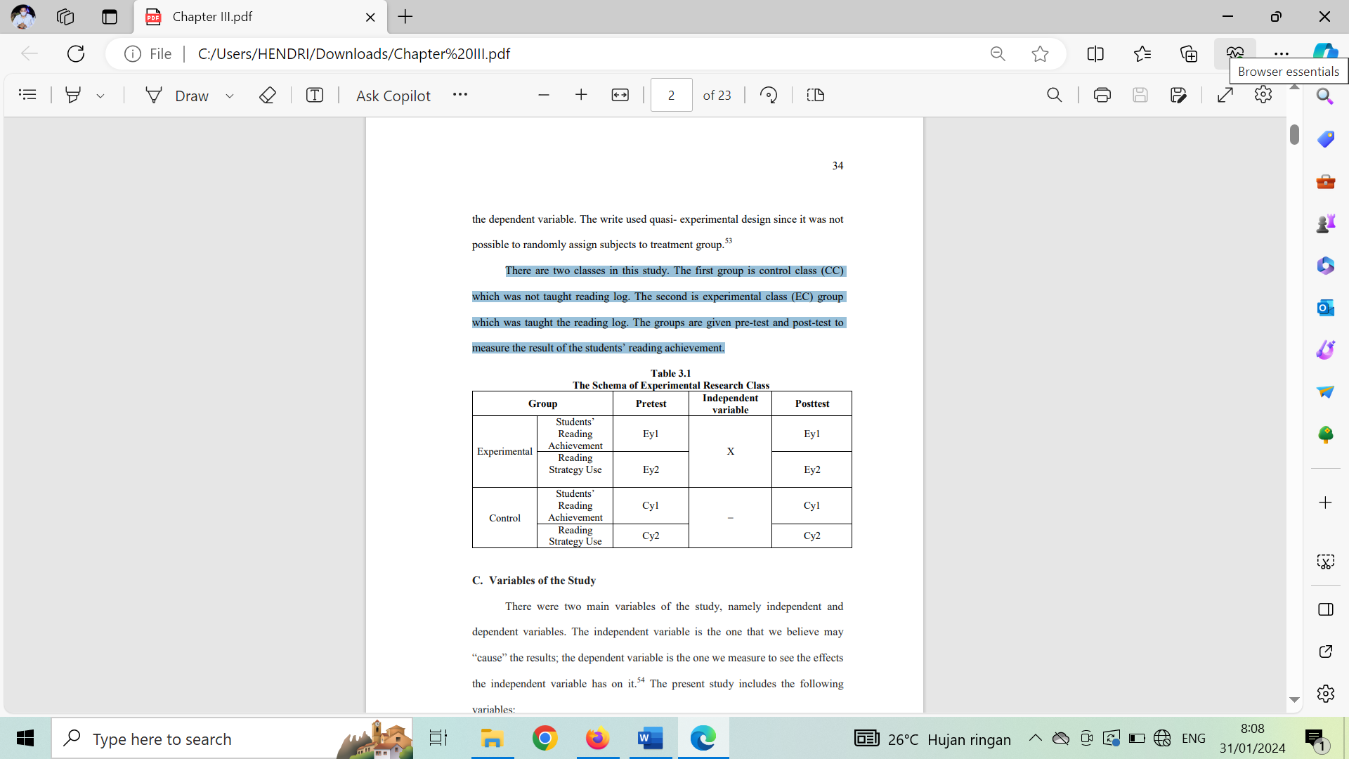There are two classes in this study. The first group is control class (CC) which was not taught reading log. The second is experimental class (EC) group which was taught the reading log. The groups are given pre-test and post-test to measure the result of the students’ reading achievement.

1. Variables of the Study

There were two main variables of the study, namely independent and dependent variables. The independent variable is the one that we believe may “cause” the results; the dependent variable is the one we measure to see the effects the independent variable has on it.The present study includes the following variables:

1. The independent variable (X) of this study was reading log.
2. The dependent variables (Y) of this study were the result of students’ reading achievement (Y1) and students’ reading strategy (Y2).
3. Population and Sample
4. Population

The larger group about which the generalization is made is called population. A population is defined as all members of any well-defined class of people, events, or objects. The population of this study was all students of the second semester students who learn English language of SMAN 1 Kwanyar. The numbers of population were 75 students and 36 students becomes sample in this research. They were classified into four classes:

**Table 3.2**

**The Number of the second Semester Students at English Education Study Program in SMA N 1 KWanyar**

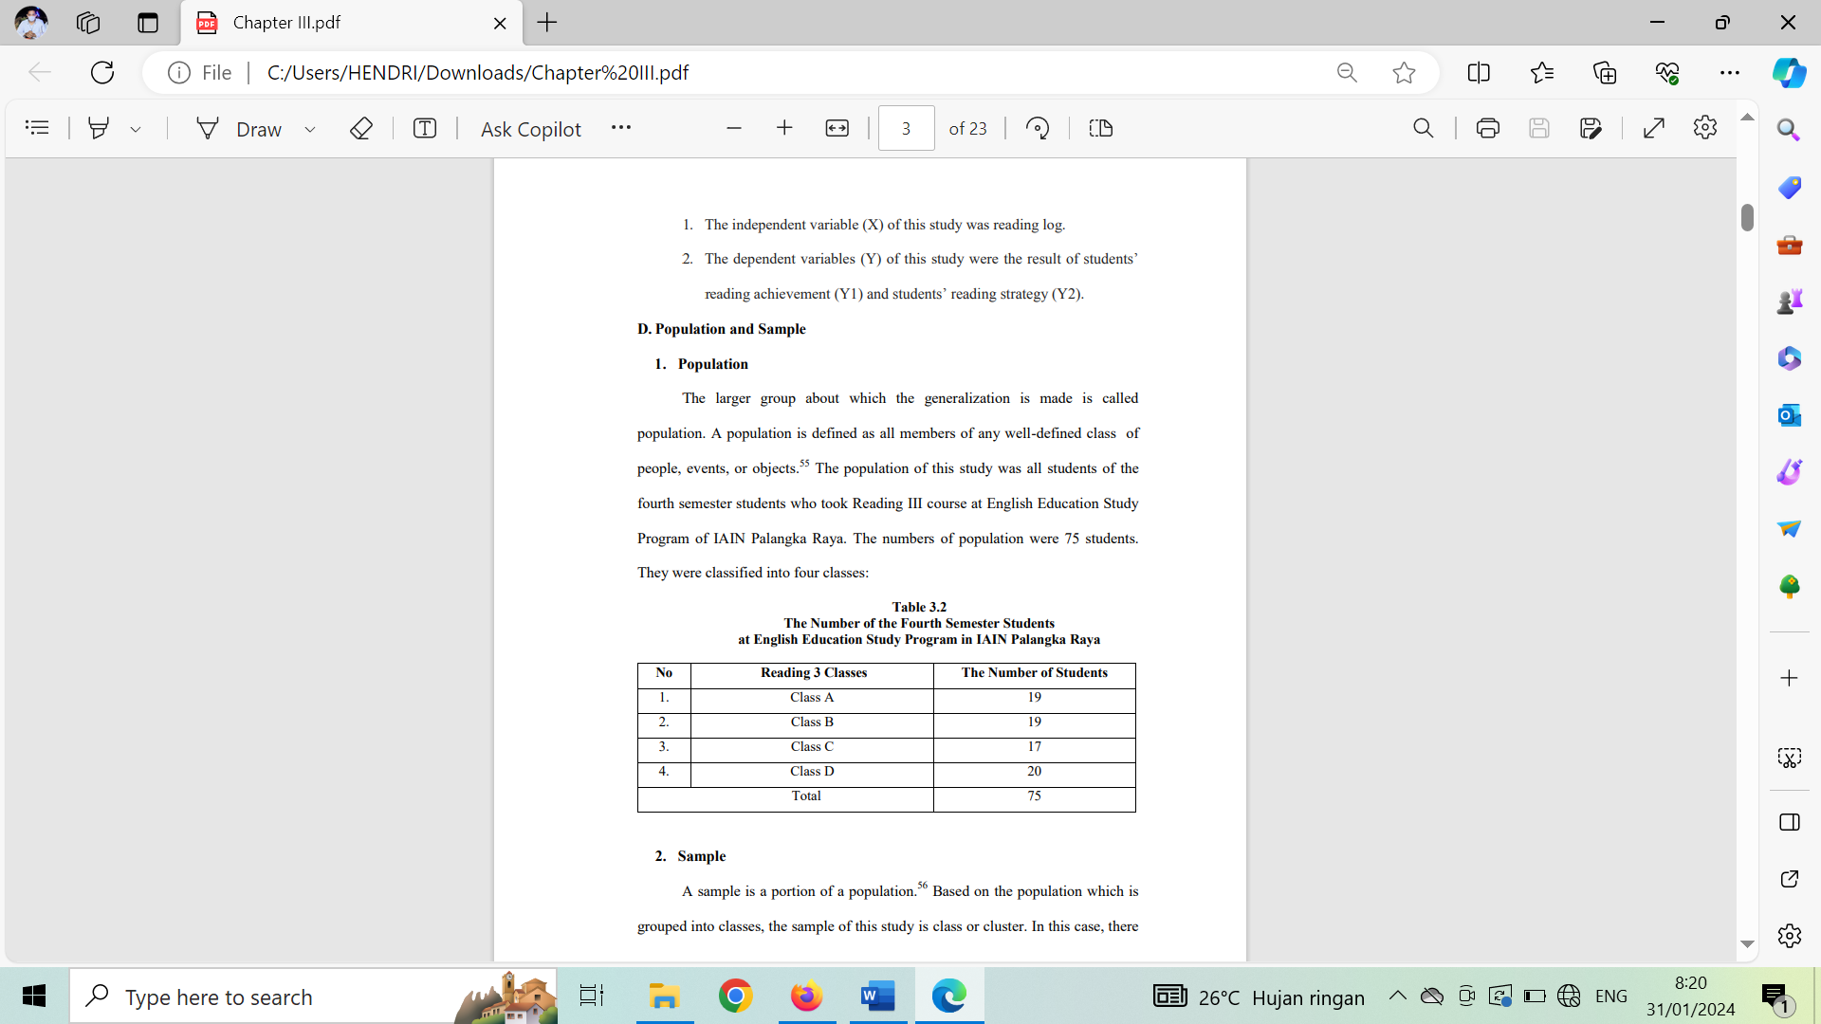

1. Sample

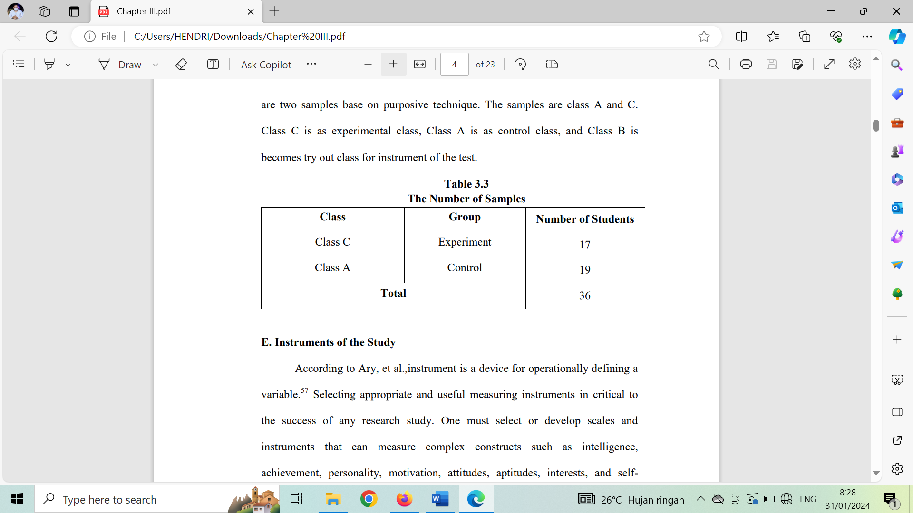A sample is a portion of a population.Based on the population which is grouped into classes, the sample of this study is class or cluster. In this case, there are two samples based on purposive technique. The samples are class A and C. Class C is as experimental class that consists of 17 students, while Class A is as control class that consists of 19 students, and Class B is becomes try out class for instrument of the tescontrol class, and Class B is becomes try out class for instrument of the test.

1. Instrument of The Study

According to [P Jirajarupat](https://scholar.google.com/citations?user=R9txf_sAAAAJ&hl=id&oi=sra), Z Yinghua (2023), instrument is a device for operationally defining a variable”. Selecting appropriate and useful measuring instruments in critical to the success of any research study. One must select or develop scales and instruments that can measure complex constructs such as intelligence, achievement, personality, motivation, attitudes, aptitudes, interests, and self concept.

There were two instruments used in this study, namely, test and questionaire:

1. **Test**

According to James T. Heaton (2023), Test may be constructed primarily as devices to reinforce learning and to motivate student, or primarily as a means of as seeing the student's performance the language. The major data in this study was the data of the students’ reading achievement score took from pre-test and post-test. Pre-test to was conducted to find out the students’ reading achievement before the treatment given, while post test was conducted to find out the students’ reading achievement after the treatment given.

The test constructed in **multiple choice** form which consist of 10 items. The test item can be seen in the following table 3.4 ( Level of Comprehension Test Items).

|  |  |  |  |
| --- | --- | --- | --- |
| No | Level of Comprehension | Item | Percentage |
|  | Literal | 5 | 50% |
|  | Inferensial | 5 | 50% |
|  | Total | 10 items | 100% |

The reason why the test item was constructed in multiple choice form was because multiple choice is objective test. Objective test are frequently criticised on the grounds that they are simpler to answer than subjective examinations. Item in an objective test, however, can be made just as easy or as difficult as the test constructor wishes. Beside of having the strength, a test in form of multiple choice also has a weakness. Multiple choice test type encourages guessing. It can be solved by doing try out of the test items to find out the test validity and reliability.

Because this test used 10 items test in the form of multiple choice, the writer gave score to the students’ result test by using the formula:

$$\text{Score}=\frac{B}{N}\text{x100\%}$$

Where:

B : Frequency of the correct answers

N : Number of test items In connection with the score of students’ test, the writer used scoring rubric as seen in table 3.5 as follows:

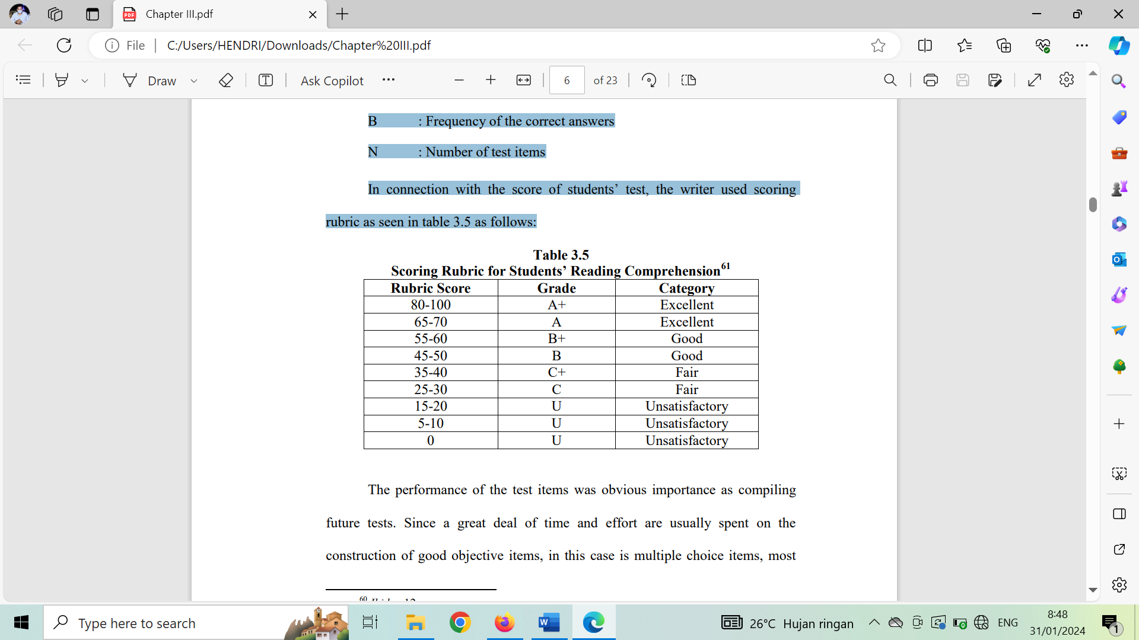

The performance of the test items was obvious importance as compiling future tests. Since a great deal of time and effort are usually spent on the construction of good objective items, in this case is multiple choice items, most teachers and test constructors will be desirous of either using them again without further changes or else adapting them future use. It is thus useful to identify these items which were answered correctly by the more able students taking the test and badly by the less able students. The identification of certain difficult items in the test, together with a knowledge of the performance of the individual distractors in multiple choice items, can prove just as valuable in its implications for teaching for testing.

1. Pretest

It is use before the students get some explanation about reading log. It consist of 10 multiple choice task.

1. Post Test

It is use after the students get some comprehension about reading log, the teacher give same question each other.

1. Research Instrument Validity

The validity of a test is the extent to which it measures what is supposed to measure and nothing else. The test can be said valid if it is able to measure what it is suppose to be measure.

* Content validity

Content Validity is concerned with what goes into the test. A test will have high content validity if the items are representative of the population of possible task. The content of a test should be decided by considering the purpose of the assessment and then drawn up as a list known as a content spesification.The instrument must be valid in content. It means that the items in the instrument are equal and proportional in their distribution as the indicators of the test.

* **Construct Validity**

According to Heaton (2023), construct validity assumes the existence of certain learning theories and constructs underlying the acquisition of abilities and skills. If a test has construct, it is capabel of measuring certain specific characteristics in accordance with a theory of language.The validities done in order to know the degree of the validity of the test items based on the coefficient correlation.

So that, construct validity to measure the valid test. The teacher giving reading test, explained what is reading about, and then the teacher giving the test one by one for the students.

VHV = 0,80 – 1.00

HV = 0,60 – 0,80

V = 0,40 – 0,60

LV = 0,20 – 0,40

VLV = 0,00 – 0,20

Validity testing is carried out for find out whether the student learning outcomes test valid or not. Internal validity testing This research was conducted using scale technique using SPSS version 25. Following is the result of validity testing obtained:

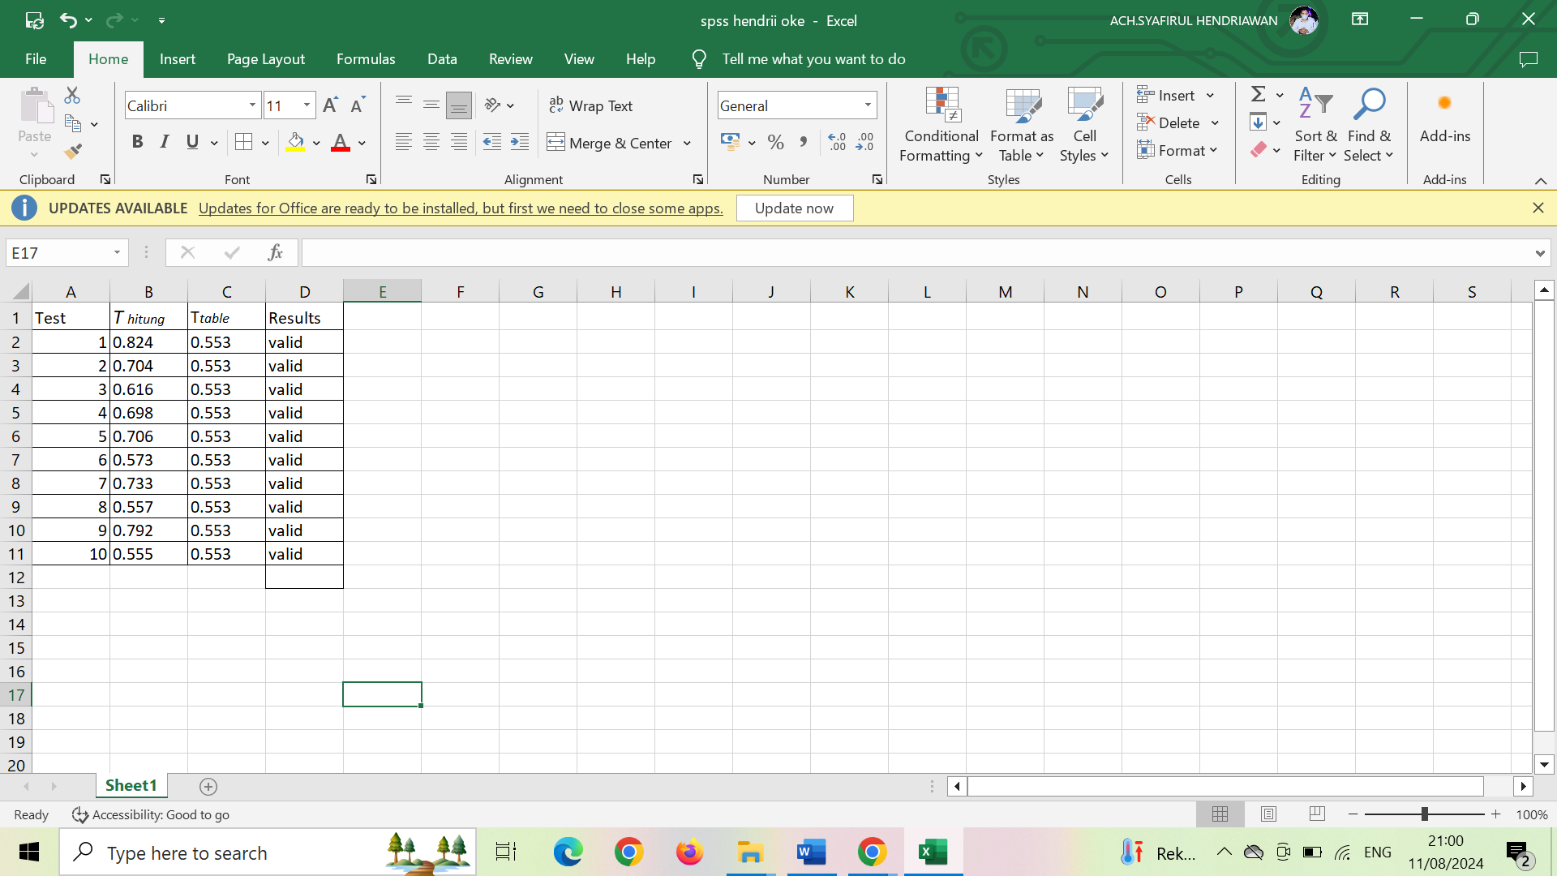 **Student Validity Test Data**

Based on Table above, test results validity which consists of 10 question items. From the results Validity calculations can be seen that rhitung > rtable contains 10 question items that are declared valid. Based on the r Product moment table in the attachment significant 5%, it is known that the rtable is 0.557 so that the items of each questionnaire scale consist of 10 question items were declared valid.

1. Research Instrument Reliability

According to Azwar (2010), reliability refers to consistency measurements that contain the meaning of accuracy measurement. Unreliable measurements will produce scores that do not can be trusted because of differences in scores produced by individuals influenced by an error factor rather than a difference factor indeed an instrument is said to be reliable if it can be trusted to collect research data.

The instrument is a reliable instrument when used several times to measure the same object, will generate the same data. Measuring tool of rubber are examples of instruments that are not reliable/consistent. In this research, the reliability will use Alpha Cronbach’s formula and it will be calculated in the SPSS (Statistical Product and Service Solution) Version 16.0 for Windows in order to 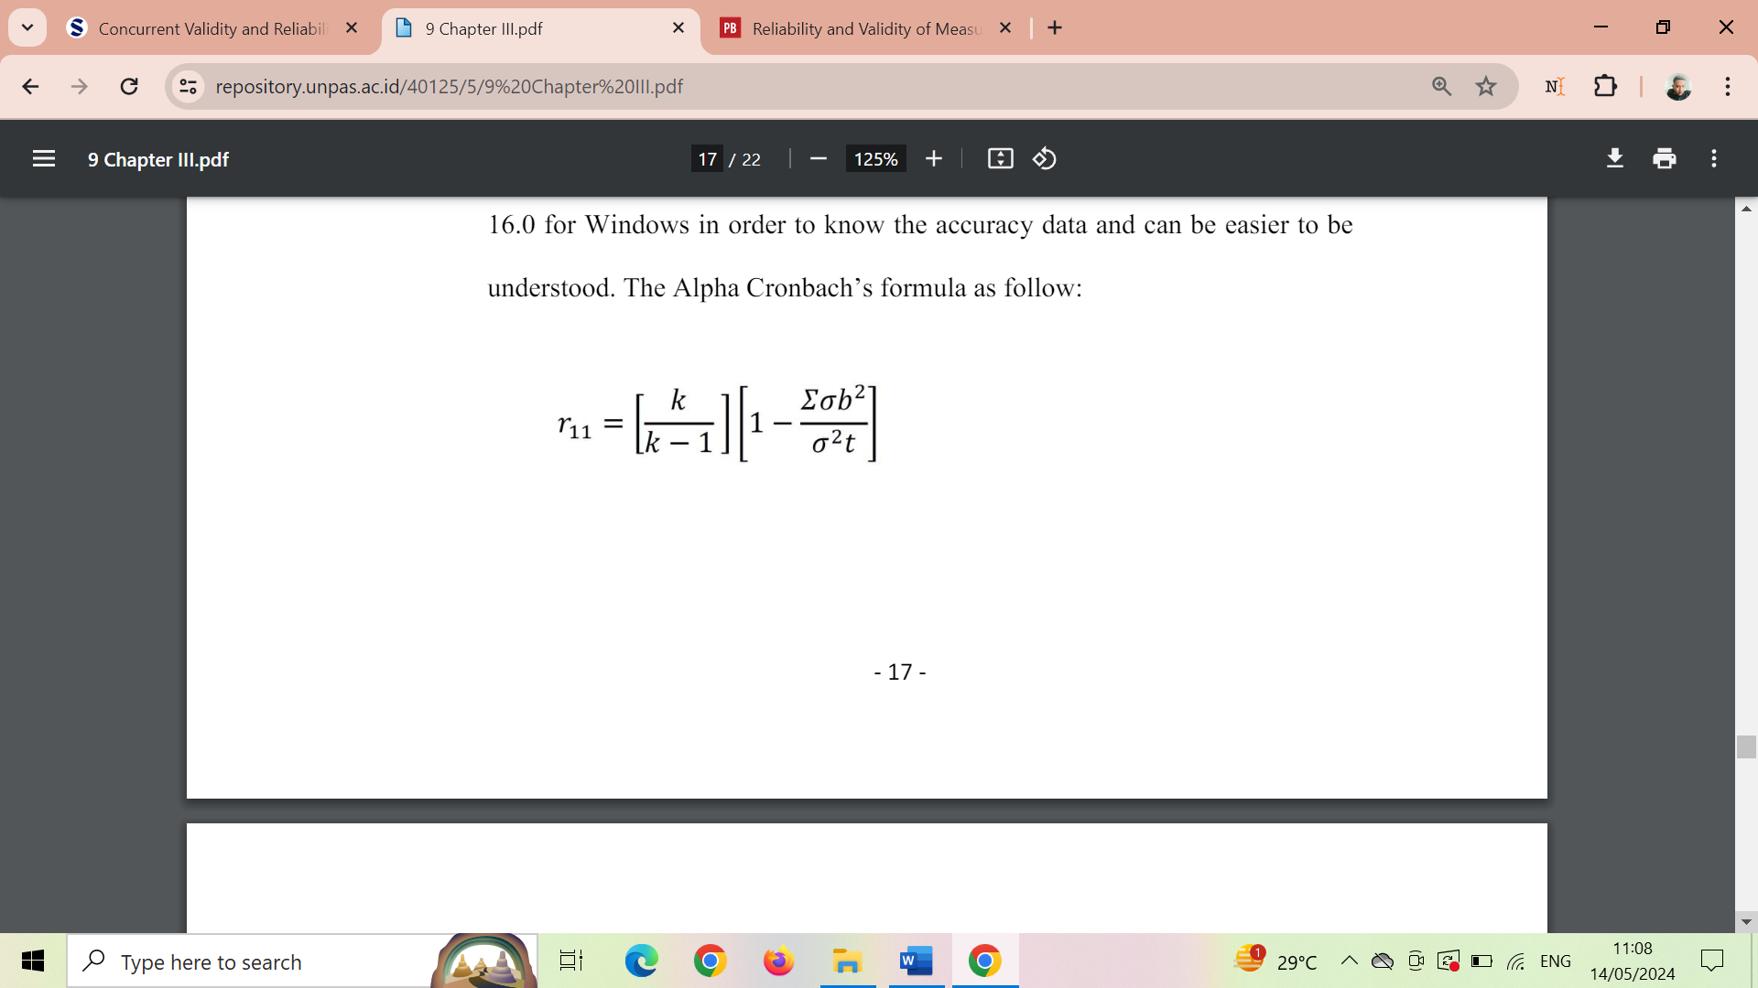know the accuracy data and can be easier to be understood. The Alpha Cronbach’s formula as follow:

a. 𝑟11 = Reliability Instrument

𝑘 = amount of item question

𝛴𝜎𝑏2 = Sum of variant item question

𝜎2𝑡 = Variant Total

According to Sekaran and Bougie (2013), said that reliability value which less than the number of 0.60 is considered poor, and the average of 0.70 can be accepted, whereas value which is more than 0.80 is considered good. To determine that the statement items are reliable, it can be compared between r alpha and r table. If r alpha is more than r table (0.444), it means that this statement items are reliable. This research uses software SPSS Statistics Version 16.0 for Windows to ease and minimize a miscalculation in calculating the reliability on processing the data. The criteria index reliability as follow:

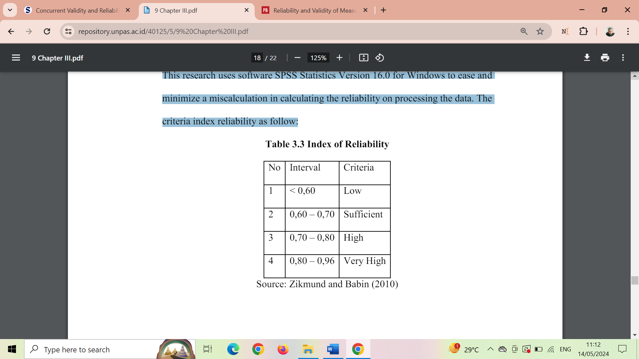

Reliability tests were carried out on items questions declared valid. This test is carried out to measure whether the question items are consistent or not in research used to measure student learning outcomes. As for the analysis tools using the scale technique using ***SPSS Version 25*.** Before testing Reliability must be the basis for decision making namely an alpha of 0.60 for the variable considered reliable if the value of the variable is greater than 0.60 if it is smaller then the 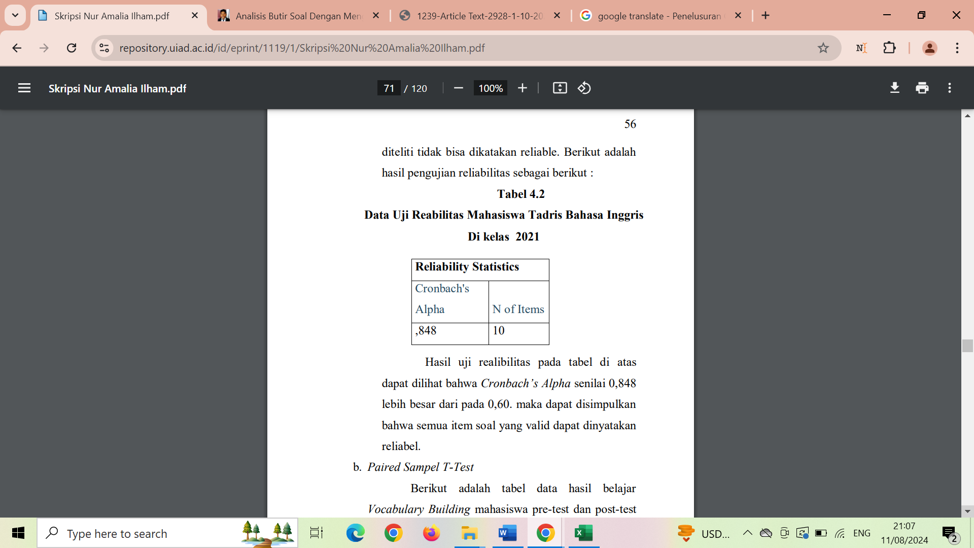variable that has been studied cannot be said to be reliable.

Reliability test results in the table above It can be seen that Cronbach's Alpha is 0.848 greater than 0.60. then it can be concluded that all valid question items can be stated reliable.

1. Technique of Data Collection

Data collection techniques are considered important for the success of the research. It involves with the way to collect the data, who the source is, and what instrument to use. The type of data source is primary data which means the data is collected immediately from the respondent. The primary source is a data source that directly provide data to data collectors. The instrument is taken from the questionnaire which distribute to the active students at senior high school SMAN 1 Kwanyar. The data collecting execution, will use questionnaire which will be shared on the paper. This purpose is in hope to make them easier, in order to be some valid and reliable statements that they should answer. The observation method will use reading log.

1. Data Analysis and Hypothesis Test
2. Data Analysis

Data processing techniques in this study use a computation calculation SPSS (Statistical Product and Service Solution) Version 16.0 for Windows because this program has a high statistical ability and the data - 20 - management system in the graphical environment use a simple descriptive menus and dialog boxes so making it easy to understand how the operation (Sugiyanto, 2012). The analytical method used in this research is Descriptive Analysis Percentage. This percentage descriptive is processed by frequency divided by the number of respondents and multiplied by 100 percent, as stated Sudjana (2001: 129) are as follow:

**P = f/N x 100%**

Description:

P = Percentage

f = Frequency

N = Number of Respondents

100% = Constant Number

The calculation of this descriptive percentage as follows:

a. Correcting the questionnaire answers from respondents.

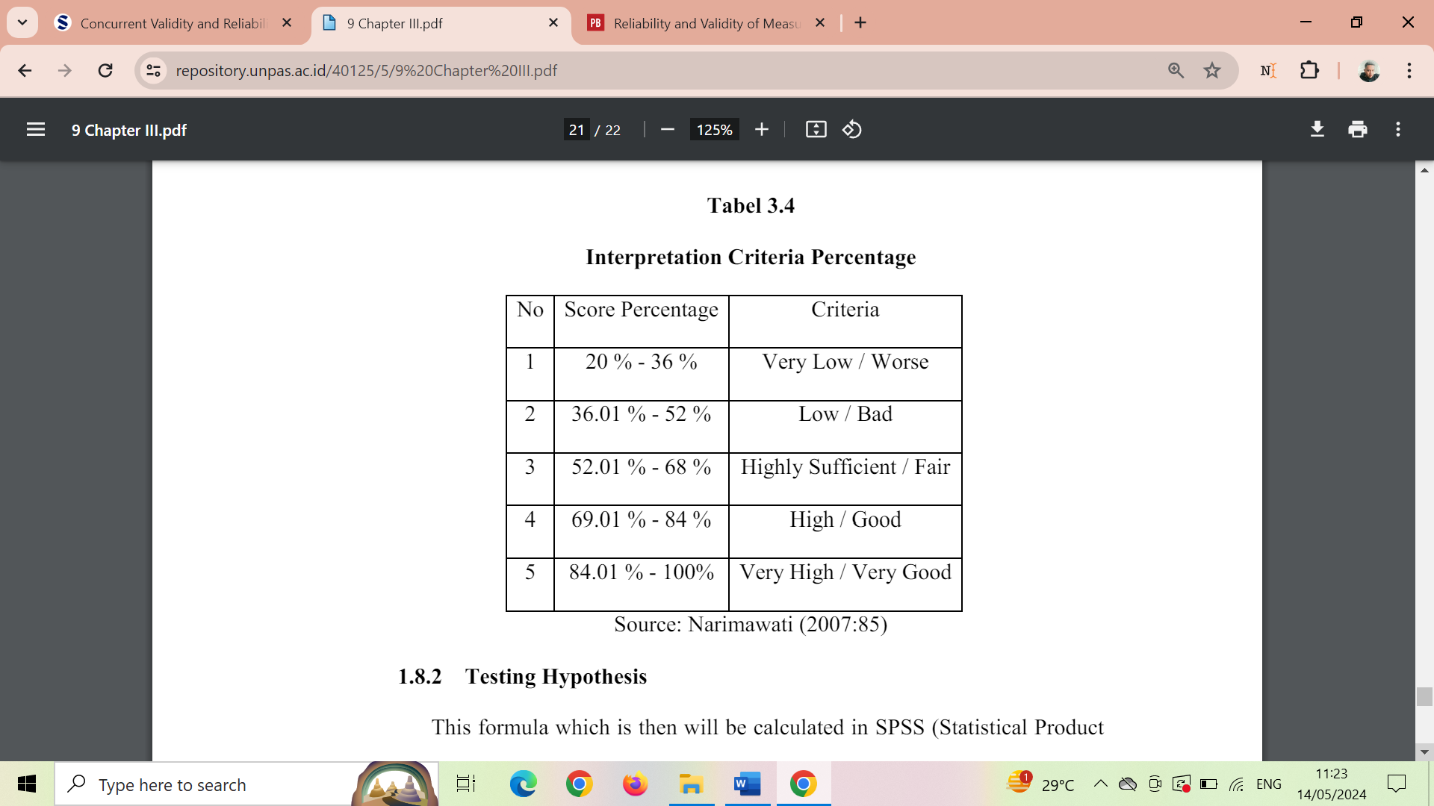b. Calculating the frequency of respondent's answers

c. The overall number of respondents

d. Insert into the formula

e. Interpret the result with the table below

1. **Hypothesis**

This formula which is then will be calculated in SPSS (Statistical Product and Service Solution) Version 16.0 for Windows program that in the end will be taken the decision by comparing the ρ_count and ρ_table (ρ= rho) as we can see from the determining statistical hypothesis as follow:

H0: There is no correlation between The Interest in Practicing English conversation on the speaking fluency

Ha: There is a positive and significant correlation between The Interest in Practicing English conversation on the speaking fluency

Reject H0 and Accept Ha if ρ_count > ρ_table

Accept H0 and Reject Ha if ρ_count ≤ ρ_table

Before determining the hypothesis, the critic value of ρ_table should be known in advance. It is used as the standard of ρ_table which will then be compared with ρ_count. The method to know the critic value of ρ_table is by using the degree freedom = n-2 (df = n-2) formula with a significant level of 5 % or equal to 0.05. Then, to interpret the coefficient correlation between both of the variable, it is used the table criteria as follow:

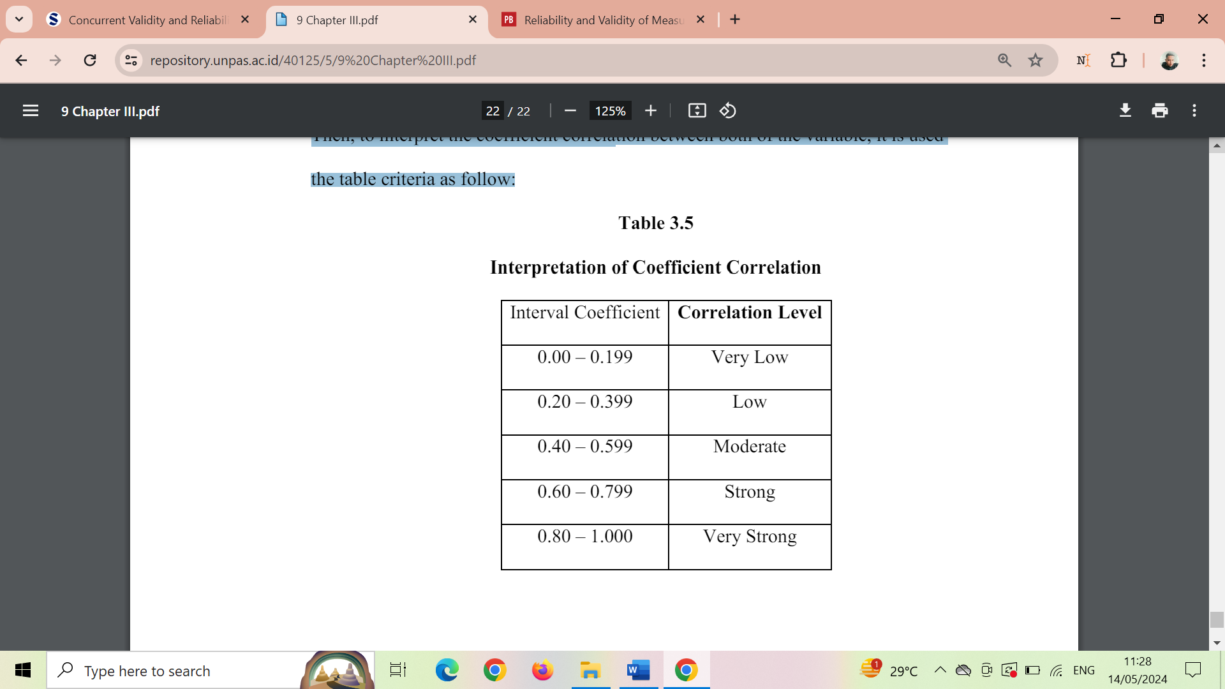

# RESULT OF THE STUDY

In this chapter, the writer presents the data which had been collected from the research in the field of study which consists of description of the data, result of data analysis, and discussion.

1. Descriptions of the Data
2. The Result of Pre-Test and Post Test Score Students’ Reading Achievement of the Experiment and Control Class.
3. The Result of Pre-Test and Post Test Score of Students’ Reading Achievement in the Experiment Class.

The pre-test at the experiment class had been conducted in class C with the number of student was 17 students on Wednesday , 1th May 2024. Then the post test at the experiment class had been conducted in class C with the number of student was 17 students on Wednesday , 17th May 2024. The pre-test and post test score of students’ reading achievement were presented in table 4.1 below

**Table 4.1 the Result of Pre-Test and Post Test Scores of Students’ Reading Achievement in Experiment Class**

|  |  |  |  |  |  |  |  |  |  |  |  |  |  |  |  |  |  |  |  |  |  |  |  |  |  |  |  |  |  |  |  |  |  |  |  |  |  |  |  |  |  |  |  |  |  |  |  |  |  |  |  |  |  |  |  |  |  |  |  |  |  |  |  |  |  |  |  |  |  |  |  |  |  |  |  |  |  |  |  |  |  |  |  |  |  |  |  |  |  |  |  |  |  |  |  |  |  |  |  |  |  |  |  |  |  |  |  |  |  |  |  |  |  |  |  |  |  |  |  |  |  |  |  |  |  |  |  |  |  |  |  |  |  |  |  |  |  |  |  |  |  |  |  |  |  |  |  |  |  |  |  |  |  |  |  |  |  |  |  |  |  |  |  |  |  |  |  |  |  |  |  |  |  |  |  |  |  |  |  |  |  |  |  |  |  |  |  |  |  |  |  |  |  |  |  |  |  |  |  |  |  |  |  |  |  |  |  |  |  |  |  |  |  |  |  |  |
| --- | --- | --- | --- | --- | --- | --- | --- | --- | --- | --- | --- | --- | --- | --- | --- | --- | --- | --- | --- | --- | --- | --- | --- | --- | --- | --- | --- | --- | --- | --- | --- | --- | --- | --- | --- | --- | --- | --- | --- | --- | --- | --- | --- | --- | --- | --- | --- | --- | --- | --- | --- | --- | --- | --- | --- | --- | --- | --- | --- | --- | --- | --- | --- | --- | --- | --- | --- | --- | --- | --- | --- | --- | --- | --- | --- | --- | --- | --- | --- | --- | --- | --- | --- | --- | --- | --- | --- | --- | --- | --- | --- | --- | --- | --- | --- | --- | --- | --- | --- | --- | --- | --- | --- | --- | --- | --- | --- | --- | --- | --- | --- | --- | --- | --- | --- | --- | --- | --- | --- | --- | --- | --- | --- | --- | --- | --- | --- | --- | --- | --- | --- | --- | --- | --- | --- | --- | --- | --- | --- | --- | --- | --- | --- | --- | --- | --- | --- | --- | --- | --- | --- | --- | --- | --- | --- | --- | --- | --- | --- | --- | --- | --- | --- | --- | --- | --- | --- | --- | --- | --- | --- | --- | --- | --- | --- | --- | --- | --- | --- | --- | --- | --- | --- | --- | --- | --- | --- | --- | --- | --- | --- | --- | --- | --- | --- | --- | --- | --- | --- | --- | --- | --- | --- | --- | --- | --- | --- | --- | --- | --- | --- | --- | --- | --- | --- | --- |
| |  |  |  |  |  |  |  |  |  | | --- | --- | --- | --- | --- | --- | --- | --- | --- | | **NO** | **NAME** | **PRE-TEST** | **GRADE** | **CATE**  **GORY** | **POST-TEST** | **GRADE** | **CATE**  **GORY** | IMPROV  EMENT | | 1 | Nusa | 60 | A | Excellent | 70 | A | Excellent | 4 | | 2 | Arumi | 50 | B | Good | 62 | B+ | Good | 12 | | 3 | Hilwa | 68 | B | Good | 70 | B+ | Good | 2 | | 4 | Rafi | 64 | A | Excellent | 82 | A+ | Excellent | 18 | | 5 | Sudais | 34 | B | Good | 60 | B+ | Good | 26 | | 6 | Saiba | 64 | B | Good | 78 | B | Good | 14 | | 7 | Zakiya | 56 | B | Good | 60 | B+ | Good | 4 | | 8 | Shanum | 46 | B | Good | 76 | B | Good | 30 | | 9 | Qoris | 52 | A | Excellent | 54 | B | Excellent | 2 | | 10 | Adi | 48 | A | Excellent | 72 | B | Excellent | 24 | | 11 | Adam | 70 | C | Fair | 76 | B+ | Fair | 6 | | 12 | Ahmad | 68 | B | Good | 68 | B+ | Good | 0 | | 13 | Siti | 76 | C | Fair | 82 | B+ | Fair | 6 | | 14 | Hoi | 64 | B | Good | 72 | B | Good | 8 | | 15 | Hisom | 74 | A | Excellent | 76 | A | Excellent | 2 | | 16 | Yuhana | 66 | A | Excellent | 72 | B+ | Excellent | 6 | | 17 | Radit | 46 | B | Good | 60 | B+ | Good | 14 | |  |  |  |  |  |  |  |  |  | |  | **SUM** | **1012** |  |  | **1190** |  |  | **178** | |  | **HIGHEST SCORE** | **76** |  |  | **82** |  |  |  | |  | **LOWER**  **SCORE** | **34** |  |  | **54** |  |  |  | |  | **MEAN** | **59,53** |  |  | **70,00** |  |  |  | |  | **STANDARD**  **DEVISION** | **11,695** |  |  | **8,276** |  |  |  | |

It can be seen in the table 4.1 above, based on the result of research in class C as experiment class before giving treatment, the highest pre-test score of students in experiment class was 76 and the lowest score was 34 with sum of the score was 1012, mean was 59.53, and standard deviation was 11,695. Then the result of research in class C as experiment class after taught using reading log, the highest post test score of students in experiment class was 82 and the lowest score was 54 with sum of the score was 1190, mean was 70.00, and standard deviation was 8.276. In conclusion, mean of pre-test score was 59.53 and in the post test was 70.00.

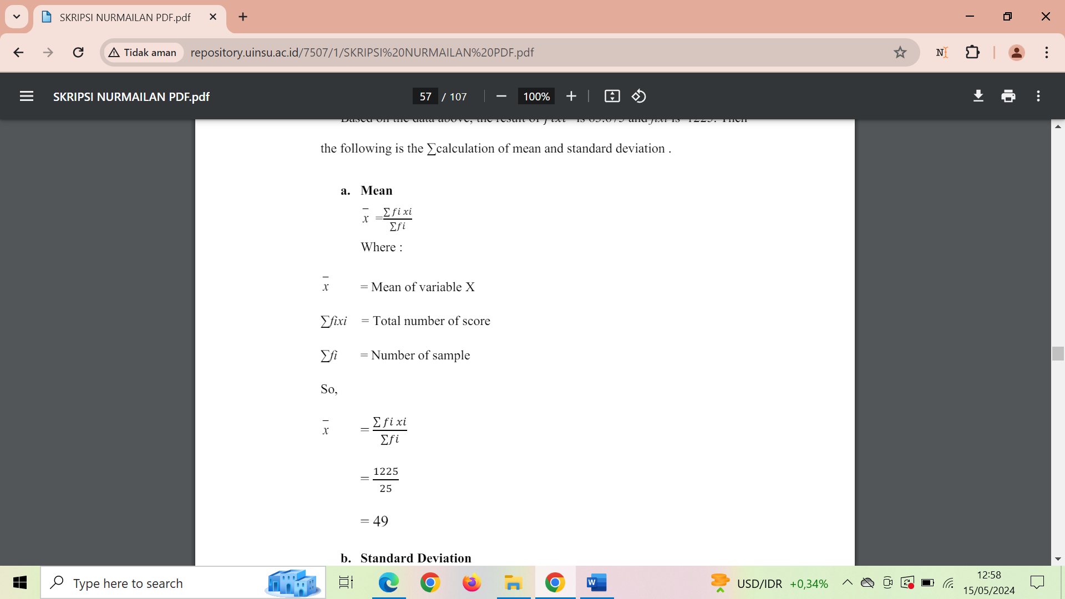In the pre-test there were 3 students got fair category with precentage 17.64%, 8 students got good category with percentage 47.05% and 6 students got excellent category with percentage 35.30%. Then in the post test there was no one got fair category, 5 students got good category with percentage 29.41% and 12 students got excellent category with percentage 70.59%. It could be concluded that the students’ reading achievement scores of experiment class was increased from pre-test to post test.

***Mean***

$$x=\frac{1012}{17}=59,53$$

1. **The Result of Pre-Test and Post Test Score Students’ Reading Achievement of the Control Class**

The pre-test at the control class had been given in class A with the number of student was 19 students on Thursday, 2th May 2024. Then the post test at the control class had been given in class A with the number of student was 19 students on Thursday, 9th May 2024. The post test scores of students’ reading achievement were presented in table 4.2.

**Table 4.2 the Result of Pre-Test and Post Test Scores of Students’ Reading Achievement in Control Class**

|  |  |  |  |  |  |  |  |  |
| --- | --- | --- | --- | --- | --- | --- | --- | --- |
| **NO** | **NAME** | **PRE-TEST** | **GRADE** | **CATEGORY** | **POST=TEST** | **GRADE** | **CATEGORY** | **IMPROVEMENT** |
| 1 | ALI | 74 | A | Excellent | 74 | A | Excellent | 0 |
| 2 | ANA | 60 | B | Good | 68 | A | Excellent | 8 |
| 3 | ANI | 58 | B | Good | 58 | B | Good | 0 |
| 4 | ISA | 76 | A | Excellent | 72 | A | Excellent | - |
| 5 | SAMIN | 64 | A | Excellent | 82 | A | Excellent | 18 |
| 6 | LISA | 76 | A | Excellent | 78 | A | Excellent | 2 |
| 7 | ALIA | 72 | A | Excellent | 80 | A | Excellent | 8 |
| 8 | NANCY | 68 | A | Excellent | 78 | A | Excellent | 10 |
| 9 | QOTRIN | 52 | B | Good | 60 | B | Good | 8 |
| 10 | ULUM | 54 | B | Good | 82 | A | Excellent | 28 |
| 11 | UDIN | 64 | B | Good | 88 | A | Excellent | 24 |
| 12 | NADIF | 66 | A | Excellent | 80 | A | Excellent | 14 |
| 13 | ILHAM | 62 | B | Good | 70 | A | Excellent | 8 |
| 14 | HERU | 66 | A | Excellent | 70 | A | Excellent | 4 |
| 15 | HERMAN | 60 | B | Good | 56 | B | Good | - |
| 16 | HANI | 72 | A | Excellent | 68 | A | Excellent | - |
| 17 | INA | 64 | B | Good | 74 | A | Excellent | 10 |
| 18 | IMAM | 74 | A | Excellent | 70 | A | Excellent | - |
| 19 | SEIMAH | 66 | A | Excellent | 84 | A | Excellent | 18 |
|  |  |  |  |  |  |  |  |  |
|  | **SUM** | 1244 |  |  | 1392 |  |  | 160 |
|  | **HIGHEST SCORE** | 76 |  |  | 88 |  |  |  |
|  | **LOWER SCORE** | 52 |  |  | 56 |  |  |  |
|  | **MEAN** | 65,47 |  |  | 73,26 |  |  |  |
|  | **STANDARD DEVIATION** | 7,14429 |  |  | 8,875 |  |  |  |

It can be seen in the table 4.2 above, based on the result of research in class A as control class, the highest pre-test score of students in control class was 76 and the lowest score was 52, with sum of the score was 1224, mean was 65. 4737, and standard deviation was 7.14429. Then, class A as control class which was not taught using reading log, the highest post test score of students in control class was 88 and the lowest score was 56 with sum of the score was 1392, mean was 73.26, and standard deviation was 8.875.

In conclusion, mean of pre-test score was 65. 4737 and in the post test was 73.26. It meant that the students’ reading achievement scores of control class was increased from pre-test to post test. In the pre-test there were 8 students got good category with percentage 42.10% and 11 students got excellent category with percentage 57.90%. Then in the post test there was no one got fair category, 3 students got good category with percentage 15.79% and 16 students got excellent category with percentage 84.21%. It could be concluded that the students’ reading achievement scores of contol class was increased from pre-test to post test. The comparison reading score pre-test and post test between experiment and control class presented in the figure 4.3 below:

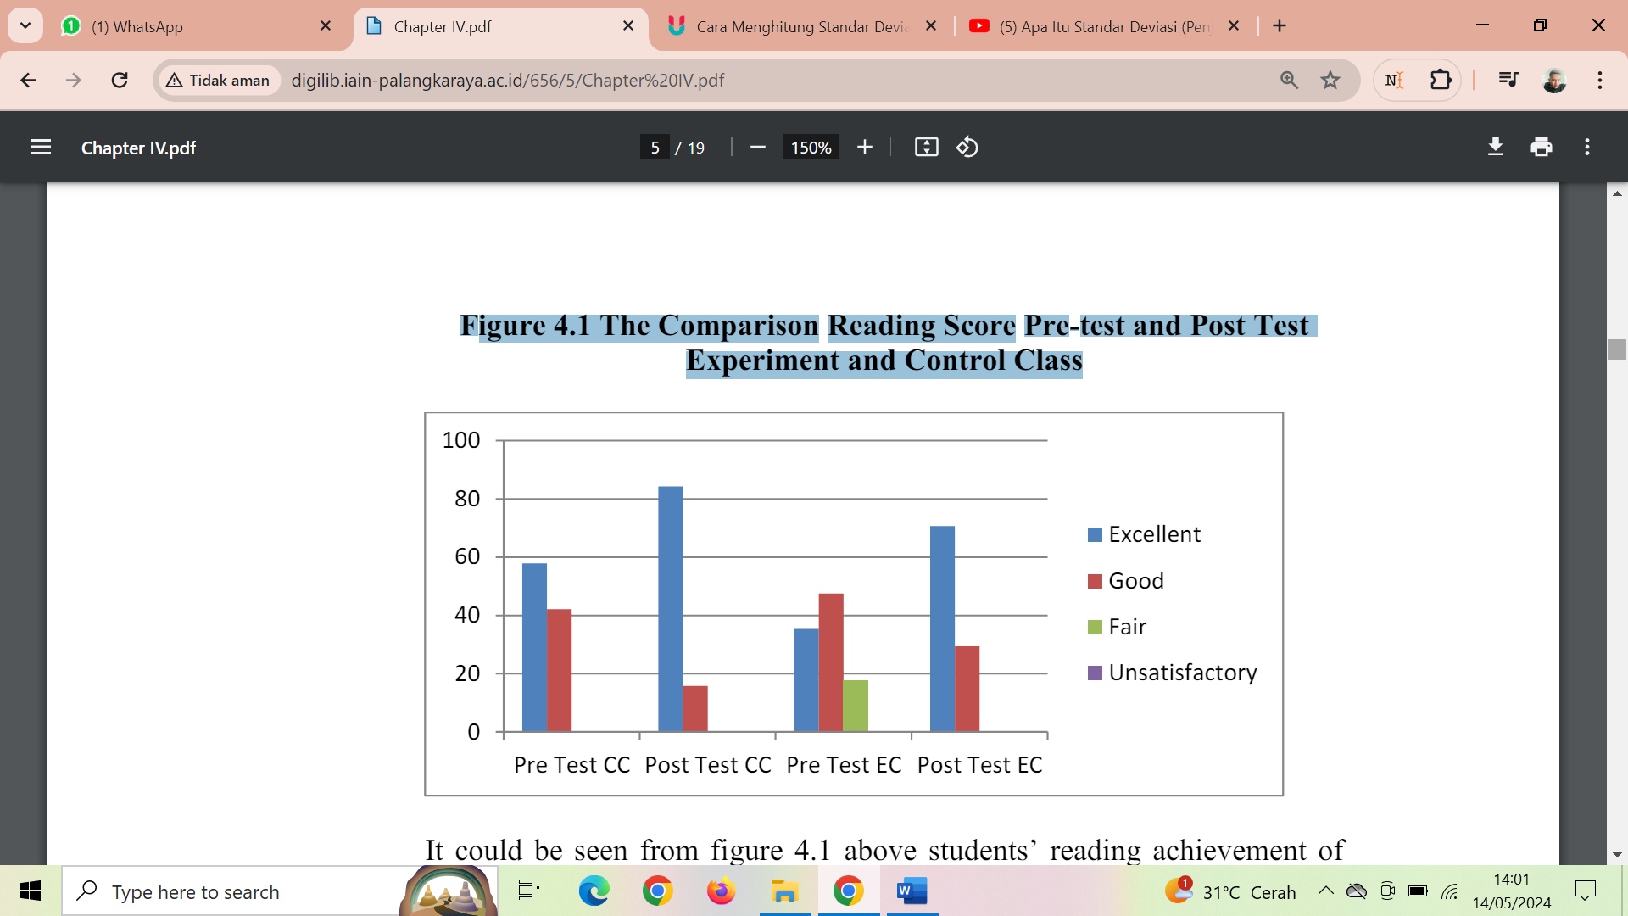**Figure 4.3 The Comparison Reading Score Pre-test and Post Test Experiment and Control Class**

It could be seen from figure 4.3 above, students’ reading achievement of control class and experiment class was increased from pre-test to post test. The discussion was available in the description before.

1. The Questionnaire Result of Students’ Reading Strategy Use of the Experiment and Control Class

**a. The Questionnaire Result of Pre-Test and Post Test of the Experiment Class**

The pre-test and post test questionnaire result of students’ reading strategy use were presented in table 4.3 below:

**Table 4.3 the Questionnaire Result of Pre-Test and Post Test in Experiment Class**

|  |  |  |  |  |  |  |  |
| --- | --- | --- | --- | --- | --- | --- | --- |
| **NO** | **NAME** | **PRE-TEST** | **MEAN** | **POST=TEST** | **MEAN** | **IMPROVEMENT** | **IMPROV**  **EMENT MEAN** |
| 1 | Nusa | 117 | 2.925 | 140 | 3.5 | 23 | 0.575 |
| 2 | Arumi | 136 | 3.4 | 145 | 3.625 | 9 | 0.225 |
| 3 | Hilwa | 142 | 3.55 | 144 | 3.6 | 2 | 0.05 |
| 4 | Rafi | 128 | 3.2 | 133 | 3.325 | 5 | 0.125 |
| 5 | Sudais | 147 | 3.675 | 152 | 3.8 | 5 | 0.125 |
| 6 | Saiba | 124 | 3.1 | 136 | 3.475 | 15 | 0.375 |
| 7 | Zakiya | 117 | 2.295 | 132 | 3.3 | 15 | 0.375 |
| 8 | Shanum | 141 | 3.525 | 154 | 3.85 | 13 | 0.325 |
| 9 | Qoris | 126 | 3.15 | 135 | 3.375 | 9 | 0.225 |
| 10 | Adi | 142 | 3.55 | 148 | 3.7 | 6 | 0.15 |
| 11 | Adam | 149 | 3.725 | 168 | 4.2 | 19 | 0.475 |
| 12 | Ahmad | 118 | 2.95 | 123 | 3.075 | 5 | 0.125 |
| 13 | Siti | 121 | 3.025 | 149 | 3.725 | 28 | 0.7 |
| 14 | Hoi | 141 | 3.525 | 145 | 3.625 | 4 | 0.1 |
| 15 | Hisom | 122 | 3.05 | 123 | 3.075 | 1 | 0.025 |
| 16 | Yuhana | 130 | 3.25 | 138 | 3.45 | 8 | 0.2 |
| 17 | Radit | 132 | 3,3 | 142 | 3.55 | 10 | 0.25 |
|  |  |  |  |  |  |  |  |
|  |  |  |  |  |  |  |  |

# CHAPTER V CONCLUSION AND SUGGESTION

1. CONCLUSION

Based on the presentation of data and analysis in chapter IV, it can be concluded that the results of this study are as follows:

1. There was significant effect of reading log toward reading achievement of the fourth semester students of English Education Study Program in SMAN 1 kwanyar. It was shown that the result showed the significant value was lower than alpha (0.00 lower ≤ 0.05). It meant that the use of reading log is effective toward reading achievement of the fourth semester students at English Education Study Program SMAN 1 Kwanyar.
2. There was significant effect of reading log toward reading strategy use of the fourth semester students of English Education Study Program SMAN 1 Kwanyar. It was shown that the result showed the significant value was lower than alpha (0.00 lower ≤ 0.05). It meant that the use of reading log is effective toward reading strategy use of the fourth semester students at English Education Study Program in SMAN 1 Kwanyar.
3. There was no significant different between reading achievement and reading strategy use of the fourth semester students of English Education Study Program in SMAN 1 Kwanyar. It was shown that the result showed the significant value was higher than alpha (155 > 0.05).
4. Suggestion

According to the conclusion of the study result, the writer would like to propose some suggestions for the students, teachers or lecturer and the future researchers as follow:

1. Students

The students should read more article, journal, academic text to improve their reading ability. In particular for EFL college or university students, the ability to read academic texts is one of the most important skill. The students should be able to become independent learner and they can use reading log to motivate them and record their reading activity.

1. Teacher or Lecturer

The writer recommended that lecturer can be able to apply reading log in reading course. Considering of the study result, the use of reading log showed significant effect toward students’ reading achievement and reading strategy use. It meant the use of reading log is effective because students’ reading achievement and reading strategy use was improved.

1. Future Researchers

In this study, the writer realized that design of the study was very simple. There are still many weaknesses that could be seen. Therefore, for further writer; it is expected that the other writers can improve this study with better design and different object in order to support the result finding. In other word, the other writer can use this study as the reference for conducting their research. In addition, the writer suggest to future researcher to make deeper analysis about students reading strategy use and make underline particular strategy which students use because in this study the writer only describe about the frequency of students’ strategy use

# REFERENCES

R. S. Akbar, H. A. Taqi, A. A. Dashti, and T. M. Sadeq, “Does e-reading enhance reading fluency?,” English Language Teaching, vol. 8, no. 5, pp. 195–207, 2015, doi: 10.5539/elt.v8n5p195.

DH Tracey, LM Morrow - 2024 - books.google.com

MSQ Madaminova - Academic research in educational sciences, 2024 - cyberleninka.ru

[AR Fatmawan](https://scholar.google.com/citations?user=g5FGa08AAAAJ&hl=id&oi=sra), [NPA Dewi](https://scholar.google.com/citations?user=HABwx9AAAAAJ&hl=id&oi=sra)… - Edusaintek …, 2023 - journalstkippgrisitubondo.ac.id

L Luthfaturrohmah - 2024 - etheses.uingusdur.ac.id

C **Carlisle** - Victorian Studies, 2020 – JSTOR

T Solathtanavong, [M Anugerahwati](https://scholar.google.com/citations?user=yQiDZIoAAAAJ&hl=id&oi=sra) - Jurnal Pendidikan, 2021 - core.ac.uk

[S Ueno](https://scholar.google.com/citations?user=Na0Fv6AAAAAJ&hl=id&oi=sra), J **Aliponga** - **Journal**of NELTA, 2021 - academia.edu

Weber, S. (2018). How teachers can guide library book selection to maximize the value of independent reading time. The Language and Literacy Spectrum, 28(1), Article 4.

Delarriva, O. O., Basabe, E. A. (2015) Reading Logs and Literature Teaching Models in English Language Teacher Education. International License. License Deed can be consulted at <http://creativecommons.org/licenses/by-nc-nd/4.0/>

A Holland - 2023 - red.mnstate.edu

X Lian, [WCH Hong](https://scholar.google.com/citations?user=XOZ9Jc8AAAAJ&hl=id&oi=sra), X Xu, [KZ Kimberly](https://scholar.google.com/citations?user=8W9ijWkAAAAJ&hl=id&oi=sra)… - International journal of …, 2023

[P Jirajarupat](https://scholar.google.com/citations?user=R9txf_sAAAAJ&hl=id&oi=sra), Z Yinghua - … of Education and Literacy **Studies**, 2023 - journals.aiac.org.au

[TJ Heaton](https://scholar.google.com/citations?user=tMf0PScAAAAJ&hl=id&oi=sra), M Butzin, [E Bard](https://scholar.google.com/citations?user=qOkHfWEAAAAJ&hl=id&oi=sra), [CB Ramsey](https://scholar.google.com/citations?user=4b22PLkAAAAJ&hl=id&oi=sra), KA Hughen… - …, 2023 - cambridge.org

Aulia, “PROMOTING EXTENSIVE READING ACTIVITY THROUGH CONSTRUCTING READING LOGS PROJECT IN EFL CLASS,” Research and Innovation in Language Learning, vol. 2, no. 2, May 2019, doi: 10.33603/rill.v2i2.2042.

BA DeVries - 2023 - taylorfrancis.com

Bakkalbasioglu, “The Qualitative Report The Qualitative Report How to Access Elites When Textbook Methods Fail? Challenges How to Access Elites When Textbook Methods Fail? Challenges of Purposive Sampling and Advantages of Using Interviewees as of Purposive Sampling and Advantages of Using Interviewees as ‘Fixers’ ‘Fixers.’” [Online]. Available: https://nsuworks.nova.edu/tqr

Muliasari, S. Tinggi, I. E. Aas, and S. Indonesia, “TYPES OF READING QUESTION ANALYSIS IN ELECTRONIC SCHOOL BOOK ‘BAHASA INGGRIS’ FOR THE TWELVE GRADE OF SENIOR HIGH SCHOOL”.

Rezigalla, “Observational Study Designs: Synopsis for Selecting an Appropriate Study Design,” Cureus, Jan. 2020, doi: 10.7759/cureus.6692.

J. Bamford and R. R. Day, “Extensive Reading: What Is It? Why Bother?” [Online].Available:http://jaltpublications.org/old_tlt/files/97/may/extensive.html “The More I Read, The More I Want To Read”.

Hurriyat Ibodullayevna, “International Journal for Social Studies The Effective Use Of Reading Logs As Continious Assessment In Reading Classes”, [Online]. Available: https://journals.eduindex.org/index.php/ijss

K. Kalsum, F. Abdul Rauf, and A. Sardi, “Implementation of Reading-Log to Increase Students’ Interest on Literacy at Islamic Boarding School,” IDEAS: Journal on English Language Teaching and Learning, Linguistics and Literature, vol. 10, no. 2, Jan. 2023, doi: 10.24256/ideas.v10i2.3202.

Deacon, S. H., & Levesque, K. (2024). Mechanisms in the relation between morphological awareness and the development of reading comprehension. Journal of Educational Psychology. Advance online publication. [https://doi.org/10.1037/edu0000871](https://psycnet.apa.org/doi/10.1037/edu0000871)

[3], [4], [5], [6], [7], [8], [9]