**TEACHER-STUDENTS INTERACTION PATTERNS ON**

**STUDENT'S SPEAKING SKILLS IN SMP**

**NAHDLATUL ULAMA AROSBAYA**

**Badus Salam**1)**, Mariyatul Kiptiyah**2)

1,2English Department, STKIP PGRI Bangkalan

E-mail: [**badussalam8@gmail.com**](mailto:badussalam8@gmail.com)**1),** [**mariyatulkiptiyah@stkippgri-bkl.ac.id**](mailto:mariyatulkiptiyah@stkippgri-bkl.ac.id)**2)**

**Abstrak:**

Berbicara merupakan bentuk komunikasi manusia yang paling dasar, dilakukan dalam kehidupan sehari-hari dan memegang peranan penting dalam interaksi sosial. Keterampilan berbicara seringkali dianggap sebagai bakat bawaan, padahal keterampilan ini dapat dipelajari dan dilatih, namun dengan sering berlatih maka akan meningkatkan keterampilan dan rasa percaya diri (Fitria, 2022). Keterampilan berbicara mempunyai peranan penting dalam ilmu linguistik dan kehidupan sehari-hari. Meski terlihat sederhana, namun menguasai keterampilan berbicara bukanlah hal yang mudah, terutama bagi siswa SMA. Guru harus menggunakan metode yang kreatif dan mampu memantau siswa secara efektif, salah satunya melalui diskusi kelompok kecil yang dapat meningkatkan keterampilan berbicara siswa (Crisianita & Mandasari, 2022). Namun pembelajaran bahasa Inggris di SMP Nahdlatul Ulama Arosbaya menghadapi kendala terutama terkait penggunaan bahasa Inggris dalam komunikasi sehari-hari di kelas, Komunikasi yang efektif antara guru dan siswa merupakan kunci dalam pendidikan, dan interaksi yang baik dapat membantu siswa memahami dan mengingat materi dengan lebih baik.

**Kata Kunci**: Berbicara, Komunikasi, Interaksi, Diskusi.

***Abstract:***

*Speaking is the most basic form of human communication, carried out in everyday life and plays an important role in social interactions. Speaking skills are often considered an innate talent, even though this skill can be learned and trained, with frequent practice it will increase skills and self-confidence (Fitria, 2022). Speaking skills have an important role in linguistics and daily life. Even though it looks simple, mastering speaking skills is not easy, especially for high school students. Teachers must use creative methods and be able to monitor students effectively, one of which is through small group discussions which can improve students' speaking skills (Crisianita & Mandasari, 2022). However, learning English at Nahdlatul Ulama Arosbaya Middle School faces obstacles, especially regarding the use of English in daily communication in the classroom. Effective communication between teachers and students is key in education, and good interaction can help students understand and remember the material better.*

***Keywords:*** *Speaking, Communication, Interaction, Discussion.*

**INTRODUCTION**

Speaking is the most elementary form of human communication, which is carried out in everyday life. Speaking is also a means of communication between persons in society. Not a few people think that the ability to speak in public is accepted talent. In authenticity, there are people who are endowed and there are people who are not. Basically, public speaking skills can be learned and trained, the more often we do it, the more skilled and confident we become (Fitria 2022).

English learning has not been exploited due to the lack of application of english in the form of communication or speaking using english both in the classroom and in the school setting from the english language program in one full day (English Day). Based on findings from inerviews with class VIII english teachers, including english teachers at SMPNahdlatul Ulama Arosbaya, the greatest important problem is that students are ashamed and afraid to communicate with their own teachers on the selected day of englishday (Taslim 2022).

From communication there is an act of interaction between the sender and recipient, the sender and recipient have an involvement that gives meaning to what is conveyed to the recipient. In the world of education, communication is carried out by teachers and students. To create effective communication, almost every time the teacher communicates with many communication partners. Communication with students will be different from communicating with fellow teachers or other people. Communication skills can be in the form of the ability to understand and capture material or topics of discussion. Learning interactions must be familiarized in the classroom so that they can form students' good character towards learning (Taufik 2020).

In the speaking lesson, students faced numerous problems such as the learners show a low enthusiasm and motivation in speaking, scared and shy to speak. It arises because of some factor such a low attention, material, and improper technique which apply in the class. In solving those problems, it needed an attractive interaction patterns. Many students experience complications in learning to speak, one of the influences that must be analyzed is learning strategies that are lessmotivating, and relations or interactions between students that do not chance prospects (RirihKusumasar & Aini, 2023).

Teaching and learning activities at SMP Nahdlatul Ulama carried out in the classroom so far is often one way where students only listen to what the teacher says. Therefore, students are more actively involved in interacting with teachers or between students. The percentage of student's ability to understand and remember material previously studied is only 5% if they just listen to the teacher's explanation. Students will be able to remember and understand the material to others. Students understanding and memory in explaining the content of the material to others reached 90%. Interaction is also an important point in teaching and learning activities because not only students benefit, but teachers also get feedback on whether the material presented is well received by students.

Based on my experience regarding students' speaking problems during my time at Nahdlatul Ulama Arosbaya Middle School, namely that there were still relatively few students who were able to speak English, I am sure that the teachers there have used many methods and techniques to progress learning speaking skills. The teachers there have provided speaking lessons through conferences, reading, lecturing but the results are still nil because these methods tend to be boring. Therefore, through this research, provide another way, namely TEACHER-STUDENTS INTERACTION PATTERNS ON STUDENT'S SPEAKING SKILLS, so that students and teachers can practice speaking by interacting with the teacher directly, whether in terms of telling stories, asking questions and so on. This is done with the hope of opening up opportunities for students to become proficient in English speaking.

**RESEARCH METHOD**

Research design is the right plan to use in research (Dewi Nur’aini 2020). Research design is planned the research on how to collect and prosses data that can be realized to reach the research objectives.

In this study, researchers applied qualitative research to develop research. Qualitative research has a descriptive nature and tends to use an inductive approach to analysis, so that processes and meanings based on the subject's perspective are more emphasized in this qualitative research. Qualitative research as like as the other method in the research that havebeen known. The researcher feel need to used qualitative research in the research. Qualitative research design can be applied as a method in research, because the design is described in very detail so it is easy for researchers and academics (Rijal Fadli 2021).

The research process in this qualitative research was used in some step of research that research able to run properly. Qualitative research offers a different perspective on realism as something that cannot be separeted from human activity(Cosmas GatotHaryono 2020). With used the qualitative research, the researcher can be research to conduct with more dept studies

1. **Data Collection Method**
2. Observasi

According to M. Makbul (2021), observation is direct reflection using the five senses by systematically observing and recording events. The researcher observed the teaching of speaking learning at SMPNahdlatul Ulama Arosbaya in class VIII. The researcher carried out investigation and implemented observation measures. Researchers carried out the teaching process as usual including opening, learning instructions, and of course applying interaction patterns with students. Observation results are presented in the form of field notes and screenshots containing student behavior, teacher actions, and everything that happens in the teaching and learning process.

Meanwhile, accordingto(Khotimah et al., 2022), before the researcher carried out direct observations, the researcher conducted a preliminary study with the English teacher to ask for permission and conduct research at school.This is done of course because we are students who have ethics, so before researchers carry out research, researchers must obtain permission from the English teacher, who want then be directed by the English teacher to face the principal until they are allowed to research according to their objectives.

In this observation, there are many things that the researcher must do, including following the teaching and learning activities carried out by the teacher in the classroom. the researcher followed and listed to the material taught by the teacher(Khotimah et al., 2022).

1. Interview

According to M. Makbul (2021), interviews are data collection methods through conversation or questions and answers to obtain answers or information. This interview was conducted to obtain information from teachers and students before and after the action was implemented. This information includes opinions, beliefs, and interview experiences.

Meanwhile, according to(Khotimah et al., 2022), Interviews were conducted to obtain information that was not obtained during the observation section. The observation section is certainly not free from errors in data collection. This will be refined in the interview section which will of course provide more detailed data.

The researcher prepared several questions to ask selected students from the target class(Khotimah et al., 2022). These questions are part of the researcher's instrument in finding data related to teacher and student interaction patterns on students' speaking abilities. Researchers designed questions according to the implementation of teacher and student interaction patterns.

1. **Data Analisys**

Data analysis is grouping or complexing data according to research objectives. According toAbdul Fattah Nasution (2023), in qualitative research data collection is not guided by existing theories but is guided by facts found when the research was carried out. Therefore, data analysis is inductive or based on facts found.

All data results were interpreted well. In qualitative research, data analysis is often carried out concurrently with data collection through an iterative process. Meanwhile, the quantitative form of research is outlined in reports which occur in different stages.

In this study, researchers assessed several elements of speaking, especially in class VIII Nahdlatul Ulama Arosbaya Middle School. In assessing speaking skills, there are five aspects that are measured, namely: Grammatical, Vocabulary, Fluency, Pronounciation, and Comprehension. The data analysis technique in this research is descriptive statistics.

1. Reducing of Data

Reducing of data is summarizing, choose the main things, focus on the important things. The purpose of data reduction is to help researchers ensure that data can be obtained completely and comprehensively according to needs. In this data processing process, qualitative data collection is often carried out simultaneously with data analysis. Therefore, in data reduction, important parts have been taken and unnecessary data has been discarded. Data reduction is focusing the analysis according to needs and summarizing it systematically(Purnamasari&Afriansyah, 2021).

Meanwhile, the data reduction stage in this research is:

1. Analyze the results of interaction patterns with students to find out the difficulties experienced by students, especially in taking the speaking skills test.
2. Transcribe the results of interviews with students.
3. Presenting of Data

At the data presentation stage, it is presented in a form that is easier to understand(Purnamasari&Afriansyah, 2021). Data presentation is the process of displaying detailed information from observation results. In this study, researchers have described the relationship between teacher and student interaction patterns in speaking skills. Qualitative reports are presented through conveying thoughts, feelings towards objects and experiences.

1. Drawing Conclusion

In this research, conclusions are drawn to determine the number of existing samples. This research selects several required samples. The eleventh researcher interpreted observations obtained from research conducted while walking. The conclusions drawn must answer the research problem formulation (Purnamasari & Afriansyah, 2021).Furthermore, the data is still being processed and until completion the data is searched so that the data is valid for use as intended.

**RESEARCH FINDING AND DISCUSSION**

In this chapter the researcher present the data that has been taken through observations and interviews during the research carried out.

1. **Observation Result**

To answer the first research question about namely, What are the interaction patterns of teachers' and students' speaking skills? The researcher took a policy of conducting observations during two meetings. The first data based on observations that i obtained was the occurrence of the following interaction patterns:

The teacher enters the class and greets the students

Teacher: “Assalamualaikumwr.wb

Student: "WaalaykumsalamWrwb, teacher..." answered the student.

After that the teacher greeted and asked how the students were.

\Teacher: "Hi everyone! How are you today?"

Students: "Hi teachers! We are very excited today!". answer all students.

Teacher: ''Good !''

Then the teacher gave advice to all his students about the importance of maintaining health.

Teacher: "children! Health is very important when we are sick. Everyone will realize the importance and pleasure of health when we are sick! Stomach ulcers can be caused by eating late, remember to always have breakfast before going to school, remember! Prevent more better than cure!"

Student: "Yes, teacher!"

then proceed with reading prayers with wisdom together.

The second data based on observation that i obtained was the occurrence of following interaction atterns:

The teacher enters the class starting by greeting and praying together then interacting by asking the students' aspirations.

Teacher: Assalamualaikum..Good morning everyone..

Student: Waalaykumsalm.. Good morning ma'am

Teacher: How are you today?

Students: all right ma'am!

Teacher: thank God, then before studying, let's pray first.

Student: OK ma'am!

Teacher: OK students, let's continue yesterday's meeting... regarding what tolerance is! Does anyone know what tolerance is?

Student 1: tolerance is an attitude of mutual respect and respect, ma'am!

teacher: very good!!, name an example of tolerance in the classroom!?

student 2: an example is mutual respect for classmates, ma'am!

teacher: your answer is great!, we as human beings live side by side and will need each other. so you have to respect and love each other!

Student: OK, teacher!

Teacher: Name an example of intolerance in the classroom!?

Student 2: Enemy each other's friends, ma'am!

teacher: absolutely right!. Being hostile to each other is not a good attitude. don't copy it!

Student: OK, teacher..

From the creation of the dialogue above, we can indirectly observe that there has been active interaction between teachers and students which can train students' skills, especially speaking skills. Using a method like the one above, namely the question and answer method, can certainly train students to speak even on simple topics.

There are several facts that i obtained, including that there are students who can answer well, there are also those who cannot answer, and on average students are stimulated well by using this interaction pattern media. As a learning medium that relies on interaction, it is of course closely related to communication activities. This proves that the design of interface amid educators and learners really helps students' interest in learning English. Second, what kind of interaction patterns are used in the classroom? The use of interaction patterns by teachers and students is very influential in learning to improve students' speaking skills by providing concrete models and facilitating discussions about content that is relevant to everyday life. This interaction pattern will certainly stimulate students to get closer to the teacher so that it will stimulate students' imagination and motivate them to discuss other topics with their friends.

Based on the results of observations, the interaction patterns that occur in the class are:

1. One - way interaction
2. Two-way interaction
3. Multi-directional interaction

Examples of dialogue that occur in class are:

1. One - way interaction

On the firs observation the teacher starts learning, continuing last week's material, namely "Daily Activity". First, the teacher explains what Daily Activity is.

Teacher: "Children today we are learning about Dayli Activity! Daily activity is a daily activity that we do from waking up in the morning to going back to sleep at night. Examples of daily activities are reading books, reading activities books have many benefits, such as improving speaking skills!".

Student: (Students just pay attention and listen to the teacher's explanation).

Based on the dialogue above, it shows a one-way conversation because there is only one active conversation.

1. Two-way interaction

On the second observation the teacher asked about students who were absent that day.

Teacher: "Are there any students absent from class today?"

Ahnia: "There's a teacher!"

Teacher: "Really? Who is he"

Ahnia: "Noval, teacher!"

Teacher: "what's wrong with the novel?"

Ahnia: "He's sick, teacher!"

Teacher: "Since when was he sick? And where is he now?"

Ahnia: Since last night, he's been at his house, teacher!".

Teacher: "We pray together that Nova will recover quickly!"

Ahnia: "Yes, teacher!"

From the dialogue above, it shows a two-way conversation because there are two active conversations, namely between the teacher and students 1.

1. Multidirectional interaction

On the second meeting the teachers interact with students by asking questions about daily activities:

Teacher: Good morning!

Student 1: Good morning too ma'am

Teacher: have you had breakfast this morning?

Student 1: yes ma'am!

Teacher: Why do we have to eat breakfast every time we go to school?

Student 2: So you don't get sick at school, ma'am!

Student 3: Be healthy, Mom!

Student 4: To keep up the school spirit, ma'am!

then the teacher answered and gave praise to the students.

Teacher: great! "All your answers are correct! We have to have breakfast every morning so that our bodies have enough energy to carry out daily activities. We have to have breakfast every morning to stay healthy and enthusiastic in class!"

Student: "Yes mother!"

then the teacher asks another question.

Teacher: "Has today's class been swept?"

Student 1: "Yes ma'am!"

Student 2: "we swept it together!"

Teacher: Great! I am glad to hear it!.

Based on the conversation above, it shows a multi-way conversation, this is because there are many active conversations, namely between the teacher and all the students in the class.

Picture 1

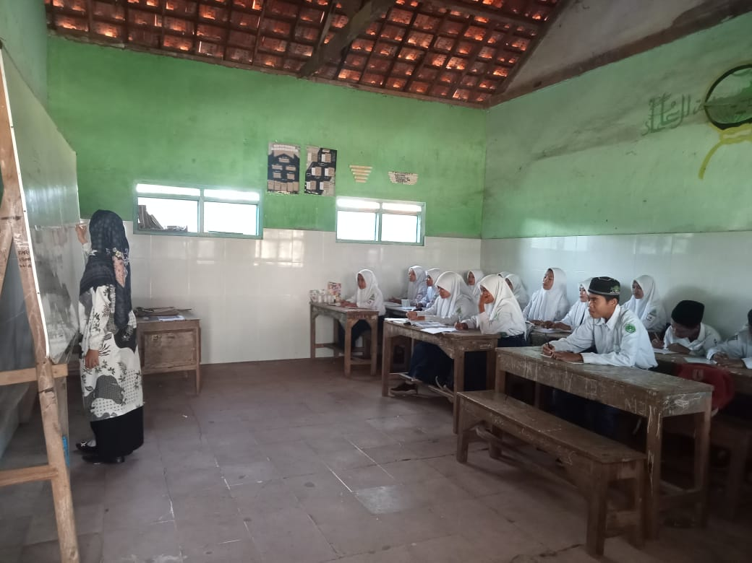

It can be concluded that learning in the classroom uses one-way, two-way and multi-way types of interaction.

As a learning medium that relies on interaction, it is of course closely related to communication activities. Teaching and learning activities which are a process of communication between teachers and students are often also called educational communication between teachers and students. In these observations, researchers generally found answers, namely that students more easily accepted the learning provided by the teacher, students felt safe and comfortable when learning, it was easy or students became brave in asking questions or complaints during learning. Meanwhile, for teachers, teachers will know the characteristics of well-educated students so that it will be easier to design appropriate learning designs.

In addition, the use of interaction patterns such as the dialogue example above can create a dynamic learning environment where students feel comfortable learning and actively participate in discussions and develop their communication skills effectively.

1. **Interview Result**

Here, the researcher asked the teacher four questions.

Picrture 2

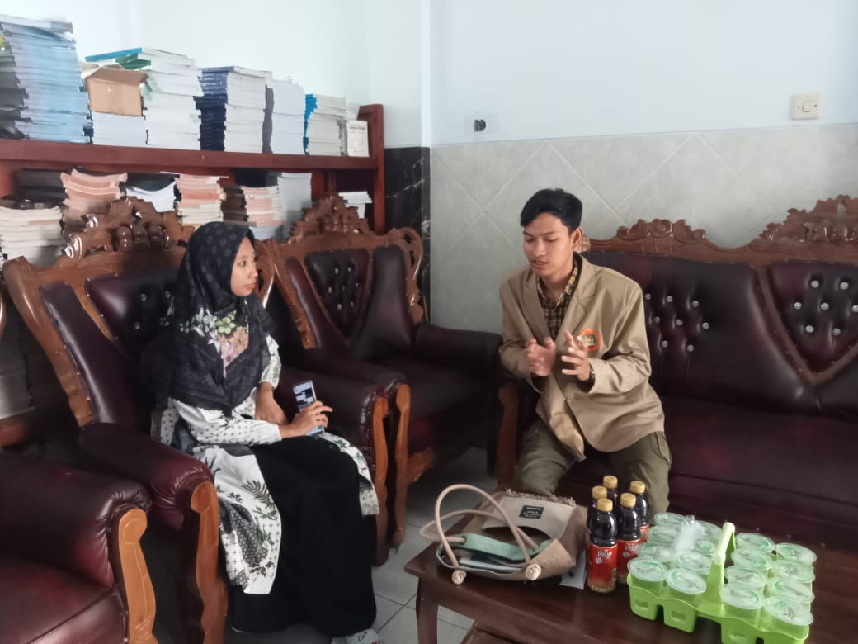

In the first question, the researcher asked how would you describe the interaction patterns between you and students in teaching and learning activities, especially regarding speaking skills? in this case the teacher describes that the design of interface among the educators and learners, especially related to students' speaking skills, is an interactive approach to students whose content is to communicate directly to students whose content is simple conversations that must be answered directly by students so that indirectly this will train students' communication skills, especially English speaking skills.

In the second question, the researcher asked what methods do you use to encourage students to speak more actively in class? in this case the teacher only uses communication interaction methods, whether asking for news, greeting students, or asking students simple questions.

in the third question the researcher asked how often do you give feedback to students regarding their speaking skills? In this case, teachers often provide communication interaction methods to students because this is very simple but there is a good response from students. By providing methods like this as often as possible, students will get used to getting attention from the teacher, which of course really motivates students to continue learning and sharpening. speaking ability in class.

On the fourth or final question, what is the biggest challenge you face in encouraging students to talk more in class? In this case, the biggest challenge is that students will not immediately understand the conversation that the teacher started so the teacher has to repeat several times until the students understand the teacher's question until they can answer it, then there are still students who are shy even if they are just talking in their seats.

Based on the results of the researcher's interview with the English teacher, it can be concluded that classroom learning is going well by involving a system or method of active and effective teacher and student interaction approaches. with a communicative approach so that students will feel at home learning with the teacher.

Next, the researcher also interviewed several students by asking five questions. The researcher's first question asked how would you describe the interaction patterns between you and the teacher in teaching and learning activities, especially regarding speaking skills? In this case, students describe that the interaction pattern between teachers and students in improving English speaking skills is a communication pattern that is provoked by the teacher so that it stimulates students to answer and indirectly students will practice english speaking skills.

The researcher's second question asked what method or activity most helped you in improving your speaking skills? In this case, students answer the teacher by practicing students' speaking skills by giving simple greetings or questions that are easy for students to understand.

Picture 3

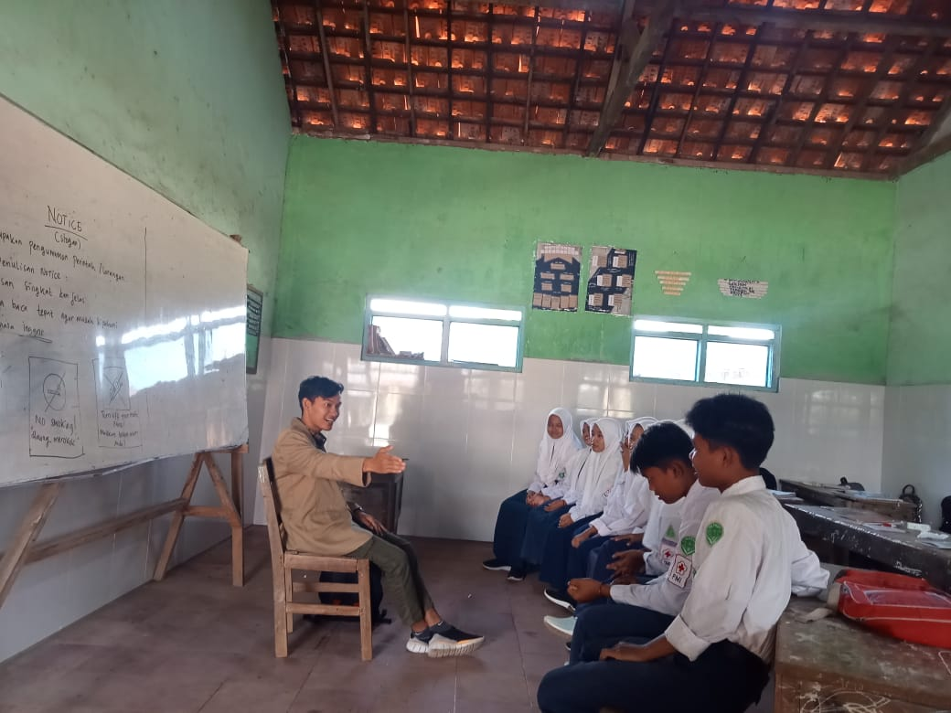

Researchers carried out interviews and observations to obtain valid data. To fulfill the research, researchers conducted it directly at Nahdlatul Ulama Arosbaya Middle School. Based on the results of observations and interviews that have been carried out, it can be said that learning using interaction patterns can help students to improve their English language skills, especially speaking skills. It can be seen that this research is also based on research conducted by (Gandari & Nurcholis, 2024), as the results obtained by researchers from interviews show that students have self-confidence and want to try speaking English on simple topics even if they have to stammer. They remain motivated to try speaking and improve their language skills. This shows that the interaction patterns carried out by English teachers can be a positive encouragement for students to overcome boredom with ordinary learning in learning English.

Learning English by prioritizing interaction patterns can help motivate students to continue to be happy and enthusiastic in learning English. This happens because of the unusual methods used by teachers with their students, by providing unique interaction patterns to students, they will tend to be closer to the teacher. so that good communication arises between teachers and students, this want then encourage students to be more courageous in carrying out their learning to improve their English skills. Another thing that the teacher want feel is that the teacher will become closer to the students so that the teacher will understand more about the students' character so that the teacher will understand more about the portion of learning that students need. Based on previous research and research that has been made by researchers, it is stated that their research is both effective and successful when applied to students and can also help teachers in teaching students in the classroom or school environment. The use of this interaction pattern is very useful in learning, it will really help them in learning English, especially speaking skills, and allows them to speak more relaxed because the topics presented are appropriate to the student's level, one of which is the question and answer method. This is in accordance with what was stated by (Gandari &Nurcholis, 2024) asking jawans carried out in English learning, especially in speaking classes, can improve students' ability to speak English and can increase students' vocabulary. This proves that the question and answer interaction pattern method can help students to be encouraged and motivated to improve their speaking skills in class interactions during learning. This question and answer can be done when you want to start a lesson, the aim is to arouse students' enthusiasm and interest in the teacher and the material to be presented.

Based on the description of interactions carried out in class, several of these learning approaches need a significant influence on student learning outcomes at school, so this approach is effective when used in learning, especially in English speaking classes. Thus, it can be concluded that classroom interaction has meaning that includes a two-way relationship between teachers and students as well as various approaches that can be used to achieve learning goals. This shows that classroom interaction must have an approach that can foster enthusiasm for learning and provide good learning motivation to students.

As an international language, English has significant rules with Indonesian. The differences are in pronunciation, grammar, intonation and vocabulary. As an international language, English is a serious need for most people in the world. Interpreting speaking teaching is not just about teaching students to produce spoken words to express their feelings, such as ideas and thoughts. Students, from the interaction patterns between teachers and students, students are motivated to be more enthusiastic about learning new vocabulary, especially speaking English.

This method of interaction certainly cannot be separated from the methods and attitudes of a professional teacher who carries out his duties with great patience, providing support and attention to students, this is what has become known as social support. So the importance of social and emotional support also plays an important role in addressing student character. When students are fully supported in social relationships, they will feel more confident in overcoming learning problems such as communication barriers.

By creating a friendly and supportive environment, individuals feel more comfortable discussing their problems and finding solutions together. Social and emotional support also plays an important role in motivating individuals to improve and reach their maximum potential. In educational settings, providing social and emotional support to students can help them feel more confident in speaking up in class and participating in learning. This is an important step in creating an inclusive environment and supporting all students in the learning process.

Due to new insights into the challenges or problems faced by students such as speaking difficulties, we can now better understand the complexity of the difficulties and provide appropriate solutions to students.

In the third question, the researchers asked whether you felt more confident speaking in class after receiving guidance from the teacher? in this case the students answered of course, gradually we felt confident because we had often received greetings or questions like this from the teacher so that we felt cared for class.

The fourth question, the researcher asked, what is the biggest challenge you face in speaking in front of the class? In this case, students answer that students are embarrassed if they have to answer questions from the teacher. Students are afraid of answering the teacher's questions incorrectly.

In the fifth and final question the researcher asked, what suggestions do you have for teachers to be more effective in helping students improve their speaking skills? In this case, the students answered that the teacher must be more patient in dealing with students, especially students who are very difficult or shy in responding to learning.

Based on the results of the researcher's interviews with students, it can be concluded that classroom learning is going well and is interesting by involving a system or method of structured teacher and student interaction approaches. With a communicative approach so that students will feel at home studying in the classroom. students are able to slowly follow the topic of conversation that the teacher brings so that it has a big influence on the student's learning process.

**CONCLUSION**

From the research results, it can be concluded that the use of creative interaction patterns in the classroom is a very useful tool to support the learning of english language skills, especially speaking skills. Using a variety of actions when teaching students skills such as one-way, two-way and multi-way interactions can support more effective learning. Apart from that, using good interaction patterns will help students to be more comfortable studying with the teacher so that all types of learning will be well received by students. With interaction patterns, teachers can explore students' imaginations because teachers can easily understand the nature and characteristics of students' learning so that teachers can organize the learning portion well. At Nahdlatul Ulama Arosbaya Middle School, the use of interaction patterns has proven successful in increasing students' self-confidence in learning. By using interaction patterns to support formal learning, schools can provide students with a more interesting and meaningful learning experience. This opens up possibilities for the development of innovative and effective learning methods in the field of speaking skills.

Overall, this research shows that the integration of media use into interaction patterns can be an effective strategy for teaching speaking skills to students. If implemented well and systematically, this method can make a positive contribution to students' communication skills in the world of education. As a result, this research provides a basis for developing innovative and practice-oriented learning approaches to improve students' speaking skills.

**ACKNOWLEDGE**

Special for the late mother. Mistiyah and Aspari's father whom I love very much. Your prayers, love and attention help me to face every difficulty in this life's journey. I dedicate this thesis to my father and mother who always provide calm, comfort, motivation, best prayers, and set aside their finances, so that I can complete my study period. You guys mean a lot to me. Thank you for the prayers and blessings that you have called for every night. May Allah always bless you in this world and the hereafter.

For my beloved engagement, Mas Uliatud Dianah. I would like to thank you for your smile, support and motivation while I was a student until I was able to complete this final assignment, I really love you.

Don't forget the teachers and lecturers who have taught and helped collect data from this final assignment as well as friends who have always accompanied this final work, hopefully success will be ours. Insyaallah.

**REFERENCE**

Andrian, D., Kiptiyah, M., StkipPgriBangkalan, ), &PgriBangkalan, S. (n.d.). *PETUNJUK PENULISAN NASKAH ARTIKEL (AN ANALYSIS OF STUDENTS’ DIFFICULTIES IN ENGLISH SPEAKING AT FRESHMAN OF ENGLISH LANGUANGE EDUCATION )*.

BojonggentengNomor, J., &BojonggentengKabSukabumi, K. (n.d.). *RagamMetodePenelitianKualitatifKomunikasi*. www.jejakpublisher.com

*BUKU METODOLOGI PENELITIAN KUALITATIF DR. NURSAPIA HARAHAP, M.HUM*. (n.d.).

Crisianita, S., &Mandasari, B. (2022). The Use of Small-Group Discussion to Imrpove Students’ Speaking Skill. In *Journal of Research on Language Education (JoRLE)* (Vol. 3, Issue 1). https://ejurnal.teknokrat.ac.id/index.php/JoRLE/index

DewiNur’aini, R. (2020). PENERAPAN METODE STUDI KASUS YIN DALAM PENELITIAN ARSITEKTUR DAN PERILAKU. In *92 INERSIA* (Vol. 1).

Fitria, R. A. (n.d.). *Pelatihan Public speaking UntukMenciptakanKomunikasiEfektif Pada Siswa SMKN 49 Jakarta Utara*.

Larosa, A. S., & Iskandar, R. (2021). AnalisisKeterampilanBerbicaraSiswaMelaluiPantun di Sekolah Dasar. *JurnalBasicedu*, *5*(5), 3723–3737. https://doi.org/10.31004/basicedu.v5i5.1207

*MetodePengumpulan Data dan InstrumenPenelitian*. (n.d.).

Nurlaelah, N., &Sakkir, G. (2020). *Model PembelajaranRespons Verbal dalamKemampuanBerbicara* (Vol. 4, Issue 1).

Pada PendekatanKualitatif dan KuantitatifArdiansyah, P., Jailani, Ms., Negeri, S., Provinsi Jambi, B., &SulthanThaha Saifuddin Jambi, U. (n.d.). *Teknik Pengumpulan Data Dan InstrumenPenelitianIlmiah*. http://ejournal.yayasanpendidikandzurriyatulquran.id/index.php/ihsan

Pasaribu, S., Pohan, I. S., &Najari, M. (n.d.). *StrategiInteraksi Guru PAI dalamMembentukAkhlakulKarimahSiswa*. https://doi.org/10.30868/ei.v12i02.4899

*POLA INTERAKSI GURU DENGAN SISWA DALAM PROSES PEMBELAJARAN IPA KELAS IV DI SD NEGERI 16 BERMANI ILIR*. (n.d.).

Purnamasari, A., &Afriansyah, E. A. (2021). *KemampuanKomunikasiMatematisSiswa SMP pada TopikPenyajian Data di PondokPesantren*.

*Retalia DAMPAK INTENSITAS PENGGUNAAN SMARTPHONE TERHADAP INTERAKSI SOSIAL*. (n.d.).

RijalFadli, M. (2021). *Memahamidesainmetodepenelitiankualitatif*. *21*(1), 33–54. https://doi.org/10.21831/hum.v21i1

RirihKusumasar, P., &Aini, F. N. (2023). *TEKNIK YANG DIGUNAKAN DALAM MENGURANGI KENDALA PADA PEMBELAJARAN SPEAKING (BERBICARA) MAHASISWA*. *4*(2).

Rohmah, H. (n.d.). POLA INTERAKSI GURU DAN SISWA DALAM PEMBELAJARAN ONLINE MATA PELAJARAN PAI KELAS VII DI SMPN 2 PERAK JOMBANG. In *Journal of Educatio*.

Rumondor, P., Islam, U., Kalijaga, N. S., Ridwan, Y., &Sineke, N. (2020a). POLA INTERAKSI GURU PAI DENGAN SISWA DALAM MENINGKATKAN HASIL BELAJAR DI SMA NEGERI 1 BELANG. In *Jurnal AL-HIKMAH* (Vol. 2, Issue 2).

Rumondor, P., Islam, U., Kalijaga, N. S., Ridwan, Y., &Sineke, N. (2020b). POLA INTERAKSI GURU PAI DENGAN SISWA DALAM MENINGKATKAN HASIL BELAJAR DI SMA NEGERI 1 BELANG. In *Jurnal AL-HIKMAH* (Vol. 2, Issue 2).

Taslim, R., Copriady, J., &Kartikowati, S. (2022). MANAJEMEN PROGRAM EKSTRAKURIKULER ENGLISH DAY DI SMP INDONESIAN CREATIVE SCHOOL. *JURNAL PAJAR (Pendidikan Dan Pengajaran)*, *6*(3), 879. https://doi.org/10.33578/pjr.v6i3.8474

Yasin, M., &RusdiantiNasution, F. (2022). *SOSMANIORA (JurnalIlmuSosial dan Humaniora) Pola InteraksiSosial Guru Terhadap Murid Kelas XI di SMK Negeri 1 MuaraWahau*. *1*(3), 298–305. https://doi.org/10.55123/sosmaniora.v1i3.854

Zubaedi, M., Azharullail, H., Yakin, H. H., Program, M., Pendidikan, S., & Islam, A. (2022). POLA INTERAKSI GURU PAI DENGAN SISWA DALAM MENINGKATKAN PRESTASI BELAJAR SISWA. In *JurnalKependidikan dan Pemikiran Islam* (Vol. 1, Issue 1).

Bahasa, J. P. (2018). P-issn 1411-3732 e-issn 2548-9097. *CLASSROOM INTERACTION PATTERNS AND TEACHERS- STUDENTS PERCEPTIONS ON ENGLISH CLASSES AT SMAN 2 BUKITTINGGI WEST SUMATRA*. https://doi.org/10.24036/komposisi.v19i2.10037

Gandari, M., & Nurcholis, I. A. (2024). *ANALISIS PENTINGNYA INTERAKSI KELAS DALAM PENGAJARAN KETERAMPILAN BERBICARA DI KELAS DUA SMA 6 BENGKULU Analysis the Importance of Classroom Interaction in Teaching*. *5*(2), 469–478.

Khotimah, H., Hafidz, M., & Inggris, P. B. (2022). *The youtube of nas daily chanel in teaching speaking skill*.

Penilaian, T., Skill, S., Kemampuan, M., Bahasa, M., Aceh, I., & Aceh, U. M. (2018). *TEKNIK PENILAIAN SPEAKING SKILL DALAM MENINGKATKAN KEMAMPUAN MAHASISWA BAHASA INGGRIS UNIVERSITAS MUHAMMADIYAH ACEH Cut Mawar Helmanda, Rahmatun Nisa*. 625–632.