**THE EFFECT OF FAIRY TALE VIDEOS ON YOUTUBE TO THE STUDENTS SPEAKING ABILITY AT THE NINETH GRADE**

**STUDENTS OF SMP AL FADLALY**

**Muhammad Nisar1),Moh. Arief Wahyudi2)**

1,2English Departement,STKIP PGRI Bangkalan

E-mail: [muhammadnisar0212@gmail.com](mailto:muhammadnisar0212@gmail.com)1), [arwah74@stkippgri-bkl.ac.id](mailto:arwah74@stkippgri-bkl.ac.id)2)

**Abstrak:**

Tujuan Penelitian in Untuk mengetahui pengaruh video YouTube cerita fairy Tale terhadap kemampuan ketrampilan berbicara serta pengaruhnya terhadap siswa kelas sembilan SMP al fadlaly. Penelitian ini menggunakan desain pre expremental dengan pendekatan kuantitatif Pre-tes dan pos-test satu kelompok. Partisipan yang ikuti dalam berjumlah 15 siswa yang di perlihatkan video yang mereka tonton sebagai bahan untuk memotivasi mereka dalam keterampilan berbicara. metode pengumpulan data meliputi pre-tes dan post-tes untuk menilai tingkat ketrampilan berbicara dan presepsi siswa. Analisis statistik menunjukkan adanya peningkatan signifikan dalam skor ketrampilan berbicara diantaranya siswa yang telah berikan media video cerita fairy Tale.

Temuan ini menunjukkan bahwa menggunakan media video cerita fairy tale ini dapat meningkatkan ketrampilan berbicara secara efektif di kalangan siswa Sekolah menengah pertama.

.

**Kata Kunci**:*: Berbicara, Dongeng Cerita Video.*

***Abstract:***

*This quantitative research investigates the influence of YouTube videos of fairy tale stories on speaking skills and their influence on class nineth students at Al Fadlaly Middle School. This research uses a pre-experimental design with a quantitative pre-test and post-test approach in one group. The participants were 15 students who were shown the video they watched as material to motivate them in their speaking skills. Data collection methods include pre-test and post-test to assess the level of students' speaking skills and perceptions. Statistical analysis shows that there is a significant increase in speaking skill scores among students who have been given fairy tale story video media.*

*These findings indicate that using fairy tale video media can improve speaking skills effectively among junior high school students*

***Keywords:*** *Speaking, Video Story Fairy Tale*.

**INTRODUCATION**

S

peaking is a primitive way to communicate with others in society. In the era of globalization, people should be able to integrate English into their language in society and in international travel. Technology and social media are the best combination to facilitate the process of learning English.Furthermore, success in learning a language can be measured above all by the ability to speak it. However, speaking a foreign language, especially English, is very difficult for beginners. There are many reasons why they have difficulty speaking, such as lack of ideas, meaning lack of vocabulary to express ideas, lack of opportunities to speak, and lack of interesting teaching methods that can inspire them to speak. That problem above can be gotten by the students at SMP Al- Fadlaly especially the Ninth-Grade students.After knowing the expalanation above, in getting the solution the researcher will hep to introduce Fairy Tale Videos on YouTube. This study is a research study whose main purpose is to explore whether the medium of video stories can improve students' speaking skills. Teachers try to improve students' speaking skills by using videos and fairy tales suitable for English classes. Previous researchManukyan A. M. and Durgaryan A. M. (2019)video stories can arouse students' curiosity, increase interest in learning and create magic and besides, video stories can cause strong emotional response and reach students' personality. therefore, author is very interested in researching. some researches the use of fairy tales as techniques used in speaking courses can be tailored to the communicative teaching format so that students can express themselves skillfully and competently(Sosas 2021).

Everyone agrees that success in learning English in school is influenced by and supported by the students' learning. One of the important elements is the use of English through teachers' use of fairy tale video media to facilitate students' communication in the classroom. Additionally, students can use fairy tale videos in different communication styles to help students use fairy tale video media as a strategy to teach English effectively and interestingly. This study aims to investigate the effectiveness of fairy tale video media as a learning media using a quantitative approach. Data collection techniques using numbers the purpose of using numbers is to provide an overview of the effectiveness of fairy tale videos as a learning medium. Furthermore, we found that student teachers consider digital storytelling to be beneficial because it enables meaningful and lasting learning that is both fun and motivating; however, it also has the disadvantage of being time-consuming and requiring technical knowledge(Gürsoy 2021a).

In addition, Ismail (2019)While noting that when we speak, we use language to achieve social functions and choose language forms that are relevant to cultural and social contexts, the student teachers find digital storytelling useful because it is meaningful and long-lasting, and learning is possible, fun, and motivating; but it also has the disadvantage of being time-consuming and requiring technical knowledge.

The study conducted by Manukyan A. M. and Durgaryan A. M. (2019) in this article reviewed experiences and selected two schools to implement two types of lesson plans. The first one was establishedFollow the school research objectives and hypotheses, implemented this ourselves. Our goal is to achievethe difference and effectiveness of our activities on speaking skills. Respondents agreed that fairy tale videos are a good tool for improving speaking skills.

Based on the theories and previous research, researchers feel interested in conducting research by the title "The Effect ofFairy tale Videos on Youtube To the Student’ theSpeaking ability at The Nineth’ Grade Students at SMP Al-Fadlaly ". The hope is that students can be more creative to express what they feel and see in the form of writing, and researchers hope that students are able to pour their ideas in the form of writing into a good paragraph, and researcher hopes that students will be able to express their ideas in the form of writing into a good paragraph by themselves.

**RESEARCH METHOD**

This study adopts quantitative research method as this study, the study focused on Nineth Grade Students at SMP AL Fadlaly, so the researchers measured objects and analyzed statistics and numbers through pre- and post-tests. The researchers conducted measurements, statistical analyzes and numbers on the objects through pre-test and post-test. Has pre-test and post-test. Quantitative research methods involve collecting data to explain phenomena using mathematically based methods described byMohajan (2020). Quantitative research is research that uses objectmeasurementsand collect digital structured data for analysis.

before proceeding, the researchers conducted a pretest with the students. The pre-test is designed to measure and evaluate students' preliminary speaking skills and test students' English pronunciation. This pre-test was designed to measure students' English proficiency before using Story as a medium to improve students' speaking skills. After discovering the problem, the researchers used video fairy tales to improve students' speaking skills. This study adopted a pre-experimental design method. The purpose of this method was to determine whether students' pronunciation improved after using video fairy tales. The design used by the researchers was a one-group pretest and posttest design. Refers to the final result of comparing pre- and post-test results to determine the progress of treatment.

The quantitative method of pre expremental, it is a type of research in which facts are collected and the relationship of these facts to other facts is examined stated by (Pilcher and Cortazzi 2023).

Research Design One group pre-test - post-test design (Sugiono,2010:112)( in Tey, Naniwarsih, and Kunci 2019) The mechanism of this study is as follows.

Tabel 01. Research Design

|  |  |  |
| --- | --- | --- |
| Pre test | Treatmen | Post Test |
| O1 | X | O2 |

Information: O1 = Pre test value before being given treatment

X = Treatment (given treatmen)

O2 = Post test value after being given treatment

This section mainly deals with video as a medium for oral teaching. Create a video fairy tale by systematically understanding the story along with new vocabulary and nouns, verbs, adjectives and adverbs through pre-test and post-test. 15 students of SMP AL Fadlaly participated in this study. The analysis was conducted by giving students a fairy tale video task. The researchers then conducted post-tests on the students to compare the results when story was used as a medium for oral language learning.

In this section, the treatment that has been carried out in the application of video as a medium for the teaching of the speaking. Design of video story fairytales from system of understanding story and new vocabulary and nouns, verbs, adjectives and adverbs through pre- and posttest. This study involved 15 students in the ninth grade of SMP Al-Fadlaly. This analysis was conducted by means of a video assignment on fairy tales to the students.

**RESULT AND DISCUSSION**

The research design in class IX SMP Al-Fadlaly with pre- and posttest instruments of a class, the researcher also explained the results of the pre- and posttest that the students did. and the researcher explained about the effectiveness of video story fairytale media to teach students' speaking skills in classes at SMP Al-Fadlaly. The samples of this study were 15 students of class IX SMP Al-Fadlaly. In this study, researcherscompared pre-test and post-test scores on the effectiveness of the fairy tale video story media used.

Researchers started this research on June 03, 2024. And it can be seen from the results above, the students' pretest scores are not good enough, some students still score below 50. This is because students in class IX of SMP Al-Fadlalyhave difficulty in speaking correctly and clearly. This also happens because some students at SMP Al-Fadlaly, especially class IX, experience a lack of vocabulary and lack of fluency in speaking pronunciation and there is no innovation in learning media or in how to speak correctly.

Therefore, the researcher gave a treatment to the students by introducing a learning media, namely Video story fairy tale media, and the researcher gave the treatment for forty minutes so that the students could use and understand this Video story Fairy tale media in learning to speak.

1. First Treatments

In the first treatment carried out on June 04, 2024 researchers began treatment by greeting students by saying morning greetings and asking how the students were so that learning could be more enjoyable and the learning process could run well.in this treatment, the researcher also introduced the media that will be used in learning to speak English, namely by using fairy tale video media. by presenting interesting fairy tale videos in learning to make it more interesting.

After the researcher finished explaining the basic speaking material, namely the use of expressionsand also how to use verbs and to be quite clearlyand introduced video media to the students, the research looked at the students' progress

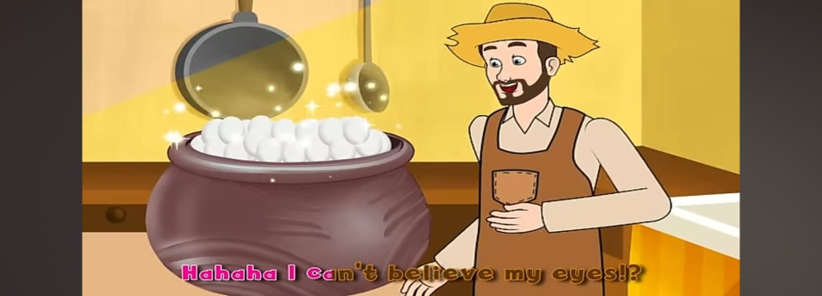01.Picture Video story magic pot

2.Second Treatments

In the second treatment which was carried out on June 5 2024. as usual the researcher greeted the students by saying "good morning" after that the researcher only repeated the material given in the first treatment by asking questions to the students and also asking the students to speak English loudly in front of them. before using fairy tale story video media.

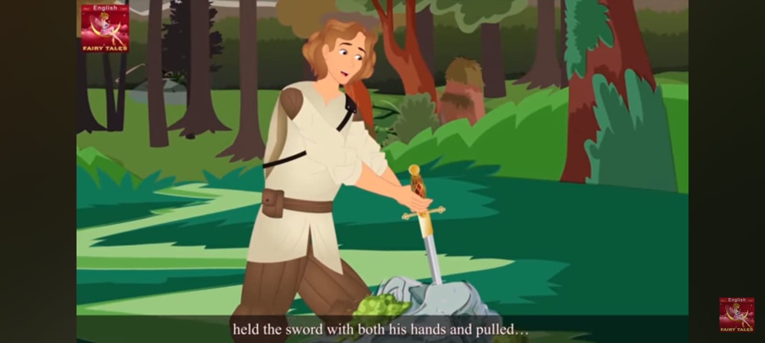02.Picture video Story sword in The Stone

After that, the researcher asked the students to come forward to speak freely and see to what extent the students gained new vocabulary from watching the fairy tale story videoentitled Sword in Stone.

Students can view or watch fairy tale story videos whenever they are at home so that students can learn to speak English wherever and whenever as long as there is an internet connection in the environment. this can improve their pronunciation and skills in speaking English. From the treatment carried out by the researcher, it can be concluded that the fairy tale video story media presented by the researcher is very influential in students' learning to speak English because the fairy tale video is a learning platform tool that is memorable and fun and also not boring for students.

All the data listed in this research study were calculated using SPSS version 26. and 15 students of class IX SMP Al-Fadlaly who provided the data. This can be seen from the results of the students' pre-test and post-test exams, which have increased from the average student score. The average student post-test (78.0000) > the average student pre-test (45.3333) These results indicate that students' speaking ability using media story fairy tale video media has a significant effect on learning outcomes.

According toManukyan A. M. and Durgaryan A. M. (2019)Fairy tale stories can encourage students' curiosity and also increase interest in learning foreign languages, be it English or other languages, besides that fairy tale stories can also elicit strong emotional responses to students' personal relationships.

In addition, the steps for teaching speaking skills using YouTube videos are below:

1. The teacher prepares the learning media, in this case determining the YouTube fairy tale video for students to watch.

2. The teacher determines the duration of the learning video. because it uses a YouTube fairy tale duration of about 7 minutes to 10 minutes.

3. The teacher prepares the class. the teacher plays the YouTube fairy tale video and is also equipped with an explanation that each learner must watch the video because the video is a chapter / material opener.

4.follow-up activities after the learners have watched the fairy tale YouTube video according to the set time, there will be a question and answer session and English-speaking practice.

In using the media story fairy tale helps learn to speak the language because the media story fairy talel can be entertaining and can also add new vocabulary and practice the correct pronunciation by just watching the video story fairy tale.fairy tale video media is an interesting, fun and straightforward media that can be used in speaking classes because it can help stimulate confidence and improve their ideas in speaking English. fairy tale video media also provides fun, and is also easily accessible and can also be used as independent learning for SMP Al-fadlaly students.

**CONCLUSION**

based on the research title "The Effect of Fairy tale Videos On Youtube To The Students Speaking Ability"which was conducted at Al-Fadlaly involving class IX, researchers can conclude that the use of media story fairy tale videos as learning media has the potential to improve students' speaking ability, this media can provide an active learning experience for students in increasing students' confidence in speaking. in this case it can be seen from the average scores of student’s posttests that have increased, where at the beginning the average value of student’s pretest scores (45.3333) increased to (78.0000) after the posttest using fairy tale video media.

Therefore, H1 which states that there is a singnificant effect on students' speaking skills by using fairy tale media video stories is stated to be accepted and HO which states that there is no effect on speaking skills by using fairy tale media video stories is rejected. this shows that the skills Student speaking using fairy tale video story media has a significant effect on student learning outcomes. On this media platform students are presented with various interesting and enjoyable videos so that students can gain new vocabulary, practice pronunciation and also increase their confidence in speaking skills.

# 

# ACKNOWLEDGEMENTS

*Alhamdulillahi rabbil 'alamin,*the researcherexpressedthankyouverymuch for the gratitude Allah SWT for blessing and mercy on the writer during the process until the finished writing this thesis. Shalawat and salam are addressedto the final chosen religious messenger, the Prophet Muhammad SAW, who has brought us from the darkness to the brightness.

Thewritercancompletethethesisentitled" The Effect of Fairy tale Videos on YouTube To the Student' Speaking Ability at The Nineth' Grade Students of SMP Alfadlaly.". In Speaking this thesis, the author faced many obstacles, but thanks to his abundant grace, the author was finally able to finish it. In addition, the preparation of this thesis is also inseparable from the guidance, direction and support from various parties. Therefore, on this occasion, the author would like to thank:

* 1. FajarHidayatullah,M.Pd,asheadofSTKIPPGRI Bangkalan.
  2. My beloved parents (wahid and museiyyenah) thank you so much for the loved, sacrifice, affection, motivation, and greatest prayer for my bright future.
  3. TeraAthena,M.Pd,asheadoftheEnglishEducationDepartment.
  4. All the lectures of the English Education Department who have already taught and educated me during the study at STKIP PGRI Bangkalan.
  5. Moh Rohmli,S. Pd,asheadof SMP AL Fadlaly Probungan Klampis
  6. Moh. Arief Wahyudi, M.Pd, as Thesis Supervisor 1 and Academic advisor who always guides and directs the writer bothduring lectures and in the prep- aration of this thesis.
  7. Mariyatul Kiptiyah,M.Pd,asThesisExaminer.
  8. The big family majoring in English education class of 2020, thank youfor being together all this time.

# 

# REFERENCE

Bruhn Jensen, Klaus. 2021. *A Handbook of Media and Communication Research; Qualitative and Quantitative Methodologies; 3rd Edition*.

Canepa, Nancy L. 2019. *TEACHING FAIRY TALES*.

Guebba, Boutaina. 2021. “The Nature of Speaking in the Classroom: An Overview.” *Middle East Research Journal of Linguistics and Literature* 1(1): 9–12. doi:10.36348/merjll.2021.v01i01.002.

Gürsoy, Gülden. 2021. “Digital Storytelling: Developing 21st Century Skills in Science Education.” *European Journal of Educational Research* 10(1): 97–113. doi:10.12973/eu-jer.10.1.97.

Hamad, Mona M., Amal Abdelsattar Metwally, and Sabina Yasmin Alfaruque. 2019. “The Impact of Using YouTubes and Audio Tracks Imitation YATI on Improving Speaking Skills of EFL Learners.” *English Language Teaching* 12(6): 191. doi:10.5539/elt.v12n6p191.

İlkay Yemenici, Aliye. 2021. “THE EFFECT OF TEACHING AESTHETIC LISTENING STRATEGIES WITH FAIRY TALES ON THE LI.” *International Journal of Eurasian Education and Culture* 6(13): 777–818. doi:10.35826/ijoecc.403.

Ismail, Ismail. 2019. “Converting a Story from Students’ Own Language in English to Increase Speaking Ability.” *MAJESTY JOURNAL* 1(1): 5–18. doi:10.33487/majesty.v1i1.54.

Kristiani, Putu Enik, and Diah Ayu Manik Pradnyadewi. 2021. “Effectiveness of YouTube as Learning Media in Improving Learners’ Speaking Skills.” *The Art of Teaching English as a Foreign Language* 2(1): 7–11. doi:10.36663/tatefl.v2i1.97.

Ličen, Branislava, and Vesna Bogdanović. 2018. “TEACHING ASSESSMENT TO DEVELOP ESP STUDENTS’ SPEAKING SKILLS.” *Facta Universitatis, Series: Linguistics and Literature*: 263. doi:10.22190/full1702263l.

Lubis, Rica Umrina, and Indra Kurniawan Siregar. 2021. “IMPROVING STUDENTS’ SPEAKING SKILL THROUGH DEBATE.”

Manukyan A. M., and Durgaryan A. M. 2019. “DEVELOPING SPEAKING SKILLS THROUGH FAIRY TALES IN ELEMENTARY SCHOOL.” *Science Review* (3(20)): 26–29. doi:10.31435/rsglobal_sr/31032019/6384.

Mawar Helmanda, Cut, and Rahmatun Nisa. *2018 | Seminar Nasional Pendidikan Dasar 625*.

Meinawati, Euis, Danang Dwi Harmoko, Nazzala Aulia Rahmah, and Nurmala - Dewi. 2020. “INCREASING ENGLISH SPEAKING SKILLS USING YOUTUBE.” *Polyglot: Jurnal Ilmiah* 16(1): 1. doi:10.19166/pji.v16i1.1954.

Mertens, Willem, Amedeo Pugliese, and Jan Recker. 2016. Quantitative Data Analysis: A Companion for Accounting and Information Systems Research *Quantitative Data Analysis: A Companion for Accounting and Information Systems Research*. Springer International Publishing. doi:10.1007/978-3-319-42700-3.

MM Firdaus. 2021. “METODOLOGI PENELITIAN KUANTIATIF.”

Mohajan, Haradhan. 2020. *Munich Personal RePEc Archive Quantitative Research: A Successful Investigation in Natural and Social Sciences*.

Mweshi, Geoffrey Kapasa, and Kwesi Sakyi. 2020. “Application of Sampling Methods for the Research Design.” *Archives of Business Research* 8(11): 180–93. doi:10.14738/abr.811.9042.

Pada Pendekatan Kualitatif dan Kuantitatif Ardiansyah, Pendidikan, MSyahran Jailani, Sma Negeri, Bungo Provinsi Jambi, and Uin Sulthan Thaha Saifuddin Jambi. *Teknik Pengumpulan Data Dan Instrumen Penelitian Ilmiah*. http://ejournal.yayasanpendidikandzurriyatulquran.id/index.php/ihsan.

Pakula, Heini-Marja. 2019. “Teaching Speaking.” *Apples - Journal of Applied Language Studies* 13(1): 95–111. doi:10.17011/apples/urn.201903011691.

Pilcher, Nick, and Martin Cortazzi. 2023. “‘Qualitative’ and ‘Quantitative’ Methods and Approaches across Subject Fields: Implications for Research Values, Assumptions, and Practices.” *Quality and Quantity*. doi:10.1007/s11135-023-01734-4.

Sosas, Rowena V. 2021. “Technology in Teaching Speaking and Its Effects to Students Learning English.” *Journal of Language and Linguistic Studies* 17(2): 958–70. doi:10.52462/jlls.66.

S Santoso. 2020. “Panduan SPSS 26.” *Panduan Lengkap SPSS 26*.

Suadi. 2019. 1 SALEE: Study of Applied Linguistics and English Education *Improving Students’ English Speaking Skill By Using Their Speaking Video Recording*. http://ejournal.stainkepri.ac.id/index.php/salee.

Sugiantiningsih, Ida Ayu, Putu Aditya Antara, Jurusan Pendidikan, Pendidikan Anak, and Usia Dini. 2019. “PENERAPAN MODEL PEMBELAJARAN TALKING STICK BERBANTUAN MEDIA FLASH CARD UNTUK MENINGKATKAN KEMAMPUAN BERBICARA.” *Jurnal Ilmiah Pendidikan Profesi Guru* 2(3).

Sulastri, Sri, Moh Nur Arifin, and As ’ Ari. *The Effectiveness of Using Fairy Tale in Teaching Writing Narrative Text*.

Sulastri, Sri, Moh Nur Arifin, and As ’ Ari. *The Effectiveness of Using Fairy Tale in Teaching Writing Narrative Text*.

Sundran, Dineshwari, and Gurnam Kaur Sidhu. *Vocabulary Skills: A Case Study*.

Taherdoost, Hamed. 2022. “What Are Different Research Approaches? Comprehensive Review of Qualitative, Quantitative, and Mixed Method Research, Their Applications, Types, and Limitations.” *Journal of Management Science & Engineering Research* 2022(1): 53–63. doi:10.30564/jmser.v5i1.4538ï.

Tatlılıoğlu, Kasım, and Nadiia Senchylo-Tatlılıoğlu. 2022. “THE EFFECT OF FAIRY TALES IN THE PRESCHOOL PERIOD: EVALUATION IN THE CONTEXT OF LANGUAGE DEVELOPMENT.” *Actual Problems in the System of Education: General Secondary Education Institution – Pre-University Training – Higher Education Institution* (2): 106–13. doi:10.18372/2786-5487.1.16587.

Tey, Nisfa, Andi Naniwarsih, and Kata Kunci. 2019. “MENGGUNAKAN TASK-BASED TEACHING UNTUK MENINGKATKAN KETERAMPILAN BERBICARA SISWA KELAS VIII DI MTS. AL-ISTIQOMAH LASOANI USING TASK-BASED-TEACHING TO IMPROVE SPEAKING SKILL OF GRADE VIII STUDENTS OF MTS. AL-ISTIQOMAH LASOANI 1.”

Trihardini, Ayu. *Pemanfaatan Youtube Sebagai Media Pembelajaran Keterampilan Berbicara Bahasa Mandarin*.

Ulker, Venera. 2017. 8 *Journal of Education and Practice Www.Iiste.Org ISSN*. Online. www.iiste.org.