AUTONOMOUS LEARNING: IMPLEMENTING EXTENSIVE LISTENING THROUGH ENGLISH LYRICS IN K-POP SONGS TO ENRICH ENGLISH VOCABULARY FOR EFL STUDENTS

Rizqy Romadhoni Anwar¹⁾, Arfiyan Ridwan²⁾, Chairuddin³⁾
^{1,2,3}STKIP PGRI Bangkalan
E-mail: rzqrmdhnnwr@gmail.com¹⁾, arfiyan.ridwan@stkippgri-bkl.ac.id²⁾, chairuddin@stikippgri-bkl.ac.id³⁾

Abstrak:
Penguasaan vocabulary sangat penting dalam pengimplementasian suatu bahasa, salah satunya berkomunikasi. Penggemar K-Pop secara internasional menggunakan Bahasa Inggris dalam berkomunikasi. Faktanya, banyak penggemar K-Pop yang masih kesulitan dan butuh perkembangan dalam vocabulary mereka. Berdasarkan kasus tersebut, peneliti tertarik untuk melakukan penelitian terkait hal tersebut menggunakan media lagu K-Pop yang menggunakan lirik Bahasa inggris dengan pengimplementasian pembelajaran otonom pada penggemar K-Pop yang mana merupakan mahasiswa Pendidikan Bahasa inggris di STKIP PGRI Bangkalan. Tujuan penelitian ini untuk mengeksplorasi implementasi lirik bahasa Inggris dalam lagu-lagu K-Pop sebagai sarana pembelajar untuk memperkaya kosa kata dan mengeksplorasi pembelajar memahami isi lagu dan menerapkan hasil pembelajaran secara efektif untuk memperkaya kosa kata mereka. Penelitian ini menggunakan pendekatan kualitatif untuk mengumpulkan dan menganalisa data yang diperoleh. Hasil dari penelitian ini dapat menjawab pertanyaan penelitian. Beberapa temuan utama tersebut antara lain: Fakta bahwa beberapa lagu K-Pop memiliki kata-kata bahasa Inggris membantu siswa dalam kehidupan sehari-hari. Lagu-lagu yang dinyanyikan oleh idola mereka ini membantu mereka mempelajari kata-kata baru dan meningkatkan keterampilan mendengarkan karena mudah dipahami dan menarik. Ini sangat cocok dengan konsep mendengarkan ekstensif. Ketika siswa bersenang-senang sambil belajar dan dihadapkan pada hal-hal baru, itu memudahkan mereka untuk mengingatnya secara alami. Hal itu membantu mereka berbicara dan menulis.

Kata Kunci: Memperkaya Kosakata, K-Pop, Lirik, Perluasan Kemampuan Mendengarkan, Pembelajaran Otonom.

Abstract:
Mastering vocabulary is crucial to language implementation, including communication. English is spoken by international K-Pop enthusiasts. In fact, many K-Pop fans need vocabulary enhancement. Based on this scenario, researcher want to use K-Pop music media with English lyrics to apply autonomous learning for STKIP PGRI Bangkalan English Education students who love K-Pop. This study examined the use of English lyrics in K-Pop songs to improve vocabulary and students' comprehension and application of learning outcomes. This study collects and analyses qualitative data. Results from this study answer research questions. Main discoveries include: K-Pop songs with English lyrics benefit students in daily life.K-Pop songs with English lyrics are catchy and easy to understand and also which sung by idols help them learn new vocabulary and enhance their listening abilities. This fits extensive listening wonderfully. When students enjoy learning and are introduced to new ideas, they remember them better. It enhances speaking and writing.

Keywords: Enriching Vocabulary, K-Pop, Lyrics, Extensive Listening, Autonomous Learning.

INTRODUCTION

G
lobalization has had a profound impact on people's lives, particularly through the spread of Korean culture, known as "Hallyu" or the Korean Wave. This influence extends to various aspects of culture, including dramas, movies, music, fashion, and consumer goods, with K-Pop music emerging as one of its most prominent and globally recognized elements. K-Pop's popularity is evident not only in its chart-topping presence on platforms like Billboard but also in the extensive international fanbase it has cultivated.
The widespread influence of K-Pop is evident through data from Google Trends (2022), highlighting significant interest in countries like the Philippines, Myanmar, Singapore, Malaysia, and particularly Indonesia. The passionate K-Pop fanbase, known as K-Popers, plays a crucial role in the Fandom culture by forming tight-knit communities, sharing their admiration for idols, and participating in global discussions using English as a common language. This phenomenon underscores the profound impact of globalization on modern culture and society as K-Pop continues to gain popularity worldwide.
In fact, learning English involves not only vocabulary but also various language skills. Vocabulary is a crucial component of language use, as highlighted by Dakhi & Fitria (2019). Salawazo et al. (2020) identified several challenges students face when learning English vocabulary, including spelling and grammar difficulties, forgetfulness, and limited attention. However, utilizing K-Pop songs with English lyrics can be a valuable resource to address these learning obstacles. In today's globalized world, English proficiency is essential, and technology provides convenient access to language learning materials, including music platforms like YouTube, Joox, Spotify, and Apple Music.
In addition, Rachmawati (2021) notes that K-Pop artists often incorporate English lyrics into their songs to cater to international fans, making their music engaging for English as a Foreign Language (EFL) learners. Furthermore, (2018) emphasize the positive impact of Hallyu (Korean Wave) on vocabulary mastery, as fans of K-Pop and K-Dramas employ unique methods to expand their English vocabulary while pursuing their hobbies. Overall, these findings highlight the potential of K-Pop songs with English lyrics as a motivating tool for enhancing English language skills among learners.
This study aims to address two key research questions regarding the implementation of English lyrics in K-Pop songs as a tool for enriching vocabulary and understanding their content. The objectives of the study are to explore these aspects, and its significance lies in both theoretical and practical benefits. The research contributes to language pedagogy by promoting innovative teaching strategies and materials, benefiting teachers, students, other researchers, and parents who may find value in unconventional methods of vocabulary acquisition.
There are several key words of this research. First, ‘Enriching vocabulary’ is a continuous process of expanding one's word knowledge, leading to improved communication and cognitive skills. Thornbury (2002) claims that without grammar, very little can be conveyed, but without vocabulary, nothing can be conveyed. Rashid et al. (2022) states that students would be unable to comprehend the ideas of others or express their own without a large vocabulary. They believed that by memorizing a particular number of English words, they would be able to master the language. So, vocabulary is crucial since it is the foundation to understanding more about English.
Second, ‘K-Pop’, short for Korean popular music, is a music genre from South Korea known for its captivating music and visuals, gaining international popularity. Yuanita (2012) says Korean pop is characterized by upbeat songs with a fast tempo, Korean lyrics mixed with a small amount of English, and dance. Aside from that, the people who work in Korean pop are mostly Koreans who are beautiful and handsome, fashionable, and give their best performance. This is the reason why numerous Asian youths mimic Korean pop culture.
Third, ‘Lyrics’, are the words in a song that convey emotions or stories, typically sung by artists or groups. Nursita et al. (2022) that listening to English music can enhance students' vocabulary knowledge. Under her research, those who listen to English (lyrics) songs acquire larger vocabularies. By repeating the songs, taking note of unusual words, and recalling the lyrics, their vocabulary increases.
Fourth, ‘Extensive listening’, involves extended exposure to authentic foreign language audio materials to enhance overall listening skills and comprehension. Extensive listening is a daily life listening activity that includes activities like radio listening, watching television, and enjoying music. Unlike intensive listening, it doesn't demand intense concentration. It's a pleasurable practice that enhances listening comprehension, as noted by Mandiri et al. (2022).
Last, ‘Autonomous learning’, empowers individuals to take charge of their own learning, leveraging resources and self-directed efforts in various educational and personal contexts. Prioritizing autonomous learning, as emphasized by Wood (1999 in Yıldırım, 2012), is essential in distance education. Autonomous learners, or independent learners, possess the ability to think divergently and convergently to solve problems and generate new ideas. Instructors play a crucial role in instilling the value of autonomy in students' learning processes, fostering responsibility in learning. Independent learning thrives when students have control over their education. This aligns with K-Pop fans' desire to independently enhance their vocabulary through extensive listening techniques while using K-Pop songs with English lyrics.
There are several previous studies which support this study. First, the researcher in this section discussed a relevant study by Riska et al. (2018) that examined the English vocabulary skills of K-Pop and K-Drama fans. The study highlighted the importance of individualized learning strategies and the influence of media, such as English-subtitled videos and fan interactions, on language acquisition. It was found that K-Pop fans generally had higher English vocabulary skills compared to K-Drama fans, with a particular emphasis on the role of K-Pop songs with full English lyrics as a learning tool.
Second, Aulyah M (2021) made research on "The Effectiveness of Retelling Meaning Song Lyrics to Improve Students' Speaking Skill at the Third Grade of MAN Palopo" demonstrated that using song lyrics as a teaching method effectively enhances the speaking skills of third-grade students. The study addressed various English-learning challenges faced by students, such as limited proficiency, environmental factors, and lack of speaking opportunities. By employing the method of retelling song lyrics, the research successfully motivated students to engage more actively in language learning. Ultimately, the study concludes that utilizing song lyrics is an effective way to improve students' speaking skills.
Third, Nurpratama (2019) researched on "Learning Vocabulary Through Songs" found that students can benefit from songs as a means of acquiring vocabulary. The research identified several advantages, including accessibility, flexibility, motivation, and pronunciation practice, with students adopting specific strategies like listening, note-taking, and dialogue integration. Overall, students found learning vocabulary through songs to be interesting, enjoyable, and effective in enhancing their language skills.
The preliminary research highlighted the challenges university students face in learning vocabulary, particularly due to limited classroom experiences. To address this issue, the researcher proposed a study that utilizes K-Pop songs with English lyrics as a medium for autonomous vocabulary learning. The selection of three informants who are avid K-Pop fans and the choice of K-Pop songs provide a relevant context for the research. The study's title is "Autonomous Learning: Implementing Extensive Listening Through English Lyrics in K-Pop Songs to Enrich English Vocabulary for EFL Students."

RESEARCH METHOD
To conduct research, the researcher requires a research design that conforms to the strategy for combining the various components of the research projects in united and connectedness ways. Ahyar et al. (2020) wrote in their book that Qualitative Approach is one of research designs. Qualitative means as an approach which purpose is to understand the condition of context in detail and deep description about what is happening in the classroom or the field of the study. Descriptive research was conducted in line with the goal, to describe or to illustrate the facts about the population systematically and clearly. From the various designs, the researcher found a design that is most appropriate to this study. Case study is a way to collect necessary data and information for this research concerning to the case. Therefore, this research is an action to develop knowledge, as the same as to develop and to check the previous studies and the researcher believe that this design would help the researcher answer the research questions.
To collected the needed information, the researcher needed to analyze the information. This process was called data analysis technique. Based on Miles to Huberman in Ahyar et al. (2020) in analyzing the data there are three steps: 1. Data Reduction, to select and reduce unnecessary data (living out) and to maintain the necessary data related to the research (living in); 2. Data Display, or also known as data presentation, is an organized collection of information that provides the possibility there is a conclusion. In this part the researcher would use Matrix Effect.; 3. Conclusion, the final result is based on the previously described description of an article.
In the process of collect information needed, the researcher collected the data at STKIP PGRI Bangkalan on May 23rd, 2023 whose informants were three students majoring English Education which are K-Pop fans. The researcher did an observation, questionnaire, and interview session to make sure all the information was collected. The first when the researcher conducted the research was to know the implementation of English lyrics in K-Pop songs as a means for learner to enrich vocabulary based their learning activites. Each student listened to their own favorite songs on music platform for 15 to 20 minutes. In the same time, the researcher observed everything which was happened and made a note. After that, on May 30th, 2023, the researcher seek answer for the second research question. The researcher gave the questionnaire sheet to the informants so that they answered it honestly. The next step was interview sessions which took around an hour. The researcher analyzed the information based on the stages mentioned before.

FINDINGS AND DISCUSSION
This section summarized the research findings obtained from students' observations, questionnaires, and interviews regarding the enrichment of vocabulary using K-Pop songs with English lyrics. The researcher employed various methods, including observation checklists, closed questionnaires, and unstructured interviews, to address the research questions. K-Pop songs from popular idol groups were chosen as the medium, as these songs were familiar to the students and regularly heard in their daily lives through platforms like Spotify and YouTube. The implementation of K-Pop songs in English lyrics for vocabulary enrichment took place on May 23rd, 2023 (Observation Session) and May 30th, 2023 (Questionnaire and In-Depth Interview Session).
The observation conducted on May 23rd, 2023, provided insights into how students enjoy K-Pop songs with English lyrics. The process involved pre-listening, while-listening, and post-listening stages. Most students used their smartphones without earphones in a comfortable environment, adjusting the volume to their liking. They paid attention to lyrics, sang along, and even danced to the rhythm. After listening, they felt more energetic and often sought the meaning of song lyrics. Overall, this observation indicated that students find enjoyment and engagement in K-Pop songs with English lyrics, enhancing their vocabulary and mood. The observation conducted also addressed the second research question, revealing that students encounter difficulties in comprehending the lyrics of the songs they listen to. To overcome this, they rely on translator applications to interpret unfamiliar words, ultimately enhancing their understanding of the song's content. In addition, the students' approach to understanding song lyrics involves repeated listening, word-for-word interpretation, and a holistic comprehension of the song's meaning.
After the observation process, the researcher proceeded with a questionnaire and in-depth interview on May 30th, 2023, involving three selected informants. The questionnaire aimed to gather insights about their experiences related to understanding song meanings and learning outcomes when exposed to K-Pop songs in English lyrics. The informants used a scale of options to convey their responses, namely: 1) SD [Strongly Disagree]; 2) D [Disagree]; 3) A [Agree]; 4) SA [Strongly Agree]. The results were presented in a chart format and were divided into three topics.

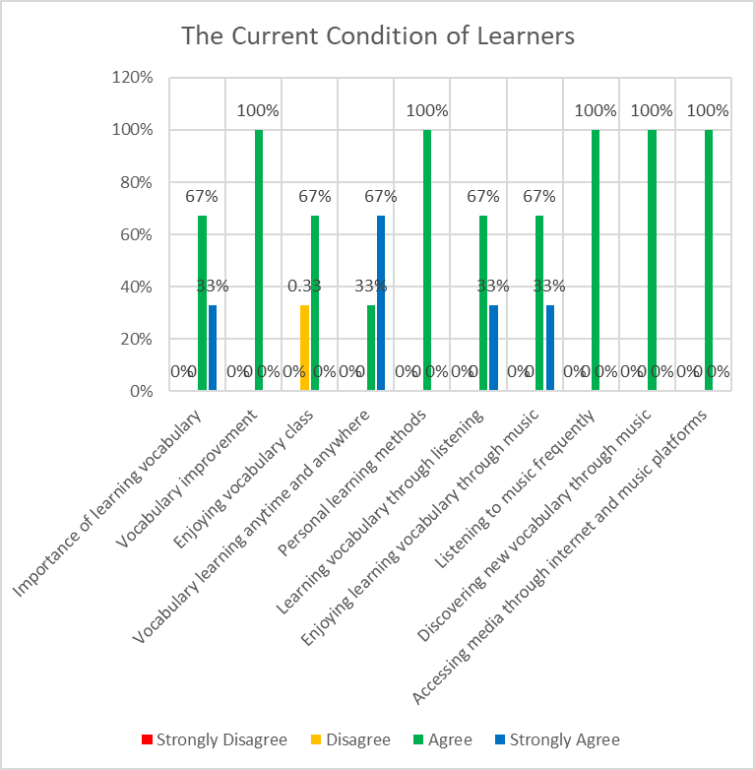
Chart 1. Informants' answers in topic about the current condition of learners through vocabulary learning
On the chart above:
- The majority of students (67%) consider learning vocabulary important.
- All informants acknowledged their limited vocabulary and the need for improvement.
- Most students (67%) enjoy learning vocabulary in class.
- The majority of students (67%) believe vocabulary can be learned anytime and anywhere.
- All informants have their own personal learning methods.
- All informants prefer learning vocabulary through listening activities.
- Most students (67%) enjoy learning vocabulary through music.
- The majority of students (67%) listen to music frequently.
- All informants often discover new vocabulary through music.
- All informants use internet media and music platforms to access their music.
These findings highlight the importance of music, particularly K-Pop songs with English lyrics, as a tool for vocabulary enrichment and learning enjoyment among students.

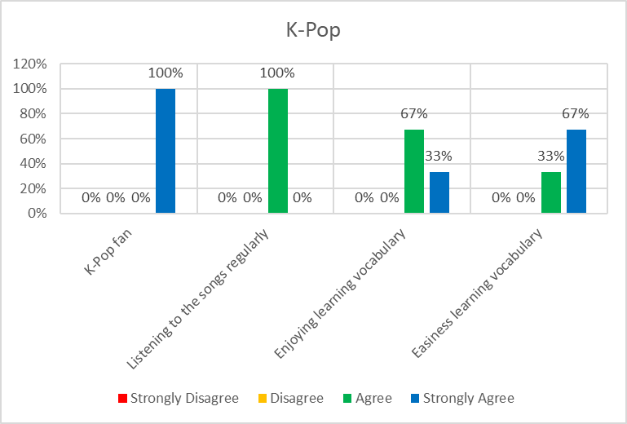
Chart 2. Informants' answers in topic about K-Pop through vocabulary learning
Based on the chart:
- All students in the research are fans of K-Pop, as they all strongly agreed with this statement.
- All students listen to K-Pop songs regularly in their daily lives.
- The majority of students (67%) find it easy to enjoy learning vocabulary through K-Pop songs and feel motivated to study more diligently.
- Most students (67%) feel that learning vocabulary through K-Pop songs with English lyrics is easy for them.
Overall, these findings demonstrate the strong connection between students' enthusiasm for K-Pop, their regular listening habits, and their positive perception of using K-Pop songs as a tool for vocabulary learning.

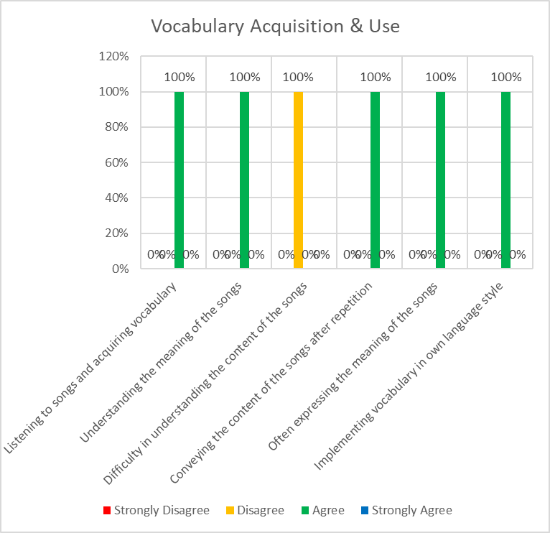
Chart 3. Informants' answers in topic about vocabulary acquisition and use
According to the chart above:
- All informants believe that listening to songs they like helps them acquire more vocabulary.
- All informants can understand the meaning of songs after acquiring the necessary vocabulary.
- None of the informants had a hard time understanding the song's content after repeated listening.
- All informants can convey the content of songs after listening to them multiple times.
- All informants often express the meaning of songs in both written and oral forms.
- All informants can effectively use the acquired vocabulary in both oral and written communication, incorporating it into their own language style.
These findings underscore the positive impact of music, particularly songs students enjoy, on vocabulary acquisition and its subsequent application in communication.
Following the questionnaire session on May 30th, 2023, the researcher conducted interviews with three selected students as informants, gathering additional data to complement the research findings. The interview dialog with all the participants in this study highlights several key points:
- Vocabulary is regarded as crucial for learning, both inside and outside the classroom, and it plays a fundamental role in basic English skills.
- Participants I-1 and I-2 found classroom learning enjoyable and engaging due to fun lessons and interesting instructors, while I-3 found it boring and unhelpful, involving repetitive memorization.
- Learning vocabulary outside the classroom is primarily self-directed, using media like songs, videos, and social platforms such as YouTube and TikTok, allowing for personalized, student-centered learning.
- Learning vocabulary through listening activities, particularly K-Pop songs in English, presents challenges due to fast-paced audio, but participants find it enjoyable and beneficial. The use of translator applications helps with unfamiliar words.
- Repeatedly playing songs enriches vocabulary and aids in understanding song meanings.
- Participants apply their acquired vocabulary in conversations and social media, using words contextually and naturally.
- Learning vocabulary through English lyrics in K-Pop songs is enjoyable, uplifting, and motivating for the participants. Each informant has their own perspective, emphasizing the pleasure of the music, the role of lyrics, and the freedom and effectiveness of this learning approach.
In summary, the interviews highlight the positive impact of using K-Pop songs with English lyrics for vocabulary acquisition, making learning enjoyable and effective for the participants.
The research revealed that university students greatly enjoy learning through music, particularly K-Pop songs with English lyrics. This approach aligns with the literature discussed in the second chapter of this thesis. The study emphasizes that students can seamlessly integrate listening-based learning into their daily lives, not just for educational purposes but also as a form of entertainment. Their choice of learning media, such as K-Pop songs in English, aligns with their personal interests.
Moreover, previous research, as supported by Riska et al. (2018), suggests that K-Pop fans tend to possess a high level of English vocabulary, demonstrating that certain strategies enable students to engage in learning outside the classroom, each in their unique way. Furthermore, the study underscores the role of K-Pop as a motivating and effective tool for language learning, as discussed in the second chapter. Pop songs, particularly those with English lyrics, have the potential to inspire and engage students, enriching their language skills. Learning vocabulary through songs is not only interesting and enjoyable but also helps learners with pronunciation.
Additionally, the research reinforces the idea that using song lyrics can boost students' speaking skills, as demonstrated by Aulyah M (2021). This represents a practical application of vocabulary in real communication. In conclusion, the research supports the appropriateness of using K-Pop songs with English lyrics to enhance the vocabulary of EFL university students. It highlights the effectiveness of this method in making learning enjoyable and engaging, while aligning with existing literature in the field.
This research highlighted the diverse perspectives on learning vocabulary, both inside and outside the classroom, among the student participants. While some found classroom learning enjoyable due to the use of song media and engaging lecturers, others found it monotonous, limited to writing and memorization.
These students exhibited a preference for self-directed learning and believed in the flexibility of vocabulary acquisition anytime and anywhere. They particularly favored learning vocabulary through listening activities, utilizing various media such as songs and movies.
The study aligns with the concept of Extensive Listening, described by Mandiri et al. (2022), which promotes engaging and enjoyable listening activities to enhance comprehension. It also reaffirms the effectiveness of learning vocabulary through songs, as supported by Nurpratama (2019), which provides access, flexibility, motivation, and pronunciation examples.
Moreover, the use of K-Pop songs as a learning medium, facilitated by technology and internet platforms like Spotify and YouTube, has become a common practice. This approach aligns with the principles of ICT in Education discussed in the second chapter, emphasizing the role of technology in enhancing learning accessibility.
The research findings indicate that students thoroughly enjoyed learning vocabulary through K-Pop songs with English lyrics, finding it easy and motivating. This method not only boosted their mood but also contributed to improving their language skills.
Furthermore, students frequently discovered new vocabulary while listening to music, and the more they listened to songs they liked, the more vocabulary they acquired. This aligns with Nursita et al. (2022) findings, suggesting that English song lyrics significantly enhance vocabulary proficiency through repeated exposure. Additionally, all students were proficient in conveying the content of songs after multiple listens and effectively used the acquired vocabulary in both oral and written communication. This speaks to the significance of vocabulary as a foundation for language skills, including speaking.
Lastly, the research emphasized the importance of vocabulary in English learning, as emphasized by Rashid et al. (2022). Students recognized the significance of an extensive vocabulary for comprehension and effective communication. In summary, the study showcased the engagement and effectiveness of learning vocabulary through English lyrics in K-Pop songs, resonating with the enthusiasm of students and enriching their language skills.

CONCLUSION
This study was conducted at STKIP PGRI Bangkalan with students in the English Education Department who are learning English as a foreign language. Students need to learn English because it is important for global communication. Additionally, teenagers enthusiastically embrace the growth of K-Pop. They are very enthusiastic about their idols. The researcher was curious about this scenario, so they decided to study how K-Pop songs with English lyrics can help improve listening skills. They had used the same material before to help with vocabulary development.
Using English lyrics in K-Pop songs positively affects students' daily experiences. The media and materials were easily accessible and free to use. Students can improve their vocabulary and listening skills anytime, anywhere. It aligns well with using Extensive Listening for Autonomous Learning. In a different situation, the songs were enjoyable and this motivated the learners. The experience was enjoyable as they learned vocabulary while fangirling over their idols. The lyrics on the screen helped learners learn new words and understand the songs better over time. K-Pop songs help learners remember English words and use them in daily life. This positively impacts listening skills, as well as speaking and writing skills. In conclusion, students used this media because they were motivated to study more by songs sung by their idols. Hence, users can listen to the songs on their smartphones through their preferred platform, anytime and anywhere.
The research aimed to answer the research questions. EFL students should utilize their learning challenges to find effective solutions.

ACKNOWLEDGEMENT
This research marks a significant milestone in the researcher's academic journey at STKIP PGRI Bangkalan. The researcher would like to express gratitude to all those who have contributed to the completion of this research:
- Fajar Hidayatullah, M.Pd., the head of STKIP PGRI Bangkalan.
- Tera Athena, M.Pd., the chairwoman of the English Education Department at STKIP PGRI Bangkalan.
- Arfiyan Ridwan, M.Pd., the first supervisor, for guidance, support, and valuable advice.
- Chairuddin, M.Pd., the second supervisor, for guidance and critical input.
- Iin Rachmawati, M.Hum., a special lecturer, for her support and companionship.
- All the lecturers of the English Education Department at STKIP PGRI Bangkalan.
- The researcher's parents for the gift of life and unwavering support.
- Beloved sister, Maysarah Moudya, for constant companionship and love.
- INFJ sister, Dwi Mery Lidiana, for wise advice and enduring friendship.
- Friends and classmates who have stood by the researcher.
- All who contributed to this thesis in various ways.
- Last but not least, gratitude to the researcher's own determination and hard work.
With the completion of this research, the researcher marks the end of a significant chapter and looks forward to new beginnings and continued growth in the future.

REFERENCES
Ahyar, H., Juliana Sukmana, D., & Helmina, A. (2020). Buku Metode Penelitian Kualitatif & Kuantitatif. CV. Pustaka Ilmu Group. Retrieved from https://www.researchgate.net/publication/340021548
Aulyah M, N. (2021). The Effectiveness of Retelling Meaning Song Lyric to Improve Students’ Speaking Skill at The Third Grade of MAN Palopo.
Dakhi, S., & Fitria, T. N. (2019). The Principles and the Teaching of English Vocabulary: A Review. JET (Journal of English Teaching), 5(1), 15. https://doi.org/10.33541/jet.v5i1.956
Google Trends. (2022). K-Pop. Retrieved November 25, 2022, from https://trends.google.co.id/trends/explore?q=%2Fm%2F02yh8l
Mandiri, I. C. P., Gunawan, M. H., & Suharno, S. (2022). EFL Student’s Difficulties in Extensive Listening Activities: A Thematic Content Analysis. English Review: Journal of English Education, 10(2), 393–400. https://doi.org/10.25134/erjee.v10i2.6240
Nurpratama, D. E. (2019). Learning Vocabulary Through Songs. Universitas Kristen Satya Wacana, Salatiga.
Nursita, N., Ruslin, R., Zuhra, Z., & Syam, H. (2022). The Effect of English Song Lyrics on The Improvement of Students’ Vocabulary Proficiency at The Eleventh Grade at SMA 4 Palu. Prosiding Kajian Islam Dan Integrasi Ilmu Di Era Society 5.0 (KIIIES 5.0), 1(1). Retrieved from https://kiiies50.uindatokarama.ac.id/38
Rachmawati, I. (2021). Korean Culture and Cultural Hybridity Product: The Soft Power of South Korea. Bangkalan: STKIP PGRI Bangkalan Press.
Rashid, Md. H., Lan, Y., & Hui, W. (2022). The Importance of Vocabulary in Teaching and Learning in Applied Linguistics. Linguistics and Culture Review, 6, 1548–1557. https://doi.org/10.21744/lingcure.v6ns2.2177
Riska, E., Ali, N. M., & Fuadul Matin, G. M. (2018). K-Popers’ and K-Drama Lovers’ English Vocabulary Master.
Salawazo, I. S., Simbolon, M., Hutabarat, V. E., Veronika, A. N., & Saragih, E. (2020). Analysis of Students’ Vocabulary in Learning English. Linguistic, English Education and Art (LEEA) Journal, 3(2), 469–475. https://doi.org/10.31539/leea.v3i2.1017
Thornbury, S. (2002). How To Teach Vocabulary. Essex: Pearson Education Limited.
Yıldırım, Ö. (2012). A Study on a Group of Indian English as a Second Language Learners’ Perceptions of Autonomous Learning. In Turkish Online Journal of Qualitative Inquiry (Vol. 3).
Yuanita, S. (2012). Korean Wave dari K-Pop Hingga Tampil Gaya Ala Korea. Yogyakarta: Idea Terra Media Pustaka.

