AN ANALYSIS OF STUDENTS LIMITEDNESS IN ENGLISH SPEAKING : A Case Study at Eight Grade of SMPN 01 SOCAH

Siti Fatimatuzzehra¹⁾, Maulana Yusuf Aditya M.Pd.²⁾
STKIP PGRI Bangkalan
E-mail: sitifatimatuzzehra@gmail.com

Abstrak:
Speaking is the way a person communicates between people, by speaking someone can convey massages, information, and ideas to other. Talking can also be done in everyday life, by speaking too someone can convey something that you want to talk about according to what it should be. Speaking is also referred to as an action to be reported through spoken words with the ability to speak. In addition, lack of self-confidence is a problem for students, often a lack of self-confidence arises so that students feel afraid or embarrassed by the limitations of students’ speaking abilities. And the difficulty of pronouncing words makes students afraid to express what they to convey, the lack of vocabulary that students have is also a problem in students’ speaking skills. In this limitation, it becomes the attention of the teacher or other students’ causing embarrassment and anxiety of the error.

Keyword: Speaking Performance, limitedness.

Abstract:
Berbicara merupakan cara seseorang berkomunikasi antar manusia, dengan berbicara seseorang dapat menyampaikan pesan, informasi, dan gagasan kepada orang lain. Berbicara juga dapat dilakukan dalam kehidupan sehari-hari, dengan berbicara pula seseorang dapat menyampaikan suatu hal yang ingin dibicarakan sesuai dengan apa yang seharusnya. Berbicara juga disebut sebagai tindakan yang dilaporkan melalui kata-kata yang diucapkan dengan kemampuan berbicara. Selain itu rasa kurang percaya diri menjadi masalah bagi siswa, sering kali rasa kurang percaya diri muncul sehingga siswa merasa takut atau malu dengan keterbatasan kemampuan berbicara siswa. Dan sulitnya mengucapkan kata-kata membuat siswa takut untuk mengungkapkan apa yang ingin disampaikannya, kurangnya kosakata yang dimiliki siswa juga menjadi permasalahan dalam keterampilan berbicara siswa. Dalam keterbatasan ini menjadi perhatian guru atau siswa lain sehingga menimbulkan rasa malu dan cemas atas kesalahan tersebut.

Kata Kunci: Performa Berbicara, keterbatasan..

INTRODUCTION

s
peaking is the way a person communicates between people, by speaking someone can convey massages, information, and ideas to other. Talking can also be done in everyday life, by speaking too someone can convey something that you want to talk about according to what it should be. Speaking is also referred to as an action to be reported through spoken words with the ability to speak.
Especially for students who have minimal English vocabulary, this is also a trigger for students to be constrained by these limitations, so often even many students are not passionate about speaking in public, sometimes it's not just a factor of lack of vocabulary or limitations students speak in speaking but there are also some students who have a sense of stage fright, namely feelings of nervousness, fear, worry and anxiety. In this case students need practice to speak well and memorize vocabulary in developing speaking skills. Therefore, from the existing research and problems, due to the limitations of students in speaking English, the researcher was interested in giving the title an analysis of Students limitedness in English Speaking.
Zhang (2019) opinion that speaking skills are something that is difficult to master for English students where they are still unable to communicate using English (Amoah & Yeboah, 2021). Tarigan (in Mahsin 2003) in article (Wahyuni & Afrianti, 2021) that speaking is a person's ability to make sound, express, convey thoughts, ideas, opinions and also to someone's wishes. And this case speaking as the main interaction is usually social interaction. Limitations in speaking are weaknesses that students have in speaking, namely where students have a lack or limitation of their fluency, perfection in speaking English. And with the limitations they have can affect students in learning. For example, students who speak weakly, because the vocabulary they have is still lacking, imperfect pronunciation will make students embarrassed in learning. There is a possibility that student learning difficulties can be caused by several internal and external factors. Internal factor come from within students, for example at tides towards student learning, student characteristics, concentration while studying, student self-confidence, student study habits, and the ability to explore learning outcomes. There is a possibility that student learning difficulties can be caused by several internal and external factors. Internal factor come from within students, for example at tides towards student learning, student characteristics, concentration while studying, student self-confidence, student study habits, and the ability to explore learning outcomes. Activities in learning and teaching speaking skills, namely speaking, writing, listening, and reading. Where when practicing speaking skills, the teacher gives direction to students to listen to other student’s opinions, read the text given by the teacher, or retell what is being said. They read in the student’s own language. Students are directed to get ideas, ideas as a tool to communicate with other students. And then the teacher gives feedback on what the students say.
RESEARCH METHODS
This research uses qualitative approach. Which carried out activities directly in the field and observed every condition of an event that took place, and in this study the researcher used instruments in the form of observation, questionnaires, and interviews. In this qualitative research where students would be the main object to obtain information and data.
Because this research is a case study, the research used in-depth interviews as the main technique and then continued with class observations and questionnaires to check validity. In collecting data, the researcher observes and analyses an object to be examined. then the researcher can record every event in the field. With these records it is important to use them in data collection. data collection and data reduction are related and interact with through the conclusion and presentation of data. In this case the data is not one-time, but needs to be looked at repeatedly, the development is sequential and interactive.
Presentation of data is the activity of compiling information, to provide the possibility of drawing conclusions and taking action to collect data. presentation of qualitative data can be in the form of narrative texts such as field notes, matrices, charts, and networks. in this case it can make it easier for researchers to see what is happening

RESEARCH RESULTS AND DISCUSSION
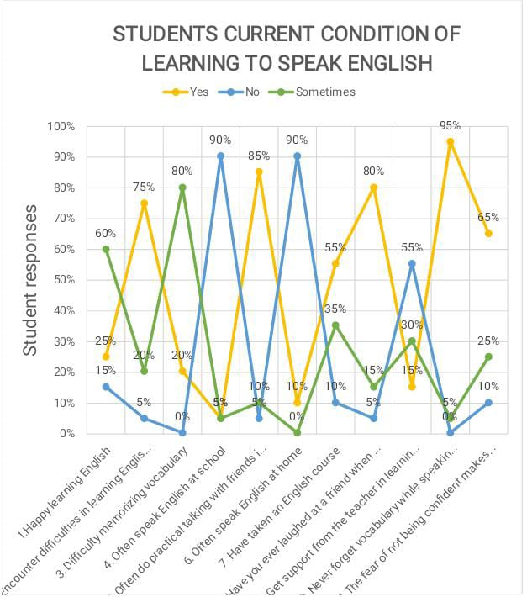
This research was conducted to find out the limitations of students in speaking English, in this case the researcher made observations, namely directly observing student activities, then the researcher also conducted student interviews and gave several questions to obtain valid information and answer, and the researcher also carried out documentation taking pictures or notes that were used as a from of documentary evidence. The results of the students' answers showed that most students had difficulty determining the correct pronunciation, besides that the students explained that it was very difficult for them to memorize vocabulary so that students often forgot vocabulary and caused students to be limited in speaking. From this it shows that apart from having difficulties in determining the correct pronunciation it causes students to be afraid in speaking students feel when speaking sentences that are read are sometimes wrong. so, students often stop when there are sentences whose pronunciation is difficult, students read like spelling. The results of the students' answers showed that most students had difficulty determining the correct pronunciation, besides that the students explained that it was very difficult for them to memorize vocabulary so that students often forgot vocabulary and caused students to be limited in speaking. From this it shows that apart from having difficulties in determining the correct pronunciation it causes students to be afraid in speaking students feel when speaking sentences that are read are sometimes wrong. so, students often stop when there are sentences whose pronunciation is difficult, students read like spelling.
This shows that vocabulary is an important factor in speaking skills, With a lot of vocabulary that students have, students can easily speak English, but it is better if the vocabulary that is owned by students is only a few, students will have difficulty speaking, besides that the thing that is difficult for students to face is forgetting vocabulary, so that students do not fluent in speaking English. Another factor of the limitations and difficulties students have in speaking English is the poor vocabulary that students have, namely students have difficulty memorizing vocabulary so that the vocabulary that students have is very small, and secondly, they forget vocabulary.
CONCLUSION
Based on the results of the research encountered, the researcher concluded that the limitations of students in speaking at junior high school at SMPN 01 SOCAH in English speaking skills were caused because students had difficulty speaking, determining correct pronunciation, students felt afraid and embarrassed in speaking English, lack of support from teachers and families, difficulties in memorizing vocabulary, and students often forget the vocabulary they have. As well as students are not used to speaking in English both at school and outside of school. This study provides a lot of information about several factors experienced by students in terms of limitations in speaking English, some of the difficulties faced by students.
ACKNOWLEDGEMENTS
All of lectures of English Education Department. My parents, Mr. Dasuki and Mrs. Suparmi (deceased) have supported and prayed for me. My sisters Siti Maryam Putri and with my Family who always support and pray for me to finish this thesis well. And for my husband Abd. Aziz A. Naim, S. Pd I would like to say thank you very much for always giving support and praying for me, and for always reminding me to finish my thesis on time. Until finally I can finish this thesis according to the time.

REFERENCES

Alberth, Wiramihardja, E., & Uden, L. (2020). WhatsApp with English language teaching? Some practical ideas and strategies. International Journal of Technology Enhanced Learning, 12(3), 262–274. https://doi.org/10.1504/IJTEL.2020.107974

Amoah, S., & Yeboah, J. (2021). The speaking difficulties of Chinese EFL learners and their motivation towards speaking the English language. Journal of Language and Linguistic Studies, 17(1), 56–69. https://doi.org/10.52462/jlls.4

Andriani Putri, S., Amri, S., & Ahmad, A. (2020). the Students’ Difficulties Factors in Speaking. J-Shelves of Indragiri (Jsi), 1(2), 115–129. https://doi.org/10.32520/jsi.v1i2.1059

Clarita, Z. (2020). An Analysis Of Students’ Speaking Difficulties at Eighth Grade Smpit At-Taqwa Surabaya.

Fabiana Meijon Fadul. (2019). 済無No Title No Title No Title. 9, 47–55.

Fadhilah, S. N. U. R., Education, E. L., & Faculty, L. (2020). Teaching Strategies on Transactional and Interpersonal by :

Gana, M., Haryanto, & Salija, K. (2018). Teachers’ Strategies in Teaching Speaking (a Case Study of an English Teacher in Sma Negeri 1 Toraja Utara). Teachers’ Strategies in Teaching Speaking, 1–10.

Maryanti, Sofyan Abdul Gani, Saiful Marhaban, D. (2021). Universitas Syiah Kuala, Banda Aceh, Indonesia. English Education Journal (EEJ), 12(4)(October 2021), 540–557.

Murti, Pramustia, Baso Jabu, S. (2022). Students’ English Speaking Difficulties and Teachers’ Strategies in English Teaching: a Case Study At Sma Negeri 10 Gowa. Journal of English Education and Literature, 1(1), 50–63.

Rijali, A. (2018). Analisis Data Kualitatif Ahmad Rijali UIN Antasari Banjarmasin. 17(33), 81–95.

Sinaga, P. D., Sari, A. S. P., & Sembiring, N. (2021). the Use of Digital Storytelling To Enhance the Speaking Skill of the Eleventh Grade Students of Sma Swasta Palapa Medan in the Academic Year of 2020/2021. Kairos English Language Teaching Journal, 5(1), 25–34. https://doi.org/10.54367/kairos.v5i1.1442

Wahyuni, N., & Afrianti, I. (2021). The Contribution of Speaking Practice with the Native Speaker to Student ’ s Speaking Ability in Junior High School. 2, 247–252.

Yusuf. (2021). The Analysis of Students’ Difficulties in English Speaking in The Classroom. STKIP PGRI Bangkalan, 1.

Zulfitri, N. (2019). Sebuah Analisa Faktor – Faktor Yang Mempengaruhi Kesulitan Berbicara Bahasa Inggris Pada Mahasiswa Pendidikan Bahasa Inggris Umn Al – Washliyah Medan, Tahun Pelajaran 2019-2020 ( Analisa Studi Psycholinguistics ). Prossiding Seminar Hasil Penelitian 2019, 580–589. file:///C:/Users/asus/Downloads/598-Article Text-2142-1-10-20210107.pdf

